Table of Contents

Repositories 9

09th March 2024 10

Installation 10

Variables 10

Type method 10

del 10

Unpacking or multiple declarations 10

F-Strings 11

Operators 11

Input 12

Format input 12

10th March 13

Python Data Structure 13

Strings 13

triple quotes 13

methods 14

Convert List to string 15

Convert String to List 15

Lists 15

len 15

append 16

remove 16

Indexing 16

index 16

extend 16

pop 17

count 17

sort 17

Mutability 17

Tuple 18

Dictionaries 18

Print Specific key value 18

Print Key and Values 18

Keys 19

Values 19

Sets 19

Remove vs Discard 19

Tuple vs List vs Set vs Dictionary 19

Iterators 20

for Loop 20

Iterating over Sequences 20

Known Number of Iterations 20

Enumeration 20

Iteration with Iterators 21

while Loop 21

Unknown Number of Iterations 21

Condition-based Iteration 22

Looping with State 22

Looping with Dynamic Conditions 22

For vs While 23

Common Applications 23

Control Flow Statements 23

break 23

continue 23

else 23

16th March, 2024 24

Slicing 24

Slicing a string 24

Slicing a list 24

Slicing a tuple 24

Escape Sequences 24

Conditional statements 25

If, elif else 25

Ternary Operator 26

17th March 27

Functions 27

Arguments 27

Return Values 27

Function Call 27

Scope 28

OOPs Concept 28

Encapsulation 28

Abstraction 29

Inheritance 29

Global Variables 30

23rd March 31

Functions as Generators 31

Return vs Yield 32

Real Time Applications 32

Using Modules 33

Creating a Module 33

Importing a Module 33

Importing Specific Functions or Variables 34

Renaming Imported Modules or Symbols 34

Accessing Module Documentation: 34

Classes 35

Defining a Class 35

Creating Objects (Instances) 35

Accessing Attributes and Calling Methods: 35

Self key word 36

Within Instance Methods 36

Accessing Instance Attributes 36

Referencing the Current Instance 36

Differentiating Between Instance and Class Variables 36

Constructors 37

Class Inheritance 37

Class Documentation 38

Private Variables 38

24th March 40

Iterators in Classes 40

Polymorphism 40

Method Overriding 41

Method Overloading 41

Variable Length Argument Lists 41

Default Parameter Values 42

KWARGS 42

The Pass Keyword 42

Placeholder for Future Code 42

Empty Code Blocks 43

Infinite Loops 43

Placeholders in Classes and Functions 43

File Operation 43

Opening a File 43

Reading from a File 43

End of File 44

Writing to a File 44

Appending to a File 44

Closing a File 45

Using "with" Statement (Context Manager): 45

File Seek and Tell 45

File Modes 45

Exception Handling 47

Raise 47

Decorators 48

30th March 51

Static Method 51

Custom Environment 51

31st March 53

NumPy 53

Advanced Indexing 54

Integer Array Indexing 54

Boolean Array Indexing 54

Complex Indexing Examples 55

Slicing Operator 55

Where Function 56

Select Function 57

arrange function 58

Reshape Function 58

Flattening Array 59

3D- reshape 59

Have to go recording from 12:30 PM 59

6th April 60

Pandas 60

Category vs Object Data Types 61

Series 61

Creating a Series 61

Custom Indexing 62

Accessing Elements 62

Operations on Series 62

Series Attributes and Methods 63

Data Frame 63

Descriptive statistics 63

For a DataFrame 64

For a Series 64

Exaplanation on the output 64

Renaming the Columns 65

Drop Null Values using dropna 66

DataFrame: 66

Series: 67

Parameters: 67

Drop Method 67

Delete Columns 67

Delete Rows 67

Filling the Null Values using fillna method 68

Change the column Type 68

Indexing using iloc and loc 68

Loc vs iloc 68

Sort_values method 69

Boolean Indexing 69

GroupBy 69

Lambda Functions 70

Example: 71

Use Cases 71

Limitations 71

Using map() with Lambda Function 71

Using filter() with Lambda Function 72

Sorting with Lambda Function 72

Read data from the excel 73

Read data from the CSV 73

07 April 74

Have to go with recording till 10.40 AM 74

CSV joins 74

Joins 74

Inner Join (how='inner') 75

Outer Join (how='outer') 75

Left Join (how='left') 75

Right Join (how='right') 75

Cross Join (Cartesian Join) 75

MatPlotLib 75

Description 75

Line Plot Graph 77

Bar Graph 78

Histogram 78

PieChart 78

Scatter Plot 78

13th April 79

14th April 80

20th April 80

21st April 81

4 May 82

Statastics / stats 82

Descriptive statistics 82

Mean / Average 82

Meadian 83

Mode 83

Range 84

Variance 84

Standard Deviation 86

Percentile 87

Quartile / quantile 89

5th May 90

Outliers 90

Correlation 92

Inferential statistics 92

11th May 93

12th May 93

18th May 93

19th May 93

25th May 94

CHI square test 94

Introduction to ML 94

Types of ML algorithms 94

Supervised Learning 94

Unsupervised Learning 95

Reinforcement Learning 97

Key Concepts in Reinforcement Learning 97

Types of Reinforcement Learning 97

Key Algorithms in Reinforcement Learning 98

Workflow of a Reinforcement Learning Task 98

Examples of Applications of Reinforcement Learning 98

26th May 99

Linear Regression 99

Linear Regression in Machine Learning 99

Types of Linear Regression 99

Key Components 99

Objective 99

Mathematical Representation 99

Assumptions 100

Sum of Square Errors (SSEs) 100

Mean Square Error (MSE) 101

Why Use MSE? 101

Interpretation of MSE 101

1st June 102

2nd June 102

6th June 102

Linear Regression 102

**Homoscedasticity** and **Heteroscedasticity** 105

Homoscedasticity 106

Heteroscedasticity 106

Example in Simple Linear Regression 107

Multicollinearity in Regression Analysis 107

Effects of Multicollinearity 108

Diagnosing Multicollinearity 108

9th July 110

Naive Model 110

Adjusted R-squared 110

Logistic Regression 111

Measure of Spread 113

15th June 115

Startify attribute 115

Importance of Stratification 115

How Stratification Works 115

Usage Example in Python with train_test_split 115

Output Explanation 116

When to Use Stratification 116

Summary 116

random_state attribute 116

Why Use random_state? 116

How random_state Works 116

fit_transform vs transform 117

fit_transform 117

When to Use fit_transform 117

transform 117

When to Use transform 117

Summary 117

Decision Trees 118

1. Concept and Structure 118

2. How Decision Trees Work 118

3. Advantages and Disadvantages 118

4. Pruning 119

5. Important Parameters 119

6. Ensemble Methods 119

Occam's Razor Principle 119

Origin and Explanation 119

Application in Science and Machine Learning 120

Examples 120

Mathematical Formulation 120

Practical Considerations 120

Summary 120

16th June 121

Overfitting vs Underfitting 121

Overfitting 121

Underfitting 121

Balancing Overfitting and Underfitting 122

Entropy 122

Conclusion 124

Random Forest 124

Key Concepts 124

How Random Forest Works 125

Advantages 125

Disadvantages 125

Hyperparameters 125

Example in Python (scikit-learn) 126

Conclusion 126

# References

GitHub Link

* [shikharkumar13 (Data Science With Shikhar) (github.com)](https://github.com/shikharkumar13)

Drive:

* [Data Science Files - Google Drive](https://drive.google.com/drive/folders/1jiKxJCI3Cnd_pgznxQ-690O8RyfmgiPV)

# 09th March 2024

This is beginning of the Python course.

## Installation

* The anaconda installation shown here.
* Shown the Jupiter Notebook usage.
* Colab.google.com is alternative for Jupiter Notebook.

## Variables

Variables can’t have

1. They can only contain letters (a-z, A-Z), digits (0-9), and underscores ('_').
2. They cannot start with a digit.
3. They cannot be a keyword or reserved word in Python.
4. Can’t use ‘-‘ (Hyphen) or ‘@’

Note:

* The '@' symbol is not allowed because it's reserved for decorators in Python. Decorators are used to modify the behaviour of functions or methods.
* The '-' symbol is not allowed because it's an operator in Python used for subtraction.

### Type method

Type is a method which explains the variable type

* Print(type(variable_name))

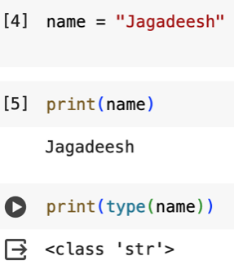

### del

We can use del to delete variables from the current namespace.

Ex:

x = 5

del x # Delete the variable x

### Unpacking or multiple declarations

We can declare and assign values to multiple variables in a single line using multiple assignment, also known as unpacking. This is commonly done using tuples, lists, or even strings.

Here are a few examples:

Ex1:

x, y, z = 1, 2, 3

Ex2:

values = [1, 2, 3]

x, y, z = values

Ex3:

x, y, z = "abc"

This assigns the characters 'a', 'b', and 'c' to variables x, y, and z respectively.

Ex4:

def get_values():

return 1, 2, 3

x, y, z = get_values()

### F-Strings

F-strings, also known as formatted string literals, are a feature introduced in Python 3.6 that allow for easier string formatting. They provide a concise and readable way to embed expressions inside string literals.

Note:

* Its like printf in CPP

To create an f-string, prefix the string with 'f' or 'F' and then place the expressions you want to embed inside curly braces {}. When the string is evaluated, the expressions inside the curly braces are replaced with their values.

Here's a simple example:

name = "Jagadeesh"

age = 40

f_string = f"My name is {name} and I am {age} years old."

print(f_string)

The Output will be:

My name is Jagadeesh and I am 40 years old.

Or we can use directly print like below which also give same output:

print(f"My name is {name} and I am {age} years old.")

## Operators

* ** is used for power values
  + 5**2 = 25
* // is for floor division
  + 63//5 = 12
  + 63/5 = 12.6

## Input

The input() function is used to accept user input from the keyboard. It allows the program to pause and wait for the user to enter some text, which is then returned as a string.

Ex:

name = input("Enter your name: ")

print("Hello,", name)

It's important to note that the value returned by input() is always a string. If you want to convert it to another data type (e.g., integer, float), you'll need to use appropriate type conversion functions like int() or float().

Ex:

age = int(input("Enter your age: "))

print(F"You are {age} years old.")

### Format input

names = ["Sachin", "Rohit", "Sourav"]

attendance = []

for name in names:

status = input(f"is {name} present or absent ")

attendance.append(status)

print(attendance)

The output will be:

Sachin is present or absent P

Rohit is present or absent A

Sourav is present or absent P

['P', 'A', 'P']

# 10th March

## Python Data Structure

* Strings
* Lists
* Tuples
* Dictionaries
* Sets

Strings  
Strings are sequences of characters enclosed within single, double, or triple quotes. Although not explicitly a data structure, strings can be manipulated in various ways and treated as sequences in Python.

Ex:

my_string = "Hello, World!"

#### triple quotes

Triple quotes (''' or """) in Python are used to define multi-line strings or to include special characters such as newline characters (\n) without using escape sequences. Here are some situations where you might want to use triple quotes:

* **Multi-line Strings:**

Triple quotes are commonly used to define multi-line strings, especially when the string spans across multiple lines in the code.

message = '''This is a multi-line

string. It spans across

multiple lines.'''

* **Docstrings:**

Triple quotes are used to write docstrings, which are documentation strings enclosed in triple quotes and used to document functions, classes, modules, or packages.

def my_function():

"""This is a docstring.

It provides information about the function."""

pass

**Including Special Characters:**

Triple quotes allow you to include special characters such as newline characters (\n) without using escape sequences.

poem = """Roses are red,

Violets are blue,

Sugar is sweet,

And so are you."""

• **Embedding Quotes:**

Triple quotes can be useful when you need to include single or double quotes within the string without escaping them.

message = """He said, "Hello!" """

#### methods

Following are the various methods which are using in Strings

1. capitalize()
   1. This method returns a copy of the string with the first character capitalized and the rest of the characters converted to lowercase.
   2. Ex:

string = "hello world"

capitalized_string = string.capitalize()

print(capitalized_string) # Output: Hello world

1. lower()
2. upper()
3. title()
   1. The title() method in Python is used to convert the first character of each word in a string to uppercase and convert all other characters to lowercase.
   2. Ex:

string = "hello world"

title_case_string = string.title()

print(title_case_string) # Output: Hello World

1. find()
2. index()
3. replace()
4. split()
5. join()
   1. This method joins the elements of an iterable (such as a list) into a single string using the string as a separator.
   2. Ex:

words = ['hello', 'world']

string = " ".join(words)

print(string) # Output: hello world, it joined two string

using space a separator

1. strip()
   1. This method returns a copy of the string with leading and trailing whitespace removed.
   2. Ex:

string = " hello world "

stripped_string = string.strip()

print(stripped_string) # Output: hello world

1. startswith()
2. endswith()
3. isalpha()
4. isdigit()
5. len()
6. count()
7. format()
   1. The format() method in Python is used to format strings by replacing placeholders {} with the values provided as arguments. It allows you to create dynamic strings where certain parts are replaced with variables or other dynamic content.
   2. Ex:

n = "Alice"

a = 30

string = "Name is {}, {} years old.".format(n, a)

print(formatted_string) # Output: Name is Alice, 30 years old.

#### Convert List to string

We have two methods here:

* Using iterative method
* Using join method

##### Iterative method

my_list = ['a', 'b', 'c']

result_string = ''

for char in my_list:

result_string += char

print(result_string) # Output: abc

##### Join method

my_list = ['a', 'b', 'c']

result_string = ''.join(my_list)

print(result_string) # Output: abc

#### Convert String to List

my_string = "hello"

my_list = list(my_string)

print(my_list) # Output: ['h', 'e', 'l', 'l', 'o']

### Lists

Lists are ordered collections of items, which can be of different data types. They are mutable, meaning you can modify the elements after creation.

Ex:

my_list = [1, “ABC”, 30.5, 4, 5]

#### len

Ex:

Len(my_list)

#### append

the append() method is used to add an element to the end of a list. It modifies the original list in place.

Ex:

my_list = [1, 2, 3]

my_list.append(4)

print(my_list) # Output: [1, 2, 3, 4]

#### remove

the remove() method is used to remove the first occurrence of a specified value from a list. It modifies the original list in place. If the specified value is not found in the list, it raises a ValueError

Ex:

my_list = [1, 2, 3, 4, 5, 3]

my_list.remove(3)

print(my_list) # Output: [1, 2, 4, 5, 3]

#### Indexing

Ex:

my_list[0]

#### index

the index() method is used to find the index of the first occurrence of a specified value within a list. It returns the index of the first occurrence of the value if it exists in the list, and raises a ValueError if the value is not found.

Ex:

my_list = [10, 20, 30, 40, 50]

index = my_list.index(30)

print(index) # Output: 2

#### extend

the extend() method is used to add elements from an iterable (such as a list, tuple, or set) to the end of a list. This method modifies the original list in place and does not return a new list.

Ex:

my_list = [1, 2, 3]

additional_elements = [4, 5, 6]

my_list.extend(additional_elements)

print(my_list) # Output: [1, 2, 3, 4, 5, 6]

We can also use extend() with other iterables, such as tuples or sets

Ex1:

my_list = [1, 2, 3]

additional_elements = (4, 5, 6) # Tuple

my_list.extend(additional_elements)

print(my_list) # Output: [1, 2, 3, 4, 5, 6]

Ex2:

my_list = [1, 2, 3]

additional_elements = {4, 5, 6} # Set

my_list.extend(additional_elements)

print(my_list) # Output: [1, 2, 3, 4, 5, 6]

#### pop

the pop() method is used to remove and return the element at a specified index from a list. It modifies the original list in place. If no index is specified, pop() removes and returns the last element of the list.

Ex1:

my_list = [1, 2, 3, 4, 5]

element = my_list.pop(2)

print(element) # Output: 3

print(my_list) # Output: [1, 2, 4, 5]

Ex2:

my_list = [1, 2, 3, 4, 5]

element = my_list.pop()

print(element) # Output: 5

#### count

The count() method is used to count the number of occurrences of a specified element in a list. It returns the number of times the specified element appears in the list.

Ex:

my_list = [1, 2, 3, 4, 1, 2, 1, 3, 1]

count_of_ones = my_list.count(1)

print(count_of_ones) # Output: 4

#### sort

the sort() method is used to sort the elements of a list in place. It modifies the original list and does not return a new list. The sort() method arranges the elements of the list in ascending order by default.

Ex:

my_list = [3, 1, 4, 1, 5, 9, 2, 6]

my_list.sort()

print(my_list) # Output: [1, 1, 2, 3, 4, 5, 6, 9]

We can also use the **reverse** parameter to sort the list in descending order

my_list.sort(reverse=True)

print(my_list) # Output: [9, 6, 5, 4, 3, 2, 1, 1]

#### Mutability

In programming, when an object is mutable, it means that its state or contents can be changed, added to, or removed from after it has been created.

Note:

* lists, dictionaries, and sets in Python are **mutable**.
  + my_list = [1, 2, 3]
  + my_list[0] = 10 # Modifying element
  + my_list.append(4) # Adding element
* tuples, strings, and integers in Python are **immutable**.
  + my_tuple = (1, 2, 3)
  + my_tuple[0] = 10 # Raises TypeError: 'tuple' object does not support item assignment

### Tuple

A tuple is an ordered, **immutable** collection of elements.

* Tuples are similar to lists, but with the key difference that tuples cannot be modified after creation.
* They are defined using parentheses ()
* Can contain elements of different data types, including other tuples.

Ex:

my_tuple = (1, 2, 3, "hello", True)

Tuples can also be created without parentheses, but it's a good practice to include them for clarity:

my_tuple = 1, 2, 3, "hello", True

We can access elements of a tuple using indexing, just like as lists:

print(my_tuple[0]) # Output: 1

print(my_tuple[3]) # Output: "hello"

### **Dictionaries**

Dictionaries are collections of key-value pairs, where each key is associated with a value. They are unordered and mutable.

Note:

* It’s kind of hash map.

Ex:

my_dict = {"name": "John", "age": 30, "city": "New York"}

print(my_dict) # {'name': 'John', 'age': 30, 'city': 'New York'}

#### Print Specific key value

Ex:

Print(my_dict(“name”)) #Output: “John”

Note

* Using indexes we can’t print dictionaries.

#### Print Key and Values

for key, value in my_dict.items():

print(key, ":", value)

The Above statement gives the out as

name : John

age : 30

city : New York

#### Keys

We can also print keys

# Print keys only

print("Keys:", my_dict.keys())

The output will be

Keys: dict_keys(['name', 'age', 'city'])

#### Values

We can print all values

print("Values:", my_dict.values())

The output will be

Values: dict_values(['John', 30, 'New York'])

### **Sets**

* Sets are unordered collections of unique elements.
* They are useful for eliminating duplicate values from a sequence and performing mathematical set operations like
  + union,
    - a.union(b)
  + intersection, etc.
    - a.intersection(b)
* In sets, add is the method which will be used to insert any new element to set.
  + Append is the method for the same operation for other data types.
* Clear is the method to clear all the data
* Del is the method to delete the set
* We can’t use pop method using the index.

Ex:

my_set = {1, 2, 3, 4, 5}

#### Remove vs Discard

Remove: Find the value and delete. If the value does’t exist throughs an error.

### Tuple vs List vs Set vs Dictionary

| **Feature** | **Tuple** | **List** | **Set** | **Dictionary** |
| --- | --- | --- | --- | --- |
| **Mutability** | Immutable | Mutable | Mutable | Mutable |
| **Ordered** | Yes | Yes | No | Python 3.7+: Insertion order is maintained; before 3.7, No |
| **Allows Duplicates** | Yes | Yes | No | Keys: No; Values: Yes |
| **Syntax** | Defined using () | Defined using [] | Defined using {} | Defined using {key: value, ...} |
| **Example** | (1, 2, 3) | [1, 2, 3] | {1, 2, 3} | {'a': 1, 'b': 2, 'c': 3} |

## Iterators

loops, or iterators, are used to execute a block of code repeatedly until a certain condition is met. Python supports two main types of loops:

* for
* while

### for Loop

The for loops are used to iterate over a sequence (such as a list, tuple, string, or range) and execute a block of code for each item in the sequence.

#### **Iterating over Sequences**

for item in sequence:

# Do something with item

Ex:

# Iterating over a list

fruits = ["apple", "banana", "orange"]

for fruit in fruits:

print(fruit)

#### **Known Number of Iterations**

Use for loops when you know the number of iterations in advance, such as iterating over a fixed-size sequence.

Ex:

# Iterate over a range of numbers

for i in range(5):

print(i)

#### **Enumeration**

for loops are often used with the enumerate() function to iterate over the elements of a sequence along with their indices.

for index, item in enumerate(sequence):

# Do something with index and item

Ex:

# Enumerate over a list

fruits = ["apple", "banana", "orange"]

for index, fruit in enumerate(fruits):

print(f"Index: {index}, Fruit: {fruit}")

The output for above code snippet is

Index: 0, Fruit: apple

Index: 1, Fruit: banana

Index: 2, Fruit: orange

#### **Iteration with Iterators**

for loops can be used to iterate over any iterable object, including generators and custom iterator objects.

Ex:

# Iterating over a string iterator

string = "hello"

for char in string:

print(char)

Short Hand Notation of For

you can use list comprehensions and generator expressions as shorthand notations for simple for loops. They provide a concise and readable way to create lists or iterators based on existing iterables.

Syntax

[expression for item in iterable]

Ex:

# Generator expression

squares_iterator = (x ** 2 for x in range(5))

# Accessing elements of the generator

for square in squares_iterator:

print(square)

Note:

* Short hand notations of for loop is used to create new lists or iterators by applying an expression to each element of an existing iterable. They are not designed to execute statements like print().

### while Loop

The while loops are used to repeatedly execute a block of code as long as a specified condition is true.

Ex:

# Print numbers from 0 to 4 using a while loop

i = 0

while i < 5:

print(i)

i += 1

#### **Unknown Number of Iterations**

while loops are used when you don't know the number of iterations in advance and want to repeat a block of code until a certain condition is met.

while condition:

# Do something

Ex:

# Iterating until a certain condition is met

count = 0

while count < 5:

print(count)

count += 1

#### **Condition-based Iteration**

Use while loops when you want to iterate until a specific condition becomes False, such as processing user input until a specific command is entered.

Ex:

# Iterating until a certain condition is met based on user input

user_input = ''

while user_input != 'exit':

user_input = input("Enter a command (type 'exit' to quit): ")

print("You entered:", user_input)

#### **Looping with State**

while loops are often used when you need to maintain state within the loop and update it based on certain conditions.

Ex:

# Looping with state to calculate the factorial of a number

number = 5

factorial = 1

while number > 0:

factorial *= number

number -= 1

print("Factorial:", factorial)

Looping with Dynamic Conditions

while loops are suitable for tasks where the termination condition depends on dynamic factors that may change during each iteration.

Ex:

# Looping with dynamic conditions

num = 1

while num < 100:

print(num)

num *= 2

### For vs While

Both for and while loops are used for iteration in Python, but they are suited for different types of tasks and scenarios. Here's a comparison of their typical applications:

#### Common Applications

* **for Loop**: Used for tasks with a fixed number of iterations or when iterating over sequences.
* **while Loop**: Used for tasks with an unknown or dynamic number of iterations or when repeating a block of code until a specific condition is met.

In summary, choose between for and while loops based on the nature of the task, whether you know the number of iterations in advance, and whether the termination condition depends on dynamic factors. Both loops have their distinct use cases and are essential tools for writing effective Python code.

### Control Flow Statements

We can also use control flow statements such as break, continue, and else within loops to control their behaviour.

#### break

Terminates the loop prematurely.

#### continue

Skips the rest of the current iteration and proceeds to the next iteration.

#### else

Executes a block of code when the loop completes normally (i.e., without encountering a break statement).

Ex:

# Print odd numbers from 1 to 9, skipping 5

for i in range(1, 10):

if i == 5:

continue

if i % 2 == 0:

print("Even:", i)

else:

print("Odd:", i)

else:

print("Loop completed normally")

# 16th March, 2024

In first part of the session, we have discussed on:

* Sets
* String

These two topics explained above.

## Slicing

slices are a way to extract a portion of a sequence (such as a string, list, or tuple). Slicing allows you to create a new sequence containing a subset of the elements from the original sequence.

The syntax for slicing is [start:stop:step], where:

* start: The index representing the start of the slice (inclusive).
* stop: The index representing the end of the slice (exclusive).
* step: Optional. The step size indicating the increment between elements to include in the slice. The default value is 1.

Here are some examples demonstrating the usage of slicing:

### Slicing a string

my_string = "hello world"

print(my_string[0:5]) # Output: hello

print(my_string[6:]) # Output: world

print(my_string[::-1]) # Output: dlrow olleh (reverse the string)

### Slicing a list

my_list = [1, 2, 3, 4, 5]

print(my_list[1:4]) # Output: [2, 3, 4]

print(my_list[:3]) # Output: [1, 2, 3]

**print(my_list[::2]) # Output: [1, 3, 5] (every other element)**

#### Slicing a tuple

my_tuple = (1, 2, 3, 4, 5)

print(my_tuple[2:]) # Output: (3, 4, 5)

## Escape Sequences

Escape sequences in Python are special characters that are preceded by a backslash (\) within a string. They are used to represent characters that are difficult or impossible to type directly into the code, such as newline characters or quotation marks.

Here are some common escape sequences in Python:

1. \n: Newline
   * Inserts a newline character.
2. \t: Tab
   * Inserts a horizontal tab.
3. \\: Backslash
   * Inserts a literal backslash.
4. \': Single Quote
   * Inserts a single quote character.
5. \": Double Quote
   * Inserts a double quote character.
6. \b: Backspace
   * Inserts a backspace character.
7. \r: Carriage Return
   * Moves the cursor to the beginning of the line.
8. \f: Formfeed
   * Inserts a formfeed character.
9. \v: Vertical Tab
   * Inserts a vertical tab character.
10. \N{name}: Unicode Character by Name
    * Inserts the Unicode character specified by name.
11. \xhh: Hexadecimal Value
    * Inserts the character with the hexadecimal value hh.
12. \uhhhh: Unicode Character by Hexadecimal Value
    * Inserts the Unicode character with the hexadecimal value hhhh.
13. \ooo: Octal Value
    * Inserts the character with the octal value ooo.

These escape sequences can be used within string literals to represent special characters or characters that are difficult to type directly.

Ex:

print("Hello\nWorld") # Output:

# Hello

# World

print("This is a\ttab") # Output: This is a tab

print("A backslash: \\") # Output: A backslash: \

print("He said, \"Hello!\"") # Output: He said, "Hello!"

print("Unicode character: \u03A9") # Output: Unicode character: Ω

## Conditional statements

### If, elif else

The main conditional statements in Python are if, elif (short for "else if"), and else.

Syntax:

if condition:

# Block of code to execute if the condition is True

elif another_condition:

# Block of code

else:

# Block of code to execute if all previous conditions are False

### Ternary Operator

The ternary operator is a concise way to write an if-else statement in a single line. It's often referred to as the conditional expression.

Syntax

<if-statement> **if** <condition> **else** <else-statement>

Ex:

x = 10

y = 20

result = x if x > y else y

print(result)

# 17th March

In this class we have explanation for

* Shorthand notation of for loop
* While loop
* Control statement

These all topics have above in this document

## Functions

A function is a block of reusable code that performs a specific task. Functions are used to organize code into manageable pieces, improve code readability, and promote code reuse. They allow you to encapsulate a sequence of statements into a single entity that can be called from elsewhere in your program.

Here are some key features of functions in Python:

**Syntax**:

* Functions in Python are defined using the def keyword, followed by the function name, parentheses (), and a colon :. The body of the function is indented.

Ex:

def my_function():

# Function body

### Arguments

* Functions can accept zero or more parameters, also known as arguments, which are specified within the parentheses after the function name. These parameters can be used inside the function to perform operations.

Ex:

def greet(name):

print("Hello,", name)

### Return Values

* Functions can optionally return a value using the return statement. This allows the function to produce output that can be used by the caller.

Ex:

def add(a, b):

return a + b

### Function Call

* To call a function, you simply write its name followed by parentheses, optionally passing arguments inside the parentheses.

Ex:

result = add(3, 5)

### Scope

* Functions introduce their own scope, meaning variables defined inside a function are local to that function by default. They cannot be accessed from outside the function unless explicitly returned.

Functions are essential building blocks in Python programming, allowing you to modularize your code and make it more structured and reusable.

Note:

* Functions are called as encapsulation in OOPs concept

## OOPs Concept

OOPS, or Object-Oriented Programming (OOP), is a programming paradigm based on the concept of "objects," which can contain data (attributes) and code (methods). OOP allows you to model real-world entities as software objects, making it easier to understand and manage complex systems.

The key principles of OOP include:

* Encapsulation
* Abstraction
* Inheritance
* Polymorphism

OOP promotes modular design, code reusability, and easier maintenance by organizing code into smaller, self-contained units (objects) that interact with each other. It encourages a more natural and intuitive way of thinking about software development by modeling the problem domain using concepts and entities from the real world. OOP is widely used in modern programming languages such as Python, Java, C++, and C#.

### Encapsulation

Encapsulation involves bundling data (attributes) and methods (functions) into a single unit, called a class. The internal state of an object is hidden from the outside world, and access to it is restricted to methods defined within the class.

Ex:

class Dog:

def __init__(self, name):

self.name = name

def bark(self):

return "Woof!"

# Creating an instance of the Dog class

my_dog = Dog("Buddy")

# Accessing the name attribute directly

print(my_dog.name) # Output: Buddy

# Accessing the bark method

print(my_dog.bark()) # Output: Woof!

In this example, the name attribute is encapsulated within the Dog class, and it can only be accessed or modified through methods like bark().

### Abstraction

Abstraction involves extracting common properties and behaviors from a set of objects to create a generalized model. Abstract classes and interfaces provide blueprints for defining common behaviours.

Ex:

class Car:

def drive(self):

pass

class Maruti(Car):

def drive(self):

return "Automated driving"

class Ford(Car):

def drive(self):

return "Manual driving"

# Creating instances of subclasses

my_maruti = Maruti()

my_ford = Ford()

In this example, the Car class is abstract, and its subclasses Maruti and Ford provide specific implementations of the drive() method.

### Inheritance

Inheritance allows a class (subclass) to inherit properties and behaviors from another class (superclass), promoting code reuse and facilitating hierarchical relationships.

Ex:

class Animal:

def speak(self):

pass

class Dog(Animal):

def speak(self):

return "Woof!"

# Creating an instance of the Dog class

my_dog = Dog()

# Using the speak method inherited from the Animal class

print(my_dog.speak()) # Output: Woof!

In this example, the Dog class inherits the speak() method from the Animal class.

## Global Variables

* Global variables are defined outside any function and can be accessed from any part of the code, including inside functions.
* They have a global scope, meaning they are visible throughout the entire program.
* Global variables are created when they are first assigned a value and persist until the program terminates.
* If you modify a global variable inside a function, you need to explicitly declare it as global using the global keyword.

Ex:

y = 20 # Global variable

x = 200

def my_function():

global y # Declaring y as global

print("Inside function y:", y)

#print("Inside function x:", x) # it returns error as x is not

defined locally

y = 30 # Modifying global variable

x = 300 # Modifying global variable, but its local only

print("Inside function x:", x) # Output: 300

my_function()

print("Outside function y:", y) # Output: 30

print("Outside function x:", x) # Output: 200

# 23rd March

## Functions as Generators

By using below keywords functions will act as generators

* Yield
* Generator

Functions in Python can act as generators when they contain one or more yield statements. Generators are a special type of iterator that generates values lazily, one at a time, instead of computing and storing all values at once. This allows generators to be memory-efficient, especially when dealing with large or infinite sequences.

Ex1: This example available in “**23rd March.ipynb**”

student_info = {

"abc" : 50, "def" : 60, "ghi" : 70, "ijk" : 80, "lmn" : 90

}

def information_generator(student_info) :

for name, marks in student_info.items():

yield(name, marks);

student_generator = information_generator(student_info)

next(student_generator)

In above example, next will print the student info by pausing and resuming the method “information_generator”

Ex2:

def countdown(n):

while n > 0:

yield n

n -= 1

# Creating a generator object

generator = countdown(5)

# Iterating over the generator to retrieve values

for value in generator:

print(value)

In this example:

* The countdown() function contains a while loop that decrements the value of n and yields the current value of n in each iteration.
* When yield is encountered, the function returns the value and temporarily suspends its execution, preserving its state.
* Each time the generator object is iterated over (e.g., using a for loop), the function resumes from the last yield statement and continues execution until the next yield.
* The for loop iterates over the generator, retrieving one value at a time until the generator is exhausted.

### Return vs Yield

| **Feature** | **return Statement** | **yield Statement** |
| --- | --- | --- |
| Purpose | Used to return a value from a function. | Used to turn a function into a generator. |
| Execution | Terminates the function immediately. | Temporarily suspends function execution. |
| Value(s) | Can return a single value or multiple values (as a tuple). | Yields a single value each time it is called. |
| State | Does not preserve the function's state. | Preserves the function's state between calls. |
| Function type | Can only be used in regular functions. | Used exclusively in generator functions. |
| Iteration | Cannot be used for lazy iteration. | Used for lazy iteration, producing values on-demand. |
| Control flow | Execution continues from the caller after the return statement. | Execution resumes from the last yield statement. |
| Example | ```python | ```python |
|  | def add(a, b): | def generate_numbers(): |
|  | return a + b | for i in range(5): |
|  | result = add(3, 5) | yield i |
|  | print(result) # Output: 8 | numbers_generator = generate_numbers() |
|  | ``` | for num in numbers_generator: |
|  |  | print(num) # Output: 0, 1, 2, 3, 4 |

### Real Time Applications

Generators are versatile constructs in Python that can be used in various scenarios to achieve different objectives. Some common applications of generators include:

1. **Lazy Evaluation**:
   * Generators are commonly used for lazy evaluation, where values are generated on-the-fly as needed, rather than pre-computed and stored in memory. This is especially useful when dealing with large or infinite sequences.
2. **Processing Large Datasets**:
   * Generators are memory-efficient, making them well-suited for processing large datasets that cannot fit into memory all at once. They allow you to read, process, and generate data in chunks, minimizing memory usage.
3. **File I/O**:
   * Generators can be used to read and process large files line by line or in chunks. Instead of reading the entire file into memory, you can use a generator to yield lines or blocks of data as needed.
4. **Data Streaming**:
   * Generators are ideal for streaming data over networks or other I/O operations. They enable you to process and transmit data in real-time, without buffering or storing large amounts of data in memory.
5. **Infinite Sequences**:
   * Generators can produce infinite sequences of values, such as numerical sequences, mathematical series, or streams of random numbers. They allow you to work with sequences of arbitrary length without consuming excessive memory.
6. **Pipeline Processing**:
   * Generators can be chained together in a pipeline to perform multi-stage data processing. Each generator in the pipeline consumes input from the previous generator, processes it, and yields output to the next generator, enabling modular and composable data processing workflows.
7. **Asynchronous Programming**:
   * Generators can be used in conjunction with asynchronous programming techniques, such as coroutines and async/await syntax, to implement non-blocking I/O operations and concurrent execution. They allow you to write asynchronous code that is more readable and maintainable.
8. **Stateful Iterators**:
   * Generators can maintain internal state between iterations, allowing them to implement complex behavior or algorithms that require persistent state. This makes them suitable for implementing stateful iterators, such as parsers, state machines, or generators with memoization.

## Using Modules

Modules in Python are files containing Python code that can define functions, classes, and variables. They allow you to organize code into reusable units and facilitate better code organization, modularity, and reusability.

Here's how you can use modules in Python:

### Creating a Module

You can create a module by saving Python code in a .py file. For example, suppose you have a file named my_module.py with the following content:

# my_module.py

def greet(name):

return f"Hello, {name}!"

def add(a, b):

return a + b

pi = 3.14159

### Importing a Module

To use the functions and variables defined in a module, you need to import it into your Python script or interactive session.

# Importing the entire module

import my_module

# Using functions and variables from the module

print(my_module.greet("Alice")) # Output: Hello, Alice!

print(my_module.add(3, 5)) # Output: 8

print(my_module.pi) # Output: 3.14159

### Importing Specific Functions or Variables

You can import specific functions or variables from a module using the from keyword.

# Importing specific functions and variables from the module

from my_module import greet, pi

# Using the imported functions and variables directly

print(greet("Bob")) # Output: Hello, Bob!

print(pi) # Output: 3.14159

### Renaming Imported Modules or Symbols

You can rename imported modules or symbols using the as keyword.

# Importing a module with a different name

import my_module as mm

# Using the module with the new name

print(mm.greet("Charlie")) # Output: Hello, Charlie!

### Accessing Module Documentation:

You can access documentation for modules, functions, and variables using the help() function or by accessing the __doc__ attribute.

# Accessing module documentation

print(help(my_module))

# Accessing function documentation

print(help(my_module.greet))

Above Code snippet will give following output

Help on module my_module:

NAME

my_module - # my_module.py

FUNCTIONS

add(a, b)

greet(name)

DATA

pi = 3.14159

FILE

c:\users\windows 10\my_module.py

None

Help on function greet in module my_module:

greet(name)

None

Using modules in Python allows you to organize your code into logical units, manage dependencies, and promote code reuse. Modules are a fundamental concept in Python programming and are widely used in practice to build complex software systems.

## Classes

In Python, a class is a blueprint for creating objects (instances) with specific properties and behaviors. Classes are fundamental to object-oriented programming (OOP) and provide a way to model real-world entities as software objects. Each class defines a set of attributes (data) and methods (functions) that operate on the data.

Here's how you can define and use classes in Python:

### Defining a Class

You can define a class using the class keyword, followed by the class name and a colon. Inside the class body, you can define attributes and methods.

class Person:

# Constructor method (__init__)

def __init__(self, name, age):

self.name = name # Attribute

self.age = age # Attribute

# Method

def greet(self):

return f"Hello, my name is {self.name} and I'm {self.age} years old."

### Creating Objects (Instances)

Once a class is defined, you can create objects (instances) of that class using the class name followed by parentheses. The constructor method __init__() is called automatically to initialize the object's attributes.

# Creating objects (instances) of the Person class

person1 = Person("Alice", 30)

person2 = Person("Bob", 25)

### Accessing Attributes and Calling Methods:

You can access an object's attributes using dot notation (object.attribute) and call its methods using dot notation as well (object.method()).

# Accessing attributes and calling methods

print(person1.name) # Output: Alice

print(person2.age) # Output: 25

print(person1.greet()) # Output: Hello, my name is Alice and I'm 30 years old.

### Self key word

self is a special keyword that represents the instance (object) of a class. It is the first parameter of instance methods in a class and is passed automatically when calling the method. The purpose of self is to reference the current instance of the class, allowing you to access and modify attributes and call other methods within the class.

Here's how self is used in Python classes:

#### Within Instance Methods

In Python, instance methods within a class must have self as the first parameter, although you can choose any name for this parameter (although self is the convention and widely used).

class MyClass:

def __init__(self, x):

self.x = x # Assigning the value of 'x' to the instance attribute 'self.x'

def print_x(self):

print(self.x) # Accessing the instance attribute 'x' using 'self'

# Creating an instance of MyClass

obj = MyClass(10)

# Calling an instance method using the object

obj.print_x() # Output: 10

#### Accessing Instance Attributes

Within instance methods, self is used to access instance attributes (variables) and call other instance methods. Without self, Python would not know which instance's attributes or methods you're referring to.

#### Referencing the Current Instance

When you call an instance method on an object, Python automatically passes the instance itself as the first argument (self). This allows you to work with the data associated with the specific instance that the method is being called on.

#### Differentiating Between Instance and Class Variables

Using self helps differentiate between instance variables (belonging to a specific instance) and class variables (shared among all instances of the class). By prefixing instance variables with self, you make it clear that they belong to the instance.

Ex:

Here's an example demonstrating the use of self within a class method:

class Counter:

def __init__(self):

self.count = 0

def increment(self):

self.count += 1

def get_count(self):

return self.count

# Creating an instance of Counter

counter = Counter()

# Calling methods on the instance

counter.increment()

counter.increment()

print(counter.get_count()) # Output: 2

In this example, self.count refers to the count attribute of the specific instance (counter), allowing each instance of Counter to maintain its own count.

### Constructors

A constructor is a special method used for initializing new instances (objects) of a class. The constructor method is called __init__() and is defined within a class. When a new instance of the class is created, the constructor method __init__() is automatically called.

Ex:

class MyClass:

def __init__(self, name, age):

self.name = name

self.age = age

def display_info(self):

print("Name:", self.name)

print("Age:", self.age)

# Creating an instance of the class with constructor arguments

obj1 = MyClass("Alice", 30)

# Calling a method of the object

obj1.display_info()

### Class Inheritance

Python supports class inheritance, allowing you to create subclasses that inherit attributes and methods from a parent (base) class. Subclasses can also define additional attributes and methods.

class Person:

def __init__(self, name):

self.name = name

def displayName(self):

print(f"The person name is: {name}")

# Creating a subclass of Employee

class Employee(Person):

def __init__(self, empName, empNo):

super().__init__(empName)

self.empNo = empNo

def displayEmployee(self):

print(f"{self.name} --> {self.empNo}")

# Creating an object of the Employee class

emp = Employee("ABC", 70)

emp.displayEmployee() # Output: ABC --> 70

### Class Documentation

You can provide documentation for a class using docstrings, which are enclosed in triple quotes (""" ... """) and appear as the first statement in the class definition.

class Person:

"""A class representing a person."""

def __init__(self, name, age):

self.name = name

self.age = age

...

In summary, classes in Python provide a way to define custom data types with attributes and methods. They encapsulate related data and functionality, promoting code organization, modularity, and reusability. By creating and using classes, you can model complex systems and build object-oriented software solutions in Python.

### Private Variables

can create private variables in a class by prefixing the variable name with double underscores __. This naming convention indicates that the variable is intended to be private and should not be accessed directly from outside the class. However, it's important to note that Python does not enforce strict access control like some other programming languages, so the concept of private variables is more of a convention than a rule.

Here's how you can define and use private variables in a class:

class Circle:

def __init__(self, radius):

self.__radius = radius # Private instance attribute

def get_radius(self):

return self.__radius # Getter method for radius

def set_radius(self, radius):

if radius > 0:

self.__radius = radius # Setter method for radius

def area(self):

return 3.14 * self.__radius ** 2

# Creating an instance of the Circle class

circle = Circle(5)

# Accessing private variable indirectly using getter method

print("Radius:", circle.get_radius()) # Output: Radius: 5

# Trying to access private variable directly

# This will result in an AttributeError

# print("Radius:", circle.__radius)

# Modifying private variable indirectly using setter method

circle.set_radius(7)

print("Radius after setting:", circle.get_radius()) # Output: Radius after setting: 7

# Calculating area using public method

print("Area:", circle.area()) # Output: Area: 153.86

# 24th March

### Iterators in Classes

Iterators are objects that implement the iterator protocol, which consists of the __iter__() and __next__() methods. An iterator is an object that represents a stream of data and allows you to iterate over its elements one at a time. You can create iterators in classes by implementing these methods within the class definition.

Here's an example of how to create an iterator in a class:

class MyIterator:

def __init__(self, max_value):

self.max_value = max_value

self.current_value = 0

def __iter__(self):

return self

def __next__(self):

if self.current_value < self.max_value:

self.current_value += 1

return self.current_value

else:

raise StopIteration

# Creating an instance of the MyIterator class

iterator = MyIterator(5)

# Iterating over the iterator using a for loop

for num in iterator:

print(num)

In this example:

* We define a class MyIterator that implements the iterator protocol by providing the __iter__() and __next__() methods.
* The __init__() method initializes the iterator with a maximum value.
* The __iter__() method returns the iterator object itself.
* The __next__() method generates the next value in the iterator's sequence and raises a StopIteration exception when the sequence is exhausted.
* We create an instance of the MyIterator class with a maximum value of 5.
* We iterate over the iterator using a for loop, which internally calls the __iter__() and __next__() methods to retrieve each element from the iterator.

## Polymorphism

Polymorphism is a fundamental concept in object-oriented programming (OOP) that allows objects of different classes to be treated as objects of a common superclass. It enables a single interface to be used to manipulate objects of different types, providing flexibility and extensibility in software design.

Polymorphism can be achieved by using following two methods:

* Method Overriding
* Method Overloading

### Method Overriding

Method overriding allows subclasses to provide a specific implementation of a method that is already defined in its superclass.

Ex:

class Animal:

def speak(self):

pass # Placeholder method to be overridden by subclasses

class Dog(Animal):

def speak(self):

return "Woof!"

class Cat(Animal):

def speak(self):

return "Meow!"

# Function that takes any Animal object and calls its speak() method

def make_sound(animal):

return animal.speak()

# Creating instances of different subclasses

dog = Dog()

cat = Cat()

# Calling the make_sound function with different types of animals

print(make_sound(dog)) # Output: Woof!

print(make_sound(cat)) # Output: Meow!

### Method Overloading

Method overloading enables multiple methods with the same name but different signatures to exist within the same class.

This can be achieved using below two methods:

* Variable Length Argument Lists
* Default Parameter Values

#### Variable Length Argument Lists

Ex:

class MathOperations:

def add(self, *nums):

result = 0

for num in nums:

result += num

return result

# Creating an instance of MathOperations class

math_ops = MathOperations()

# Calling the add() method with different number of arguments

print(math_ops.add(2, 3)) # Output: 5

print(math_ops.add(2, 3, 4, 5)) # Output: 14

print(math_ops.add(2, 3, 4, 5, 6)) # Output: 20

#### Default Parameter Values

Ex:

class MathOperations:

def add(self, a, b=0):

return a + b

# Creating an instance of MathOperations class

math_ops = MathOperations()

# Calling the add() method with different number of arguments

print(math_ops.add(2, 3)) # Output: 5

print(math_ops.add(5)) # Output: 5 (default value of b is used)

#### KWARGS

kwargs is a special syntax used in function definitions to allow a function to accept an arbitrary number of keyword arguments. The **kwargs parameter collects any keyword arguments passed to the function into a dictionary.

Ex:

def my_function(**kwargs):

for key, value in kwargs.items():

print(key, ":", value)

# Calling the function with multiple keyword arguments

my_function(name="Alice", age=30, city="New York")

## The Pass Keyword

The pass keyword is a null statement that does nothing when executed. It is used as a placeholder to indicate that no action needs to be taken or no code needs to be executed at a particular point in the program.

Here are some common use cases for the pass keyword:

### Placeholder for Future Code

We can use pass as a placeholder when writing skeleton code or defining functions, classes, or conditional blocks that you plan to implement later.

Ex:

def some_function():

pass # Placeholder for future implementation

class MyClass:

def some_method(self):

pass # Placeholder for future implementation

if condition:

pass # Placeholder for future implementation

### Empty Code Blocks

In cases where Python syntax requires an indented block of code but you don't want to execute any code within that block, you can use pass to satisfy the syntax requirements.

Syntax:

if condition:

# Empty if block

pass

### Infinite Loops

pass can be used as the body of an infinite loop when you want to create a loop structure that does nothing until terminated by an external condition.

Syntax:

while True:

pass # Infinite loop

### Placeholders in Classes and Functions

We can use pass as a placeholder inside classes or functions to temporarily satisfy syntax requirements without implementing any functionality.

Ex:

class MyClass:

pass # Placeholder for class definition

def my_function():

pass # Placeholder for function definition

In summary, the pass keyword is a no-operation statement used as a placeholder in Python code where a statement is syntactically required but no action needs to be taken. It is often used to indicate that a block of code is intentionally left empty or as a placeholder for future implementation.

## File Operation

### Opening a File

We can open a file using the built-in open() function. It takes two parameters: the file path and the mode (e.g., "r" for reading, "w" for writing, "a" for appending, etc.).

Ex:

# Open a file for reading

file = open("example.txt", "r")

### Reading from a File

We can read the contents of a file using various methods like read(), readline(), or readlines().

Ex:

# Read the entire contents of the file

content = file.read()

# Read one line from the file

line = file.readline()

# Read all lines from the file into a list

lines = file.readlines()

#### End of File

In Python, there isn't a special "end of file" (EOF) character or marker like some other programming languages. Instead, Python file objects have a behavior that allows them to indicate the end of the file when you try to read from it.

When you read from a file using methods like read(), readline(), or readlines(), Python returns an empty string ('') when it reaches the end of the file. This empty string serves as an indication that there are no more characters or lines left to read.

Ex:

file2 = open("example.txt", "r")

while True:

content = file2.readline()

# Keep reading lines until the end of the file

if (content == ''):

print("reached end of the file")

break

else:

print(content)

file2.close()

### Writing to a File

We can write data to a file using the write() method. If the file does not exist, it will be created. If it already exists, its contents will be overwritten.

Ex:

# Open a file for writing

file = open("example.txt", "w")

# Write data to the file

file.write("Hello, World!\n")

file.write("This is a new line.")

### Appending to a File

We can append data to the end of a file using the "a" mode or the write() method.

Ex:

# Open a file for appending

file = open("example.txt", "a")

# Append data to the file

file.write("\nThis is appended data.")

### Closing a File

After you're done with a file, it's good practice to close it using the close() method to release system resources.

Ex:

# Close the file

file.close()

### Using "with" Statement (Context Manager):

Python supports the "with" statement, which automatically closes the file when the block is exited, ensuring proper resource cleanup.

Ex:

with open("example.txt", "r") as file:

content = file.read()

# File is automatically closed when the block is exited

### File Seek and Tell

You can use the seek() method to change the file's current position, and the tell() method to get the current position within the file.

Ex:

file.seek(0) # Move to the beginning of the file

position = file.tell() # Get the current position within the file

### File Modes

when you open a file using the open() function, you can specify a mode that determines how the file should be opened and what operations are allowed on it. Here are the different modes you can use:

1. **Read Mode ('r')**:
   * Opens the file for reading.
   * The file must exist. If it doesn't, an error will occur.
   * File pointer is placed at the beginning of the file.
   * This is the default mode if no mode is specified.
2. **Write Mode ('w')**:
   * Opens the file for writing.
   * If the file already exists, its contents are truncated (i.e., deleted). If the file does not exist, a new file is created.
   * File pointer is placed at the beginning of the file.
3. **Append Mode ('a')**:
   * Opens the file for appending.
   * If the file exists, new data is written at the end of the file. If the file does not exist, a new file is created.
   * File pointer is placed at the end of the file.
4. **Read and Write Mode ('r+')**:
   * Opens the file for both reading and writing.
   * The file must exist.
   * File pointer is placed at the beginning of the file.
5. **Write and Read Mode ('w+')**:
   * Opens the file for both reading and writing.
   * If the file exists, its contents are truncated. If the file does not exist, a new file is created.
   * File pointer is placed at the beginning of the file.
6. **Append and Read Mode ('a+')**:
   * Opens the file for both reading and appending.
   * If the file exists, new data is written at the end of the file. If the file does not exist, a new file is created.
   * File pointer is placed at the end of the file.
7. **Binary Mode ('b')**:
   * Appended to any of the above modes to indicate that the file should be treated as a binary file.
   * For example, 'rb' for reading a binary file, 'wb' for writing a binary file, etc.

You can combine these modes as needed, for example, 'r' for reading, 'w' for writing, 'a' for appending, 'r+' for reading and writing, etc.

Here's an example of opening a file in different modes:

Ex:

# Open a file for reading

file = open("example.txt", "r")

# Open a file for writing (creates a new file if it doesn't exist)

file = open("example.txt", "w")

# Open a file for appending (creates a new file if it doesn't exist)

file = open("example.txt", "a")

# Open a file for reading and writing (creates a new file if it doesn't exist)

file = open("example.txt", "r+")

# Open a binary file for reading and writing

file = open("example.bin", "rb+")

# Open a text file for reading and writing

file = open("example.txt", "rt+")

When you're done working with a file, remember to close it using the close() method or by using a with statement.

## Exception Handling

Exception handling in Python allows you to deal with runtime errors or exceptional situations gracefully, preventing your program from crashing unexpectedly. Python provides a mechanism to catch and handle exceptions using the try, except, else, and finally blocks.

Here's a brief overview of each part of the exception handling mechanism:

1. **try**: The try block is used to enclose the code that may potentially raise an exception.
2. **except**: The except block is used to handle specific exceptions that occur within the try block. You can have multiple except blocks to handle different types of exceptions. If an exception of the specified type occurs in the try block, control flows to the corresponding except block.
3. **else**: The else block is optional and is executed only if no exceptions occur in the try block.
4. **finally**: The finally block is optional and is always executed, regardless of whether an exception occurs or not. It is typically used to perform cleanup actions, such as closing files or releasing resources.

Ex:

try:

# Code that may raise an exception

num1 = int(input("Enter a number: "))

num2 = int(input("Enter another number: "))

result = num1 / num2

except ZeroDivisionError as zde:

# Handle division by zero exception

print("Error: Cannot divide by zero.")

except ValueError:

# Handle invalid input exception

print("Error: Invalid input. Please enter a valid number.")

except Exception as e:

# Handle invalid input exception

print(f"got exception {e}")

else:

# Execute if no exception occurs

print("Result:", result)

finally:

# Always execute, regardless of exceptions

print("Exiting the program.")

### Raise

the raise statement is used to explicitly raise exceptions or errors during the execution of a program. It allows you to generate custom exceptions or propagate built-in exceptions to higher levels of code for handling.

Here's how the raise statement is typically used:

**Raising Built-in Exceptions**: We can raise any built-in exception by specifying its type.

raise ValueError("Invalid input")

**Raising Custom Exceptions**: We can define your own custom exceptions by creating a new exception class that inherits from the built-in Exception class, and then raise instances of that class.

class CustomError(Exception):

pass

raise CustomError("This is a custom error message")

**Raising Exceptions with Arguments**: We can provide additional information or arguments when raising exceptions.

divisor = 0

if divisor == 0:

raise ZeroDivisionError("Cannot divide by zero")

**Raising Caught Exceptions**: We can re-raise exceptions that were caught and handled by a try-except block, allowing them to propagate to higher levels of code for further handling.

def example_function():

try:

# Some code that may raise exceptions

raise ValueError("An error occurred in example_function")

except ValueError as e:

# Handle the exception

print("Caught and handled the exception:", e)

# Re-raise the exception to propagate it further

raise

try:

# Call the function that may raise exceptions

example_function()

except ValueError as e:

# Handle the re-raised exception

print("Caught the re-raised exception:", e)

When we use the raise statement, Python interrupts the normal flow of execution and searches for the nearest exception handler (try-except block) to handle the raised exception. If no suitable handler is found, the program terminates, and Python displays the exception traceback.

The raise statement is useful for signaling errors or exceptional situations in your code and allows you to gracefully handle them using exception handling mechanisms.

## Decorators

decorators are a powerful and flexible feature that allows you to modify or extend the behavior of functions or methods without directly modifying their code. Decorators are functions themselves that wrap other functions or methods to add functionality to them. They are commonly used for implementing cross-cutting concerns such as logging, authentication, caching, and more.

Here's a basic overview of how decorators work:

1. **Decorator Function**: A decorator is a function that takes another function as its argument, adds some functionality to it, and then returns the modified function.
2. **Syntax**: Decorators use the @decorator_name syntax, where decorator_name is the name of the decorator function. This syntax is placed on top of the function to be decorated.
3. **Execution Order**: Decorators are executed at the time the function they decorate is defined, not when the function is called.

Ex1:

# Decorator function

def my_decorator(func):

def wrapper():

print("Something is happening before the function is called.")

func() # Call the original function

print("Something is happening after the function is called.")

return wrapper

# Function to be decorated

@my_decorator

def say_hello():

print("Hello!")

# Calling the decorated function

say_hello()

Output:

Something is happening before the function is called.

Hello!

Something is happening after the function is called.

In this example:

* We define a decorator function my_decorator, which takes another function func as its argument.
* Inside my_decorator, we define a nested function wrapper, which adds some functionality before and after calling the original function func.
* We decorate the say_hello function using @my_decorator syntax. This is equivalent to calling say_hello = my_decorator(say_hello).
* When we call say_hello(), it actually calls the wrapper function, which in turn calls the original say_hello function with additional functionality added by the decorator.

Decorators are widely used in Python for various purposes such as logging, caching, authentication, performance monitoring, and more. They provide a clean and concise way to enhance the behavior of functions or methods without modifying their source code directly.

Ex2:

This example uses the parameters in the method.

import time

# Decorator function

def myDecorator(func):

def myWrapper(**name**):

start_time = time.time()

print("Something is happening before the function is called.")

func(name) # Call the original function

print("Something is happening after the function is called.")

end_time = time.time()

print(f"The time taken to execute the method {func} is {end_time-start_time:.20f}")

return myWrapper

# Function to be decorated

@myDecorator

def say_hello(name):

print(f"Hello using decorators {name}!")

# Calling the decorated function

say_hello("test")

Output:

Something is happening before the function is called.

Hello using decorators test!

Something is happening after the function is called.

The time taken to execute the method <function say_hello at 0x000001A335BFE700> is 0.00099968910217285156

Ex3:

In this example we are re-using above defined decorators

# New function to be decorated

@myDecorator

def newMethod(name):

print("Inside new Method block")

Output:

Something is happening before the function is called.

Inside new Method block

Something is happening after the function is called.

The time taken to execute the method <function newMethod at 0x000001A336324B80> is 0.00225019454956054688

# 30th March

## Static Method

A static method is a method that belongs to a class but does not operate on instances of that class. Unlike instance methods, which require an instance of the class as the first parameter (self by convention), static methods do not have access to the instance or class attributes and can be called directly from the class itself.

Static methods are defined using the @staticmethod decorator or by using the staticmethod() built-in function. They are typically used when a method does not depend on instance or class state and can be implemented as a utility function associated with the class.

Ex:

class MathUtils:

@staticmethod

def add(x, y):

return x + y

@staticmethod

def subtract(x, y):

return x - y

# Calling static methods directly from the class

sum_result = MathUtils.add(5, 3)

difference_result = MathUtils.subtract(5, 3)

print("Sum:", sum_result) # Output: 8

print("Difference:", difference_result) # Output: 2

## Custom Environment

Note:

* ‘Base’ is the default environment

Following command creates an environment

>conda create -n intellipaat_test python==3.10

Below command lists all available environments

> conda info --envs

Following command uses/switches an environment

> conda activate intellipaat_test

Following command is to deactivate any environment

> conda deactivate

Following is the command to install ipykernal

>pip install ipykernel

Following is the command to activate the environment in Jupiter notebook

>python -m ipykernel install --user --name=intellipaat_test

Once we open Jupiter notebook we have to select the Kernel from the top right corner which is depicted in the below image.

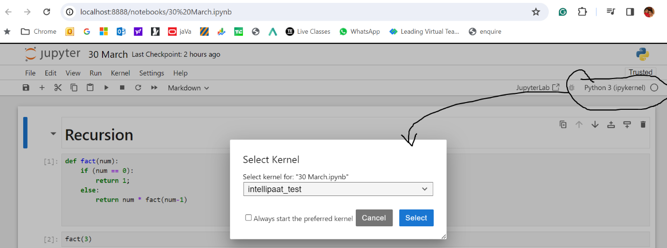

# 31st March

## NumPy

NumPy, which stands for Numerical Python, is a fundamental package for numerical computing in Python. It provides support for large, multi-dimensional arrays and matrices, along with a collection of mathematical functions to operate on these arrays efficiently. NumPy is an essential library for scientific computing and data analysis in Python.

Here are some key features of NumPy:

1. **Multi-dimensional Arrays**: NumPy provides an ndarray (n-dimensional array) data structure, which is a powerful and efficient container for arrays of homogeneous data types. These arrays can be one-dimensional, two-dimensional, or multi-dimensional.
2. **Vectorized Operations**: NumPy allows you to perform mathematical and logical operations on arrays without the need for explicit looping, using a syntax that is similar to scalar operations on individual elements.
3. **Broadcasting**: NumPy provides broadcasting, which is a powerful mechanism that allows arrays of different shapes to be combined together in arithmetic operations. This makes it possible to perform operations on arrays of different shapes without explicitly reshaping them.
4. **Mathematical Functions**: NumPy includes a wide range of mathematical functions for performing arithmetic, statistical, and linear algebra operations on arrays. These functions are optimized for performance and can operate on entire arrays efficiently.
5. **Random Number Generation**: NumPy includes a random module (numpy.random) for generating random numbers from various probability distributions. This is useful for simulations, random sampling, and generating synthetic data.
6. **Integration with Other Libraries**: NumPy is the foundation for many other scientific computing libraries in Python, including SciPy (Scientific Python), Pandas (Data Analysis), Matplotlib (Data Visualization), and scikit-learn (Machine Learning).

Ex:

import numpy as np

# Create a NumPy array

arr = np.array([1, 2, 3, 4, 5])

# Perform arithmetic operations

print("Sum:", np.sum(arr)) # Output: 15

print("Mean:", np.mean(arr)) # Output: 3.0

print("Square root:", np.sqrt(arr))

# Output: [1. 1.41421356 1.73205081 2. 2.23606798]

NumPy's efficient implementation of arrays and mathematical functions makes it a cornerstone of numerical computing and data analysis in Python.

### Advanced Indexing

Advanced indexing in NumPy refers to the method of selecting subsets of data from NumPy arrays using arrays of indices or boolean masks. It allows for more complex and flexible indexing operations compared to basic indexing (using integers or slices).

There are two main types of advanced indexing in NumPy:

#### Integer Array Indexing

* + Integer array indexing involves using arrays of integers to select specific elements from a NumPy array. Each integer in the index array specifies the position of the element to be selected along a particular axis.
  + Integer array indexing allows for arbitrary selection of elements from different positions in the array.
  + Here's an example of integer array indexing:

python

* •
* import numpy as np
* arr = np.array([[1, 2], [3, 4], [5, 6]])
* indices = np.array([0, 2])
* result = arr[indices, :]
* print(result)
* # Output:
* # [[1 2]
* # [5 6]]

#### Boolean Array Indexing

* Boolean array indexing involves using boolean arrays (also called boolean masks) to select elements from a NumPy array based on a condition. Each element in the boolean array corresponds to a position in the original array, and elements corresponding to True values are selected.
* Boolean array indexing is useful for filtering data based on conditions or criteria.
* Ex:

import numpy as np

arr = np.array([1, 2, 3, 4, 5])

mask = arr > 2

result = arr[mask]

print(result) # Output: [3 4 5]

In this example, the boolean mask arr > 2 creates a boolean array indicating which elements of arr are greater than 2. Then, the boolean array is used to select elements from arr where the corresponding value in the mask is True.

Advanced indexing in NumPy provides a powerful mechanism for selecting subsets of data based on complex criteria, enabling more sophisticated data manipulation and analysis tasks.

#### Complex Indexing Examples

Create a NumPy

student_marks = np.array([[20,30,40], [10,20,30],[40,50,65]])

Get the marks which have more than 40

student_marks[student_marks>40]

Get the marks which have greater than mean of the student marks

student_marks[student_marks > np.mean(student_marks)]

student_marks[(student_marks > 20) & (student_marks < 60)]

### Slicing Operator

the colon (:) is used as a slicing operator. It is commonly used to create slices of sequences, such as lists, strings, and arrays.

In the context of NumPy arrays, the colon (:) is used inside square brackets ([]) to specify slicing along a particular axis. When used in the form start:end, it selects elements starting from the index start up to, but not including, the index end.

Here's a breakdown of the syntax start:end:

* If start is not provided, the slice starts from the beginning of the sequence (index 0).
* If end is not provided, the slice extends to the end of the sequence.
* If both start and end are provided, the slice includes elements from the index start up to, but not including, the index end.

In NumPy arrays, the colon (:) is often used in conjunction with other slicing operators to create more complex slices. For example:

* : selects all elements along a particular axis.
* start: selects elements starting from the index start up to the end of the axis.
* :end selects elements from the beginning of the axis up to, but not including, the index end.
* start:end:step selects elements starting from the index start, up to, but not including, the index end, with a step size of step.

In the context of the code snippet student_data[:, :2], the colon (:) is used twice to specify slicing along both axes:

* student_data[:, :2] selects all rows (:) and the first two columns (:2) of the student_data array.

Ex:

student_data = np.array([

[18,85,88,92],

[20,75,85,80],

[19,95,90,94],

[21,78,85,88],

[22,82,88,87]

])

student_data[3:, ]

#output

array([[21, 78, 85, 88],

[22, 82, 88, 87]])

student_data[:2, ]

#output

array([[18, 85, 88, 92],

[20, 75, 85, 80]])

student_data[:, 2: ]

#output

array([[18, 85],

[20, 75],

[19, 95],

[21, 78],

[22, 82]])

student_data[:, 2:]

#output

array([[88, 92],

[85, 80],

[90, 94],

[85, 88],

[88, 87]])

student_data[:2, :2]

#output

array([[18, 85],

[20, 75]])

#### Where Function

NumPy provides a function called np.where() which serves a similar purpose. The np.where() function is used to return elements chosen from two arrays based on a condition.

Syntax:

np.where(condition, x, y)

* condition: A boolean array-like object or a condition that evaluates to a boolean array. If True, elements from x are chosen, otherwise elements from y.
* x: The value to be used where the condition is True.
* y: The value to be used where the condition is False.

Ex:

np.where(student_data>70, "Grade A", "Grade B")

#output

array([['Grade B', 'Grade A', 'Grade A', 'Grade A'],

['Grade B', 'Grade A', 'Grade A', 'Grade A'],

['Grade B', 'Grade A', 'Grade A', 'Grade A'],

['Grade B', 'Grade A', 'Grade A', 'Grade A'],

['Grade B', 'Grade A', 'Grade A', 'Grade A']], dtype='<U7')

### Select Function

NumPy provides various functions for selecting elements from arrays based on certain conditions. One such function is np.select(), which allows you to choose elements from a list of arrays based on multiple conditions.

Syntax:

result = np.select(condlist, choicelist, default=0)

Here:

* condlist: A list of boolean arrays or conditions.
* choicelist: A list of arrays or values to choose from based on the corresponding conditions in condlist.
* default (optional): The default value to choose when none of the conditions in condlist are True.

Ex1:

conditions = [ (student_data >= 90),

(student_data >= 60) & (student_data < 90),

(student_data >= 35) & (student_data < 60),

(student_data <35)

]

choices = [ “Grade A”, “Grade B”, “Grade C”, “Grade D”]

np.select(conditions, choices)

#output

array([[‘Grade D’, ‘Grade B’, ‘Grade B’, ‘Grade A’],

[‘Grade D’, ‘Grade B’, ‘Grade B’, ‘Grade B’],

[‘Grade D’, ‘Grade A’, ‘Grade A’, ‘Grade A’],

[‘Grade D’, ‘Grade B’, ‘Grade B’, ‘Grade B’],

[‘Grade D’, ‘Grade B’, ‘Grade B’, ‘Grade B’]], dtype=’<U7’)

Ex2:

Below writes same above example but uses **default** option:

conditions = [ (student_data >= 90),

(student_data >= 60) & (student_data < 90),

(student_data >= 35) & (student_data < 60)

]

choices = [ “Grade A”, “Grade B”, “Grade C”]

np.select(conditions, choices, “**Grade D**”)

### arrange function

Ex:

np.arange(1,10)

#output

array([1, 2, 3, 4, 5, 6, 7, 8, 9])

### Reshape Function

The reshape() function is used to change the shape (dimensions) of an array without changing its data. It returns a new array with a modified shape, while maintaining the same elements as the original array.

Syntax:

numpy.reshape(array, newshape, order='C')

Here:

* array: The array to be reshaped.
* newshape: The new shape (dimensions) of the array. It can be a tuple specifying the desired dimensions or an integer specifying the size of one dimension (in which case, the other dimensions are inferred).
* order (optional): Specifies the order in which the elements of the array are read. It can be 'C' for row-major (C-style) order or 'F' for column-major (Fortran-style) order. By default, it is 'C'.

Ex:

# Create a 1D array with 12 elements

arr = np.arange(12)

# Reshape the array into a 3x4 matrix

reshaped_arr = np.reshape(arr, (3, 4))

print("Original array:")

print(arr)

print("\nReshaped array with default option 'C':")

print(reshaped_arr)

print("\nReshaped array with option 'F':")

print(reshaped_arr1)

#output

Original array:

[ 0 1 2 3 4 5 6 7 8 9 10 11]

Reshaped array with default option 'C':

[[ 0 1 2 3]

[ 4 5 6 7]

[ 8 9 10 11]]

Reshaped array with option 'F':

[[ 0 3 6 9]

[ 1 4 7 10]

[ 2 5 8 11]]

### Flattening Array

Ex:

arr = np.arange(12)

arr.reshape(1, -1) # row based flattening

arr.reshape(-1, 1) # Column based flattening

#### 3D- reshape

Ex:

arr = np.arange(12)

array_3d = arr.reshape(2,3,2)

#output

array([[[ 0, 1],

[ 2, 3],

[ 4, 5]],

[[ 6, 7],

[ 8, 9],

[10, 11]]])

# Have to go recording from 12:30 PM

# 6th April

Download the titanic dataset

Open anaconda prompt

Run below command to activate intellipaat_test environment

>conda activate intellipaat_test

Run below command to install pandas

> pip install pandas

## Pandas

Pandas is a popular open-source Python library used for data manipulation and analysis. It provides data structures and functions that make it easy to work with structured data, such as tables and time series data. The primary data structures in Pandas are Series and DataFrame.

* **Series**: A one-dimensional array-like object that can hold any data type, such as integers, floats, strings, etc. Each element in a Series has an associated index.
* **DataFrame**: A two-dimensional labeled data structure with columns of potentially different types. It is similar to a spreadsheet or SQL table, where data is arranged in rows and columns. DataFrames can be thought of as dictionaries of Series objects.

Pandas provides a wide range of functionalities for data manipulation, including:

* Reading and writing data from various file formats (e.g., CSV, Excel, SQL databases, JSON, HTML)
* Data cleaning and preprocessing (e.g., handling missing values, removing duplicates, data normalization)
* Indexing, slicing, and subsetting data
* Aggregation and grouping operations
* Merging, joining, and concatenating datasets
* Time series analysis and manipulation
* Data visualization using integration with other libraries like Matplotlib and Seaborn

Overall, Pandas is widely used in data science, machine learning, and data analysis workflows due to its ease of use, flexibility, and powerful features for handling and analyzing structured data.

Ex for data frame:

import pandas as pd

titanic_df = pd.read_csv("titanic.csv")

titanic_df

#output

It display the titanic.csv file content in tabular form

### Category vs Object Data Types

| **Feature** | **object Data Type** | **category Data Type** |
| --- | --- | --- |
| Purpose | Generic data type for any Python objects, including strings, lists, dictionaries, etc. | Specifically designed for categorical data with a fixed and limited number of unique values. |
| Memory Usage | Can consume more memory, especially for large datasets or columns with heterogeneous data types. | Typically consumes less memory, especially for columns with a limited number of unique values. |
| Performance | Operations may be slower, especially for grouping, sorting, and value counts, due to heterogeneous data types and dynamic nature. | Operations can be faster, especially for grouping, sorting, and value counts, due to efficient storage and handling of categorical values. |
| Efficiency | Less memory-efficient, especially for categorical variables with repetitive values. | More memory-efficient, especially for categorical variables with a limited number of unique values. |
| Flexibility | Provides flexibility to store heterogeneous data types within the same column. | More specialized, suitable for categorical variables with a fixed set of values. |
| Use Cases | Suitable for columns with mixed or heterogeneous data types. | Suitable for categorical variables with a small number of unique values, such as gender, country, product categories, etc. |

This table summarizes the key differences between object and category data types in

### Series

A Series in Pandas is a one-dimensional labeled array capable of holding any data type (integers, floats, strings, Python objects, etc.). It is essentially a single column of data. Each element in a Series has a corresponding index, which by default starts from 0 and increases sequentially.

#### Creating a Series

You can create a Pandas Series from various data types like lists, arrays, dictionaries, etc. Here's how you can create a Series:

import pandas as pd

# Creating a Series from a list

data = [10, 20, 30, 40, 50]

series = pd.Series(data)

print(series)

#Output:

0 10

1 20

2 30

3 40

4 50

dtype: int64

#### Custom Indexing

By default, Pandas assigns numeric indices to the elements in a Series. However, you can provide custom indices as well:

data = [10, 20, 30, 40, 50]

custom_index = ['a', 'b', 'c', 'd', 'e']

series = pd.Series(data, index=custom_index)

print(series)

#Output:

a 10

b 20

c 30

d 40

e 50

dtype: int64

#### Accessing Elements

You can access elements in a Series using index labels:

print(series['b']) # Accessing element with index label 'b'

print(series[1]) # Accessing element at index position 1

#Output:

20

20

#### Operations on Series

Pandas Series supports various mathematical operations, broadcasting, and aggregation:

# Adding a scalar to all elements

print(series + 5)

# Multiplying all elements by a scalar

print(series * 2)

# Computing the mean of all elements

print(series.mean())

Output:

a 15

b 25

c 35

d 45

e 55

dtype: int64

a 20

b 40

c 60

d 80

e 100

dtype: int64

30.0

#### Series Attributes and Methods

Series objects also have various attributes and methods for exploring and manipulating data, such as dtype, size, shape, head(), tail(), describe(), etc.

print(series.dtype) # Datatype of elements in the Series

print(series.size) # Number of elements in the Series

print(series.shape) # Shape of the Series (returns a tuple)

print(series.head()) # Returns the first few elements of the Series

print(series.describe()) # Generates descriptive statistics of the Series

These are some of the basic functionalities of Pandas Series. It's a powerful tool for handling and analyzing one-dimensional data in Python.

### Data Frame

### Descriptive statistics

Descriptive statistics in Pandas refer to statistical summary measures that provide insights into the characteristics and distribution of a dataset. These summary statistics help analysts and data scientists understand the central tendency, variability, and shape of the data. Pandas provides a variety of methods to compute descriptive statistics for DataFrame and Series objects. Some commonly used descriptive statistics include:

1. **Count**: Number of non-null observations in the dataset.
2. **Mean**: Average value of the observations.
3. **Median**: Middle value of the dataset when it is sorted in ascending order.
4. **Standard Deviation**: Measure of the dispersion or spread of the dataset.
5. **Minimum**: Smallest value in the dataset.
6. **Maximum**: Largest value in the dataset.
7. **Quantiles**: Values that divide the dataset into equal parts, such as quartiles, deciles, or percentiles.
8. **Sum**: Total sum of all values in the dataset.
9. **Describe**: Generates a comprehensive summary of the dataset, including count, mean, standard deviation, minimum, quartiles, and maximum.

These descriptive statistics can be computed using methods available in Pandas DataFrame and Series objects. For example:

#### For a DataFrame

import pandas as pd

# Create a DataFrame

df = pd.DataFrame({

'A': [1, 2, 3, 4, 5],

'B': [5, 10, 15, 20, 25]

})

# Compute descriptive statistics

print(df.**describe()**)

#### For a Series

import pandas as pd

# Create a Series

series = pd.Series([1, 2, 3, 4, 5])

# Compute descriptive statistics

print(series.**describe()**)

These methods provide a quick way to understand the distribution and summary characteristics of the data, which is essential for exploratory data analysis and data preprocessing tasks. Descriptive statistics can reveal outliers, skewness, and other patterns in the data, guiding further analysis and modeling decisions.

#### Exaplanation on the output

The describe() method in Pandas generates a comprehensive summary of the dataset, providing various descriptive statistics for each numeric column in the DataFrame or Series. Let's break down each component of the result produced by the describe() method:

Here's an example DataFrame:

import pandas as pd

# Create a DataFrame

data = {

'A': [1, 2, 3, 4, 5],

'B': [5, 10, 15, 20, 25]

}

df = pd.DataFrame(data)

print(df.describe())

#output

A B

count 5.000000 5.000000

mean 3.000000 15.000000

std 1.581139 7.905694

min 1.000000 5.000000

25% 2.000000 10.000000

50% 3.000000 15.000000

75% 4.000000 20.000000

max 5.000000 25.000000

Here:

1. **count**: Number of non-null values in each column. It indicates how many observations are present in each numeric column. In this example, both columns 'A' and 'B' have 5 non-null values.
2. **mean**: Average value of the observations in each column. It represents the central tendency of the data. In this case, the mean of column 'A' is 3 and the mean of column 'B' is 15.
3. **std**: Standard deviation, a measure of the dispersion or spread of the data points around the mean. It indicates the variability of the data. A higher standard deviation implies greater variability. In this example, the standard deviation of column 'A' is approximately 1.58, and for column 'B' it's approximately 7.91.
4. **min**: The smallest value in each column.
5. **25% (1st Quartile)**: The value below which 25% of the data falls. Also known as the first quartile or lower quartile.
6. **50% (2nd Quartile / Median)**: The median, which represents the middle value of the data when sorted in ascending order. Half of the observations fall below this value, and half above.
7. **75% (3rd Quartile)**: The value below which 75% of the data falls. Also known as the third quartile or upper quartile.
8. **max**: The largest value in each column.

### Renaming the Columns

Renaming columns in a Pandas DataFrame can be necessary for various reasons, such as improving readability, conforming to a specific naming convention, or resolving naming conflicts. Pandas provides several methods to rename columns effectively:

1. **Using the rename() method**: The rename() method allows you to rename one or more columns by specifying a dictionary where the keys are the current column names and the values are the new column names. You can use this method to rename one or more columns at once.

Example:

import pandas as pd

# Create a DataFrame

data = {

'old_name1': [1, 2, 3],

'old_name2': [4, 5, 6]

}

df = pd.DataFrame(data)

# Rename columns

df.rename(columns={'old_name1': 'new_name1', 'old_name2': 'new_name2'}, inplace=True)

• **Direct assignment to columns attribute**: You can directly assign a list of new column names to the columns attribute of the DataFrame.

Example:

# Directly assign new column names

df.columns = ['new_name1', 'new_name2']

• **Using list comprehension or string methods**: You can also use list comprehension or string methods to generate new column names based on existing ones.

Example:

# Using list comprehension

df.columns = ['new_' + col for col in df.columns]

# Using string methods

df.columns = df.columns.str.replace('old', 'new')

• **Using the set_axis() method**: The set_axis() method can be used to set new column names directly. This method provides more flexibility, allowing you to specify axis, inplace, and other parameters.

Example:

# Using set_axis()

df.set_axis(['new_name1', 'new_name2'], axis='columns', inplace=True)

Remember to set the inplace parameter to True if you want to modify the original DataFrame in place. Otherwise, Pandas will return a new DataFrame with the modified column names. Renaming columns is a common operation in data manipulation workflows and is essential for data preprocessing and analysis.

### Drop Null Values using dropna

The dropna() method in Pandas is used to remove missing values (NaN or None) from a DataFrame or Series. Missing values can occur due to various reasons such as incomplete data, data corruption, or data manipulation operations. Dropping these missing values can be necessary to ensure accurate analysis and modeling.

The dropna() method provides flexibility in handling missing values and allows you to specify different parameters to control the behavior of the operation. Here's how the method works:

### DataFrame:

import pandas as pd

# Create a DataFrame with missing values

data = {

'A': [1, 2, None, 4],

'B': [5, None, 7, 8],

'C': [None, None, None, None]

}

df = pd.DataFrame(data)

# Drop rows with any missing values

cleaned_df = df.dropna()

# Drop columns with any missing values

cleaned_df = df.dropna(axis=1)

# Drop rows where all values are missing

cleaned_df = df.dropna(how='all')

# Drop rows with a minimum number of non-null values

cleaned_df = df.dropna(thresh=2)

### Series:

python

import pandas as pd

# Create a Series with missing values

series = pd.Series([1, 2, None, 4])

# Drop missing values

cleaned_series = series.dropna()

### Parameters:

* **axis**: Specifies whether to drop rows (axis=0) or columns (axis=1) containing missing values. By default, it drops rows (axis=0).
* **how**: Specifies whether to drop rows or columns where any or all values are missing. Options are 'any' (default) or 'all'.
* **thresh**: Specifies the minimum number of non-null values required to keep a row or column. Rows or columns with fewer than this threshold will be dropped.
* **subset**: Specifies a subset of columns or rows to consider for dropping missing values. Only those columns or rows specified will be examined.

By default, dropna() returns a new DataFrame or Series with missing values removed. However, you can use the inplace=True parameter to modify the original DataFrame or Series in place.

### Drop Method

#### Delete Columns

titanic_df.drop(["Name", "Ticket"], axis=1, inplace=True)

Here:

* We are deleting column wise deletion
  + It will be indicates by column axis = 1
* Deleting columns
  + Name
  + Ticket
* Inplace=True means delete without displaying the output

#### Delete Rows

titanic_df.drop(1)

titanic_df.drop(1, axis=0, inplace=True)

Here:

* We are deleting a row
* Deleting a row which have index as ‘1’
* Axis attribute is optional and default value is ‘0’ which indicates row deletion.

### Filling the Null Values using fillna method

titanic_df["Age"] = titanic_df["Age"].fillna(titanic_df["Age"].mean())

### Change the column Type

Below code snippet change the data type to Category type

titanic_df["Sex"] = titanic_df["Sex"].astype('category')

### Indexing using iloc and loc

By using two different methods we can use indexes in the Pandas

* Iloc
  + Ex:
    - titanic_df.iloc[:5,3:5]
* loc
  + Ex:
    - titanic_df.loc[1:3, "Name":"Age"]
      * It will display 1& 2 rows
      * It will display column starting from “Name” to “Age”
    - #output

|  | **Name** | **Sex** | **Age** |
| --- | --- | --- | --- |
| **1** | Cumings | female | 38.0 |
| **2** | Heikkinen | female | 26.0 |
| **3** | Futrelle | female | 35.0 |

#### Loc vs iloc

| **Feature** | **loc** | **iloc** |
| --- | --- | --- |
| Syntax | DataFrame.loc[row_label, column_label] | DataFrame.iloc[row_index, column_index] |
| Indexing | Label-based indexing | Integer-based indexing |
| Selection | Selects data based on row and column labels | Selects data based on row and column integer indices |
| Usage | Primarily used with label indices | Primarily used with integer indices |
| Inclusive/Exclusive | Inclusive of the end index | Exclusive of the end index |
| Error handling | Raises KeyError if labels don't exist | Raises IndexError if index is out of range |
| Flexibility | Allows selection based on labels that don't exist | Requires existing integer indices |

### Sort_values method

Ex:

titanic_df.sort_values(by='Age')

titanic_df.sort_values(by=['Age'])

titanic_df.sort_values(by='Age', ascending=False)

titanic_df.sort_values(by=['Age', 'Fare'])

### Boolean Indexing

Ex:

titanic_df[titanic_df['Age'] > 35]

titanic_df[(titanic_df['Age'] > 35) & (titanic_df['Age'] < 50)]

### GroupBy

The groupby() function in Pandas is used to group DataFrame rows based on one or more columns, allowing for efficient data aggregation and analysis within each group. Here are some examples demonstrating the use of groupby():

Example 1: Grouping by a Single Column and Computing Aggregations

import pandas as pd

# Create a DataFrame

data = {

'Category': ['A', 'B', 'A', 'B', 'A'],

'Value': [10, 20, 30, 40, 50]

}

df = pd.DataFrame(data)

# Group by 'Category' column and compute mean value for each group

grouped = df.groupby('Category').mean()

print(grouped)

Output:

Value

Category

A 30

B 30

Example 2: Grouping by Multiple Columns and Computing Aggregations

# Group by multiple columns ('Category' and 'Type') and compute sum for each group

grouped = df.groupby(['Category', 'Type']).sum()

print(grouped)

Output:

Value

Category Type

A X 40

Y 60

B X 20

Y 40

Example 3: Iterating Over Groups

# Iterating over groups and printing each group

for group_name, group_data in df.groupby('Category'):

print(f'Category: {group_name}')

print(group_data)

print()

Output:

Category: A

Category Value

0 A 10

2 A 30

4 A 50

Category: B

Category Value

1 B 20

3 B 40

Example 4: Applying Custom Aggregation Functions

# Define custom aggregation function

def my_custom_sum(x):

return x.sum() * 2

# Apply custom aggregation function to 'Value' column

grouped = df.groupby('Category')['Value'].agg(my_custom_sum)

print(grouped)

Output:

Category

A 180

B 120

Name: Value, dtype: int64

These examples demonstrate the versatility of the groupby() function in Pandas for grouping and aggregating data based on one or more columns. It's a powerful tool for performing complex data analysis and manipulation tasks efficiently.

## Lambda Functions

A lambda function is a small anonymous function that can have any number of arguments but can only have one expression. They are often referred to as "anonymous" functions because they do not have a name like a regular function defined with the def keyword. Instead, they are defined using the lambda keyword.

Syntax:

lambda arguments: expression

Here,

* lambda is the keyword that indicates the definition of a lambda function.
* arguments are the parameters of the function.
* expression is a single expression that is evaluated and returned by the function.

### Example:

Here's a simple example of a lambda function that calculates the square of a number:

square = lambda x: x ** 2

# Calling the lambda function

result = square(5)

print(result) # Output: 25

### Use Cases

Lambda functions are typically used in situations where you need a small function for a short period and don't want to define a formal function using the def keyword. Some common use cases include:

* Passing a function as an argument to higher-order functions like map(), filter(), and sorted().
* Writing short and concise code in situations where a full function definition might be unnecessary or cumbersome.
* Creating simple callbacks and inline functions.

### Limitations

* Lambda functions are limited to a single expression. They cannot contain multiple expressions or statements.
* They are often less readable than regular functions, especially for complex operations.
* Debugging lambda functions can be challenging due to their anonymous nature.

Although lambda functions are useful for simple and short-lived operations, it's generally recommended to use regular functions for more complex tasks or when the code needs to be more readable and maintainable.

### Using map() with Lambda Function

The map() function applies a given function to each item of an iterable (such as a list) and returns a new iterable with the results.

Example: Using map() to square each element in a list.

# Original list

numbers = [1, 2, 3, 4, 5]

# Using map() with a lambda function to square each element

squared_numbers = list(map(lambda x: x ** 2, numbers))

print(squared_numbers) # Output: [1, 4, 9, 16, 25]

### Using filter() with Lambda Function

The filter() function filters elements from an iterable based on a given function (predicate) and returns an iterator containing the elements for which the function returns True.

Syntax:

filter(lambda argument: expression, iterable)

Here:

* lambda argument: expression: This is the lambda function that defines the condition for filtering. The argument represents each element of the iterable, and the expression evaluates to True or False based on some condition.
* iterable: This is the iterable (e.g., list, tuple, etc.) from which elements will be filtered based on the lambda function.

Example: Using filter() with a lambda function to filter even numbers from a list.

# Original list

numbers = [1, 2, 3, 4, 5]

# Using filter() with a lambda function to filter even numbers

even_numbers = list(filter(lambda x: x % 2 == 0, numbers))

print(even_numbers) # Output: [2, 4]

### Sorting with Lambda Function

The sorted() function sorts the elements of a list or iterable based on a key function. Lambda functions are commonly used as the key function to specify custom sorting criteria.

Example: Sorting a list of tuples based on the second element of each tuple.

# Original list of tuples

data = [('John', 25), ('Alice', 20), ('Bob', 30)]

# Sorting the list based on the second element of each tuple (age)

sorted_data = sorted(data, key=lambda x: x[1])

print(sorted_data) # Output: [('Alice', 20), ('John', 25), ('Bob', 30)]

In each example, the lambda function is used to define a custom operation (squaring, filtering, or sorting) that is applied to each element of the iterable. Lambda functions provide a convenient way to define these operations inline without the need for separate function definitions.

## Read data from the excel

Reading data from Excel files (.xlsx) into Pandas DataFrames is a common task. You can use the read_excel() function provided by Pandas to accomplish this.

To load excel we have install openpyxl by using below command

> pip install openpyxl

Ex:

sheet1_df = pd.read_excel("dummy_data.xlsx", sheet_name='Sheet1')

excel_sheet1_df

sheet2_df = pd.read_excel("dummy_data.xlsx", sheet_name='Sheet2')

excel_sheet2_df

## Read data from the CSV

To read data from a CSV file into a Pandas DataFrame, you can use the read_csv() function provided by Pandas.

Ex:

import pandas as pd

titanic_df = pd.read_csv("titanic.csv")

titanic_df

#output

It display the titanic.csv file content in tabular form

# 07 April

# Have to go with recording till 10.40 AM

Open anaconda prompt

Run below command to activate intellipaat_test environment

>conda activate intellipaat_test

## CSV joins

In pandas, joining CSV files involves reading the CSV files into DataFrame objects and then using pandas' merge function to join them based on common columns. Here's a step-by-step guide on how to do this:

import pandas as pd

df1 = pd.read_csv('file1.csv')

df2 = pd.read_csv('file2.csv')

print(df1.head())

print(df2.head())

merged_df = pd.merge(df1, df2, on='common_column_name', how='inner')

Here:

* on: specifies the common column name to join on.
* how: specifies the type of join. Options include **'inner'**, **'outer'**, **'left'**, and **'right'**. The **default** is 'inner'.

• **Save the merged DataFrame to a new CSV file if needed:**

merged_df.to_csv('merged_file.csv', index=False)

This process assumes that both CSV files have a common column that you want to join on. If the column names are different but represent the same information, you can specify the left_on and right_on parameters instead of on. If the column names are different and you want to join on the indices of the dataframes, you can use left_index=True and right_index=True.

### Joins

Pandas supports several types of joins, which you can specify using the how parameter in the merge() function. Here are the different types of joins:

#### Inner Join (how='inner')

Returns only the rows where there is a match in both DataFrames based on the specified join columns.

pd.merge(df1, df2, on='common_column_name', how='inner')

#### Outer Join (how='outer')

Returns all rows from both DataFrames, with NaNs where there are no matches in the other DataFrame.

pd.merge(df1, df2, on='common_column_name', how='outer')

#### Left Join (how='left')

Returns all rows from the left DataFrame and matching rows from the right DataFrame. If there is no match, returns NaN.

pd.merge(df1, df2, on='common_column_name', how='left')

#### Right Join (how='right')

Returns all rows from the right DataFrame and matching rows from the left DataFrame. If there is no match, returns NaN.

pd.merge(df1, df2, on='common_column_name', how='right')

#### Cross Join (Cartesian Join)

Returns the Cartesian product of the rows from both DataFrames. It matches each row of the first DataFrame with every row of the second DataFrame.

pd.merge(df1, df2, how='cross')

These are the main types of joins supported by pandas. Depending on your use case and the data you're working with, you can choose the appropriate type of join to combine your DataFrames effectively.

## MatPlotLib

First we have to install matplotlib by using below command in anaconda console

> pip install matplotlib

### Description

Matplotlib is a comprehensive library in Python used for creating static, interactive, and animated visualizations. It provides a wide range of tools for creating plots, charts, and other graphical representations of data. Here's an explanation of some key concepts and components of Matplotlib:

1. **Figure:**
   * The entire area where your plot and any accompanying elements are drawn.
   * You can think of it as the canvas on which you're going to paint your visualization.
2. **Axes:**
   * The region of the figure where the data is plotted.
   * An individual plot is typically represented by a set of axes.
   * An Axes object contains various elements like x-axis, y-axis, ticks, labels, and the actual plotted data.
3. **Plot Types:**
   * Matplotlib supports various types of plots, including line plots, scatter plots, bar plots, histograms, pie charts, etc.
   * You can choose the appropriate plot type based on the nature of your data and the story you want to convey.
4. **Plotting Functions:**
   * Matplotlib provides a wide range of functions for creating different types of plots.
   * For example, plot() for line plots, scatter() for scatter plots, bar() for bar plots, hist() for histograms, etc.
5. **Customization:**
   * Matplotlib allows extensive customization of plots to meet specific requirements.
   * You can customize various aspects such as colors, line styles, markers, labels, titles, gridlines, legends, etc.
6. **Subplots:**
   * Subplots are multiple plots displayed within the same figure.
   * They allow you to visualize multiple datasets or different views of the same dataset side by side.
7. **Backend:**
   * Matplotlib supports different backends for rendering graphics, including interactive backends for use in GUI applications and non-interactive backends for generating images, PDFs, SVG files, etc.
8. **Integration:**
   * Matplotlib is highly compatible with other Python libraries like NumPy, Pandas, and SciPy, making it easy to visualize data from these libraries.
9. **Object-oriented Interface:**
   * Matplotlib can be used through both a state-based and an object-oriented interface.
   * The object-oriented approach provides more control and flexibility over the creation and customization of plots.
10. **Extensibility:**
    * Matplotlib is highly extensible, allowing users to create custom plots, styles, and functionalities beyond the built-in capabilities.

In summary, Matplotlib is a powerful and versatile library for data visualization in Python, providing a wide range of tools and capabilities to create publication-quality plots for various applications and domains.

Following are various graphs/plots available in matplotlib:

1. Line Plot
2. Scatter Plot
3. Bar Plot
4. Histogram
5. Pie Chart
6. Box Plot (Box-and-Whisker Plot)
7. Heatmap
8. Violin Plot
9. Area Plot
10. Contour Plot
11. Quiver Plot
12. Stem Plot
13. Polar Plot
14. 3D Plot
15. Error Bar Plot
16. Hexbin Plot
17. Streamplot
18. Spider (Radar) Plot
19. Sankey Diagram
20. Treemap

### Line Plot Graph

A line plot is a graph that displays data points connected by straight line segments. It's commonly used to visualize trends or patterns in data over time or across different variables.

Here's an example of how to create a simple line plot using Matplotlib:

import matplotlib.pyplot as plt

# Sample data

x = [1, 2, 3, 4, 5]

y = [2, 3, 5, 7, 11]

# Create a line plot

plt.plot(x, y)

# Add labels and title

plt.xlabel('X-axis')

plt.ylabel('Y-axis')

plt.title('Example Line Plot')

# Display the plot

plt.show()

In this example:

* We import the matplotlib.pyplot module as plt.
* We define two lists x and y containing our sample data points.
* We use the plot() function to create the line plot by passing x and y as arguments.
* We add labels to the x-axis and y-axis using the xlabel() and ylabel() functions, respectively.
* We set the title of the plot using the title() function.
* Finally, we display the plot using the show() function.

When you run this code, it will display a simple line plot with the data points connected by straight lines.

You can customize the appearance of the plot by adding parameters to the plot() function, such as line color, line style, marker style, etc. For example:

plt.plot(x, y, color='red', linestyle='--', marker='o', markersize=8, label='Data Points')

This would create a line plot with red dashed lines, circular markers at data points, and a legend labeled as 'Data Points'.

Line plots are useful for visualizing continuous data and understanding trends or relationships between variables. They are straightforward to create and provide a quick way to explore and interpret your data.

### Bar Graph

### Histogram

### PieChart

Have to look for color attribute

### Scatter Plot

# 13th April

# 14th April

# 20th April

Only Hands on session on Pandas

# 21st April

Hands on Session on Visualization using the Seaborn(sns)

# 4 May

## Statastics / stats

It is a branch of mathematics that deals with collection of data , presentation of data for performing analysis on it to extract meaningful information.

Stats majorly classified into two categories:

1. **Descriptive statistics**
   * It is a branch of stats that deals with collection and interpretation of data mainly Mathematical operations.
2. **Inferential statistics**
   * It is a branch of stats that deal with predictions and drawing conclusion based on sample and populations.

### **Descriptive statistics**

It is a branch of stats that deals with collection and interpretation of data mainly Mathematical operations.

Again it is classified into 2 parts:

1. **Measure of Central Tendancy -** It is used to find where does the centre of our data lies. It includes
   1. Mean
   2. Median
   3. Mode
2. **Measure of Dispersion** - It is used to find how much my data is scaterred or spread out in all the direction. It includes
   1. **Range**
   2. **Variance**
   3. **Standard Deviation**
   4. **Outliers**
   5. **Percentile**
   6. **Quartile**
   7. **Correlation**

#### Mean / Average

The mean, often referred to as the average, is a measure of central tendency that represents the typical value in a data set. It's calculated by adding up all the values in the data set and then dividing by the total number of values.

Mean = Sum of elements / number of elements

Ex:

if you have the data set [3, 7, 1, 5, 9], the mean is calculated as:

(3 + 7 + 1 + 5 + 9) / 5 = 5

So, the mean of this data set is 5.

#### Meadian

In statistics,

* the median is a measure of central tendency, which represents the middle value of a data set when it's arranged in ascending or descending order.
* If the data set has an odd number of observations, the median is simply the middle value.
* If the data set has an even number of observations, the median is the average of the two middle values.

Formula:

For even,

value of (n+1​)/2 observation

For odd,

(value of (n/2​) observation+value of ((n/2)​+1) observation​)/2

Ex:

* Odd number of values:
  + in the data set [3, 7, 1, 5, 9],
    - the median is 5 because it's the middle value when the data set is arranged in ascending order.
* Even Number of values:
  + In the data set [2, 4, 6, 8],
    - the median is (4 + 6) / 2 = 5 because there is an even number of observations.

#### Mode

The mode is a measure of central tendency that represents the value that appears **most** **frequently** in a dataset. Unlike the mean and median, which are based on numerical calculations, the mode is determined by observing the data directly.

A dataset can have:

1. **No mode:** If all values occur with the same frequency, or if no value repeats.
2. **Unimodal:** If there is only one mode, meaning one value occurs most frequently.
3. **Bimodal:** If there are two modes, meaning two values occur with the same highest frequency.
4. **Multimodal:** If there are three or more modes, meaning three or more values occur with the same highest frequency.

Ex:

In the dataset [3, 5, 5, 6, 8, 8, 8, 9], the mode is 8 because it appears more frequently than any other value.

The mode is especially useful for categorical data or when dealing with discrete values, but it can also be used with continuous data by creating intervals or categories. It's a simple and intuitive measure of central tendency, but it may not always fully represent the dataset, especially if there is no clear mode or if the dataset is skewed.

Note:

If we have same number of repetitions for two values then first occurrence among those two will be treated as mode. I.e., in the data[1, 5, 3, 4, 6, 4, 3], then mod will be 3 for this data as 3 occurred first in the list.

#### Range

The difference between min and max values of a dataset is known as range.

Ex:

Data = [25, 10, 20, 75, 40, 35, 50, 65]

Range = 75-10, range = 65

data = [1000, 990, 3000, 2500, 12000, 500, 100000]

range = np.ptp(data) # the ptp (Peek to Peek) is used to calculate the range in NumPy

print(f"The range of the data {data} is: {range}")

Output

The range of the data [1000, 990, 3000, 2500, 12000, 500, 100000] is: 99500

#### Variance

variance measures the dispersion or spread of a set of data points. It quantifies how much the data values differ from the mean.

* A high variance indicates that the data points are spread out over a wider range
* A low variance indicates that the data points are closer to the mean.

Mathematically, the variance σ2σ2 of a dataset x1,x2,…,xn ​with mean μ is calculated using the formula:

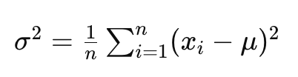

Where:

* xi​ represents each individual data point.
* μ represents the mean of the dataset.
* n represents the total number of data points.

Variance is often used in conjunction with the standard deviation, which is the square root of the variance. The standard deviation provides a measure of the average deviation of the data points from the mean, in the same units as the data.

In practical terms, variance helps in understanding the distribution of data and assessing the degree of variability or dispersion within a dataset.

**Ex for Low Variance:**

Suppose we have a dataset representing the ages of a group of people in a small town:

[30,31,32,33,34]

The mean age is 32. If we calculate the variance using the formula, we find it's quite low. Each age is close to the mean, so there's little variability:



So, the variance is 2, indicating low dispersion.

data = [30,31,32,33,34]

variance_value = np.var(data)

print(f"The varinace value for data {data} is: {variance_value}")

Output:

The varinace value for data [30, 31, 32, 33, 34] is: 2.0

**Ex for High Variance:**

Now, let's consider a dataset representing the incomes of people in a city:

[20,30,40,70,100]

The mean income is 52. If we calculate the variance using the formula, we find it's higher than in the previous example. Incomes vary significantly from the mean:

So, the variance is 856, indicating high dispersion.

data = [20,30,40,70,100]

mean = stats.mean(data)

print(f"The mean value for the data {data} is: {mean}")

variance_value = np.var(data)

print(f"The varinace value for data {data} is: {variance_value}")

The output

The mean value for the data [20, 30, 40, 70, 100] is: 52

The varinace value for data [20, 30, 40, 70, 100] is: 856.0

#### Standard Deviation

In general, Stadard deviation is square root of variance.

The standard deviation is a measure of the amount of variation or dispersion in a set of data points. It quantifies the average distance of each data point from the mean of the dataset.

Mathematically, the standard deviation σ of a dataset x1,x2,…,xn with mean μ is calculated as the square root of the variance:

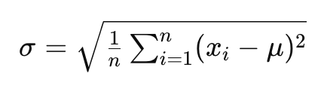

Where:

* xi represents each individual data point.
* μ represents the mean of the dataset.
* n represents the total number of data points.

Standard deviation provides a measure of the average deviation of the data points from the mean. A high standard deviation indicates that the data points are spread out over a wider range, while a low standard deviation indicates that the data points are closer to the mean.

Standard deviation is particularly useful because it's expressed in the same units as the original data, making it easier to interpret in practical terms. It's widely used in various fields of study, including science, engineering, finance, and social sciences, to understand the variability or dispersion within a dataset.

Ex:

data = [30,31,32,33,34]

stdDeviation = np.std(data)

print(f"The standard deviation of data {data} is: {stdDeviation}")

The output

The standard deviation of data [30, 31, 32, 33, 34] is: 1.4142135623730951

#### Percentile

a percentile is a measure used to indicate the value below which a given percentage of observations in a group of observations fall. It's a way of dividing a dataset into 100 equal parts, with each part representing 1% of the data.

To find a specific percentile, you first sort the data in ascending order, then find the position of the percentile within the dataset. For example, the 25th percentile is the value below which 25% of the data fall, the 50th percentile is the median (the middle value), and the 75th percentile is the value below which 75% of the data fall.

Percentiles are commonly used in various fields such as education, healthcare, finance, and environmental science to understand the distribution of data and identify specific points within a dataset. They provide a way to compare individual data points to the rest of the dataset and to interpret how values are distributed relative to each other.

Ex:

Suppose we have a class of 20 students, and their test scores are as follows:

65,70,72,75,78,80,81,82,83,85,87,88,90,92,94,95,97,98,99,10065,70,72,75,78,80,81,82,83,85,87,88,90,92,94,95,97,98,99,100

Now, let's find the percentile of a few specific values:

1. **25th Percentile (Q1):** The 25th percentile is the value below which 25% of the data fall. To find this, we need to locate the value at 25100×20=510025​×20=5th position in the sorted dataset.

Sorting the dataset: 65,70,72,75,78,80,81,82,83,85,87,88,90,92,94,95,97,98,99,100

So, the 25th percentile is 78.

1. **50th Percentile (Median):** The 50th percentile is the median, which is the value that separates the lower half from the upper half of the data. Since we have an even number of data points, we take the average of the two middle values.

Sorting the dataset: 65,70,72,75,78,80,81,82,83,85,87,88,90,92,94,95,97,98,99,100

So, the 50th percentile is (78+80)/2=79278+80​=79.

1. **75th Percentile (Q3):** The 75th percentile is the value below which 75% of the data fall. To find this, we need to locate the value at 75100×20=1510075​×20=15th position in the sorted dataset.

Sorting the dataset: 65,70,72,75,78,80,81,82,83,85,87,88,90,92,94‾,95,97,98,99,10065,70,72,75,78,80,81,82,83,85,87,88,90,92,94​,95,97,98,99,100

So, the 75th percentile is 94.

test_scores = [65, 70, 72, 75, 78, 80, 81, 82, 83, 85, 87, 88, 90, 92, 94, 95, 97, 98, 99, 100]

# Calculate percentiles

percentiles = np.percentile(test_scores, [25, 50, 75])

print("25th Percentile (Q1):", percentiles[0])

print("50th Percentile (Median):", percentiles[1])

print("75th Percentile (Q3):", percentiles[2])

The output

25th Percentile (Q1): 78.0

50th Percentile (Median): 83.5

75th Percentile (Q3): 92.0

Explanation:

* Here 25 percentile values are less than 78 values
* 50 percentile values are less than 83.5 values
* 80 percentile values are less than 92 values

##### Percentage vs percentile

**Percentage:**

* A percentage is a way to express a proportion or fraction as a number out of 100.
* It represents a part of the whole and is often used to describe relative quantities or proportions.
* For example, if you score 80 out of 100 on a test, you've achieved 80%, which means you've answered 80% of the questions correctly.

**Percentile:**

* A percentile is a specific type of percentage that indicates the relative standing of a particular value within a dataset.
* It divides a dataset into 100 equal parts, each containing 1% of the data.
* Percentiles are often used in statistics to understand the distribution of data and identify specific points within the dataset.
* For example, if you score at the 90th percentile on a standardized test, it means that your score is higher than 90% of the scores in the dataset.

Note:

One can achieve 100 percentage when he scored 100 out of 100 but he can’t get 100 percentile as he can’t cross every one in the class but not him self. So at max highest percentile can 99.99 but not 100

#### Quartile / quantile

It will divide your percentile in equal parts.

Quantiles divide a dataset into equally sized contiguous subgroups, where each subgroup contains an equal number of data points.

Commonly used quantiles include:

1. **Median (50th Quantile):** The median divides the dataset into two equal parts. 50% of the data points fall below the median, and 50% fall above.
2. **Quartiles (25th, 50th, and 75th Quantiles):** Quartiles divide the dataset into four equal parts. The first quartile (Q1) represents the 25th quantile, the second quartile (Q2) represents the 50th quantile (median), and the third quartile (Q3) represents the 75th quantile.
3. **Percentiles (Any Quantile):** Percentiles divide the dataset into 100 equal parts. For example, the 20th percentile represents the 20th quantile, dividing the dataset into 100 equal parts with 20% of the data points falling below and 80% falling above.

Quantiles are used to understand the distribution of data and to compare specific data points or subsets of data to the rest of the dataset. They are particularly useful for analyzing large datasets and identifying key summary statistics.

# 5th May

#### Outliers

Outliers are unwanted data.

The outliers are data points that significantly differ from other observations in a dataset. They are typically much higher or lower than the rest of the data points and can skew statistical analyses and interpretations.

Outliers can occur due to various reasons, such as:

* Measurement or recording errors
* Natural variability in the data
* Experimental or sampling errors
* Anomalies in the data-generating process
* Data entry mistakes

There are various methods to detect and handle outliers, including:

* Visual inspection using scatter plots, box plots, or histograms
* Statistical methods such as the z-score, which measures how many standard deviations a data point is from the mean
* Robust statistical techniques that are less sensitive to outliers, such as median-based measures

Once outliers are identified, they can be treated in different ways, including:

* Removing them from the dataset if they are determined to be errors
* Transforming the data to make it more normally distributed
* Using robust statistical methods that are less affected by outliers

##### Side Effects

**Skewing measures of central tendency:** Outliers can significantly affect measures of central tendency, such as the mean. Since the mean is sensitive to extreme values, outliers can pull the mean towards them, giving a distorted view of the typical value in the dataset.

1. **Inflating measures of dispersion:** Outliers can increase the variability of the dataset, leading to inflated measures of dispersion, such as the standard deviation or variance. This can make the spread of the data appear larger than it actually is.
2. **Distorting relationships:** In regression analysis and other modeling techniques, outliers can distort the relationships between variables. They can influence the slope and intercept of regression lines, leading to biased estimates and inaccurate predictions.
3. **Reducing model performance:** Outliers can negatively impact the performance of predictive models by introducing noise and reducing the model's ability to generalize to new data. This can lead to overfitting, where the model learns the noise in the data rather than the underlying patterns.
4. **Misleading interpretations:** Outliers can lead to incorrect interpretations of data and relationships. Analysts may draw incorrect conclusions or make faulty decisions if outliers are not properly identified and addressed.
5. **Violating assumptions:** Outliers can violate the assumptions of many statistical tests and models, such as the assumption of normality or homoscedasticity. This can invalidate the results of analyses and undermine the validity of conclusions drawn from the data.

##### Identify Outliers

1. **Visual inspection:** Plotting the data using scatter plots, box plots, histograms, or QQ plots can help identify outliers visually. Outliers will appear as points that are significantly distant from the bulk of the data.
2. **Summary statistics:** Calculating summary statistics such as the mean, median, standard deviation, and quartiles can help identify potential outliers. Observations that fall far from the mean or median, or are outside the range defined by the quartiles, may be considered outliers.
3. **Z-score:** The z-score measures how many standard deviations a data point is from the mean. Data points with a z-score greater than a certain threshold (e.g., 2 or 3) are considered outliers. The formula for calculating the z-score is: z=x−μσz=σx−μ​, where xx is the data point, μμ is the mean, and σσ is the standard deviation.
4. **Interquartile Range (IQR):** The IQR is the range between the first quartile (Q1) and the third quartile (Q3) of the data. Data points outside the range will be:



considered outliers.

1. **Box plots:** Box plots visually display the quartiles and any potential outliers in the dataset. Points beyond the "whiskers" of the box plot are typically considered outliers.
2. **Statistical tests:** There are various statistical tests for identifying outliers, such as Grubbs' test, Dixon's Q test, and Tukey's range test. These tests compare the data points to a statistical model and determine whether they are significantly different from the rest of the data.
3. **Domain knowledge:** Finally, domain knowledge and understanding of the context in which the data was collected can help identify outliers. Some values that may appear as outliers in one context may actually be valid data points in another context.

Following is the code snippet to find the outliers

data = [5.5, 5.6, 6.1, 6.2, 5.9, 5.11, 6.5, 50.5, 0.5, 60.1]

q1 = np.percentile(data, 25)

q3 = np.percentile(data, 75)

IQR = q3-q1

upper_fence = q3 + (1.5*IQR)

lower_fence = q1 - (1.5*IQR)

print(f"The Lower fence for the data {data} is: {lower_fence}")

print(f"The Upper fence for the data {data} is: {upper_fence}")

for dataPoint in data:

if dataPoint > upper_fence or dataPoint < lower_fence:

print(f"Outliers data points are: {dataPoint}")

#The output

The Lower fence for the data [5.5, 5.6, 6.1, 6.2, 5.9, 5.11, 6.5, 50.5, 0.5, 60.1] is: 4.175000000000001

The Upper fence for the data [5.5, 5.6, 6.1, 6.2, 5.9, 5.11, 6.5, 50.5, 0.5, 60.1] is: 7.774999999999999

Outliers data points are: 50.5

Outliers data points are: 0.5

Outliers data points are: 60.1

#### Correlation

The relationship between two columns and two values in a data.

Correlation is a statistical measure that describes the extent to which two variables change together. In other words, it quantifies the strength and direction of the linear relationship between two variables.

The correlation coefficient, often denoted by r, ranges from -1 to 1:

* r=1: Perfect positive correlation. This means that as one variable increases, the other variable also increases, and vice versa, following a linear pattern.
* r=−1r=−1: Perfect negative correlation. This means that as one variable increases, the other variable decreases, and vice versa, following a linear pattern.
* r=0r=0: No correlation. This means that there is no linear relationship between the two variables.

### Inferential statistics

Inferential statistics is a branch of statistics that involves making inferences or predictions about a population based on data collected from a sample of that population. It allows us to draw conclusions, make predictions, and test hypotheses about populations using sample data.

It have below categories:

1. **Hypothesis testing:** Testing hypotheses about population parameters to determine if there is enough evidence to support or reject a claim.
   1. **Null Hypothesis:** It is a random guess without using any data. Means data is non stationary
   2. **Alternative Hypothesis:** it is a guess after analysing previous data means data is stationary.
2. **Regression Analysis:** Examining the relationship between one or more independent variables and a dependent variable to make predictions or identify associations.
   1. **Independent variables**

also known as predictor variables or explanatory variables, are the variables that are used to predict or explain the values of the dependent variable.

* 1. **Dependent variables**

also known as the response variable or outcome variable, is the variable that is being predicted or explained by the independent variables. The role of the dependent variable is central to regression analysis as it is the focus of the analysis and the variable of interest.

Note:

Independent variables are used to predict the value of dependent variables. i.e., independent variables are fundamental components of regression analysis, as they are used to build models that explain and predict the values of the dependent variable based on the values of the independent variables.

# 11th May

Have to go again these recordings as we missed this in MacBook

# 12th May

Have to go again these recordings as we missed this in MacBook

# 18th May

Have to go again these recordings as we missed this in MacBook

# 19th May

Have to go again these recordings as we missed this in MacBook

# 25th May

## CHI square test

Categorical variables are those whose can be identified as separate set.

## Introduction to ML

### Types of ML algorithms

* Supervised Learning
* Unsupervised Learning
* Reinforced Learning

#### Supervised Learning

Supervised learning is a type of machine learning where the model is trained on a labeled dataset. In this context, "labeled" means that each training example is paired with an output label. The goal of the model is to learn a mapping from inputs to outputs, which can then be used to predict the labels of new, unseen data.

Here are the key components and steps involved in supervised learning:

1. **Dataset**: A collection of data points, each consisting of input features and corresponding output labels.
   * **Input Features (X)**: The variables or attributes used to make predictions.
   * **Output Labels (Y)**: The target variable or the actual result that the model aims to predict.
2. **Training**: The process where the model learns the relationship between inputs and outputs from the training data. The model makes predictions on the training data and adjusts its parameters to minimize the difference between its predictions and the actual labels.
3. **Model**: A mathematical function or algorithm that maps inputs to outputs. Common types of models used in supervised learning include linear regression, decision trees, support vector machines, and neural networks.
4. **Loss Function**: A metric used to quantify the difference between the model's predictions and the actual labels. The goal is to minimize this loss during training.
5. **Optimization Algorithm**: An algorithm used to adjust the model's parameters to minimize the loss function. Examples include gradient descent and its variants.
6. **Evaluation**: After training, the model's performance is evaluated on a separate set of data (validation or test set) to assess its accuracy and generalization ability.

##### Types of Supervised Learning

Supervised learning tasks are generally divided into two main categories:

1. **Regression**: Predicting continuous values. Examples include predicting house prices, temperatures, or stock prices.
2. **Classification**: Predicting discrete labels. Examples include spam detection (spam or not spam), image recognition (cat, dog, or other), and medical diagnosis (disease or no disease).

##### Examples of Supervised Learning Algorithms

* **Linear Regression**: Used for regression tasks where the relationship between input and output is assumed to be linear.
* **Logistic Regression**: Used for binary classification tasks.
* **Decision Trees**: Used for both classification and regression tasks, where data is split into subsets based on feature values.
* **Support Vector Machines (SVM)**: Used for classification tasks, especially with clear margin of separation.
* **k-Nearest Neighbors (k-NN)**: A non-parametric method used for classification and regression tasks.
* **Neural Networks**: Used for complex tasks in both regression and classification, especially useful for large datasets and deep learning.

##### Workflow of a Supervised Learning Task

1. **Data Collection**: Gather a labeled dataset relevant to the problem.
2. **Data Preprocessing**: Clean and prepare the data, handle missing values, normalize features, etc.
3. **Train-Test Split**: Divide the data into training and testing sets.
4. **Model Selection**: Choose an appropriate algorithm based on the problem type and data characteristics.
5. **Training**: Train the model on the training data.
6. **Evaluation**: Test the model on the test data and evaluate its performance using metrics such as accuracy, precision, recall, or mean squared error.
7. **Tuning**: Adjust model parameters and hyperparameters to improve performance.
8. **Deployment**: Deploy the model for making predictions on new, unseen data.

Supervised learning is widely used in various applications, including email filtering, fraud detection, medical diagnosis, and more.

#### Unsupervised Learning

Unsupervised learning is a type of machine learning where the model is trained on a dataset that does not contain labeled responses. Instead of using labeled data to train the model, unsupervised learning algorithms find hidden patterns or intrinsic structures in the input data. The goal is to infer the natural structure present within a set of data points.

##### Key Components and Steps in Unsupervised Learning

1. **Dataset**: A collection of data points, each consisting of input features without corresponding output labels.
   * **Input Features (X)**: The variables or attributes used to discover patterns or structures in the data.
2. **Model**: An algorithm that learns from the input data to identify patterns or structures. Unlike supervised learning, there is no explicit feedback from output labels.
3. **Evaluation**: The model's performance is evaluated based on how well it identifies patterns or structures in the data. Metrics for evaluation can include measures like silhouette score for clustering or reconstruction error for dimensionality reduction.

##### Types of Unsupervised Learning

Unsupervised learning tasks can be broadly categorized into two main types:

1. **Clustering**: Grouping data points into clusters such that points in the same cluster are more similar to each other than to those in other clusters. Examples of clustering algorithms include:
   * **k-Means Clustering**: Partitions the data into k clusters by minimizing the variance within each cluster.
   * **Hierarchical Clustering**: Builds a tree of clusters by either merging or splitting existing clusters iteratively.
   * **DBSCAN (Density-Based Spatial Clustering of Applications with Noise)**: Groups together points that are closely packed together, marking as outliers points that are in low-density regions.
2. **Dimensionality Reduction**: Reducing the number of random variables under consideration by obtaining a set of principal variables. Examples include:
   * **Principal Component Analysis (PCA)**: Transforms the data to a new coordinate system such that the greatest variances by any projection of the data come to lie on the first coordinates (principal components).
   * **t-Distributed Stochastic Neighbor Embedding (t-SNE)**: Reduces the dimensions of the data while maintaining the relationships between points in the high-dimensional space.
   * **Autoencoders**: Neural network-based models that aim to learn a compressed representation of the input data.

##### Workflow of an Unsupervised Learning Task

1. **Data Collection**: Gather the dataset with relevant features.
2. **Data Preprocessing**: Clean and prepare the data, handle missing values, normalize features, etc.
3. **Model Selection**: Choose an appropriate unsupervised learning algorithm based on the problem type and data characteristics.
4. **Training**: Train the model on the dataset to find patterns or structures.
5. **Evaluation**: Assess the model's performance using suitable metrics, such as clustering validation metrics or reconstruction error.
6. **Interpretation**: Analyze the patterns or structures identified by the model to derive meaningful insights.

##### Examples of Applications of Unsupervised Learning

* **Customer Segmentation**: Grouping customers based on purchasing behavior for targeted marketing.
* **Anomaly Detection**: Identifying unusual patterns or outliers in data for fraud detection or network security.
* **Market Basket Analysis**: Finding associations between products to improve product placement and cross-selling.
* **Image Compression**: Reducing the dimensionality of image data to store it more efficiently.
* **Topic Modeling**: Identifying topics in a collection of documents for text mining applications.

Unsupervised learning is particularly useful when you have a large amount of data but lack labeled examples, allowing you to explore and understand the data more deeply.

### Reinforcement Learning

Reinforcement learning (RL) is a type of machine learning where an agent learns to make decisions by interacting with an environment in order to maximize some notion of cumulative reward. Unlike supervised learning, where the model learns from a set of labeled examples, reinforcement learning is based on the idea of learning from experience.

### Key Concepts in Reinforcement Learning

1. **Agent**:
   * The learner or decision maker that interacts with the environment.
2. **Environment**:
   * Everything the agent interacts with, which provides feedback based on the agent’s actions.
3. **State (s)**:
   * A representation of the current situation or configuration of the environment.
4. **Action (a)**:
   * A set of all possible moves or decisions the agent can make in a given state.
5. **Reward (r)**:
   * A scalar feedback signal received after the agent performs an action in a state, indicating the immediate benefit of that action.
6. **Policy (π)**:
   * A strategy used by the agent to decide the next action based on the current state. The policy can be deterministic or stochastic.
7. **Value Function (V)**:
   * A function that estimates the expected cumulative reward from a given state, under a particular policy.
8. **Q-Value or Action-Value Function (Q)**:
   * A function that estimates the expected cumulative reward of taking a given action in a given state, and then following a particular policy.
9. **Discount Factor (γ)**:
   * A factor between 0 and 1 that represents the importance of future rewards compared to immediate rewards.

### Types of Reinforcement Learning

1. **Model-Free vs. Model-Based**:
   * **Model-Free**: The agent learns a policy or value function without learning the model of the environment (e.g., Q-learning, SARSA).
   * **Model-Based**: The agent builds a model of the environment and uses it to plan actions (e.g., Dyna-Q).
2. **Value-Based vs. Policy-Based**:
   * **Value-Based**: The agent learns value functions to derive the optimal policy (e.g., Q-learning).
   * **Policy-Based**: The agent learns the policy directly without using value functions (e.g., REINFORCE algorithm).
   * **Actor-Critic**: Combines value-based and policy-based methods by having separate structures for the policy (actor) and the value function (critic).

### Key Algorithms in Reinforcement Learning

1. **Q-Learning**:
   * A model-free, value-based algorithm that learns the value of actions in each state using the Bellman equation.
2. **SARSA (State-Action-Reward-State-Action)**:
   * Similar to Q-learning but updates the Q-values using the action actually taken by the agent.
3. **Deep Q-Networks (DQN)**:
   * Combines Q-learning with deep neural networks to handle high-dimensional state spaces.
4. **Policy Gradient Methods**:
   * Directly optimize the policy by computing gradients of expected rewards with respect to policy parameters (e.g., REINFORCE).
5. **Actor-Critic Methods**:
   * Use separate structures for the policy and value function, providing a balance between stability and efficiency (e.g., A3C, PPO).

### Workflow of a Reinforcement Learning Task

1. **Define the Environment**: Set up the environment with states, actions, and rewards.
2. **Initialize the Agent**: Initialize the policy and value functions, and any necessary parameters.
3. **Interaction and Learning**:
   * The agent interacts with the environment by taking actions.
   * The environment provides feedback in the form of rewards and new states.
   * The agent updates its policy and value functions based on the feedback.
4. **Evaluation**: Periodically evaluate the agent’s performance to ensure it is learning and improving.
5. **Deployment**: Deploy the trained agent in a real or simulated environment to perform the intended task.

### Examples of Applications of Reinforcement Learning

* **Game Playing**: Achieving superhuman performance in games like Go, chess, and video games.
* **Robotics**: Training robots to perform complex tasks such as walking, grasping objects, or navigating environments.
* **Autonomous Vehicles**: Enabling self-driving cars to make decisions in dynamic environments.
* **Finance**: Developing trading strategies and portfolio management techniques.
* **Healthcare**: Optimizing treatment strategies and personalized medicine.

Reinforcement learning is powerful for tasks that involve sequential decision-making and where the correct actions are not immediately obvious, requiring the agent to explore and exploit the environment to maximize long-term rewards.

# 26th May

## Linear Regression

Linear regression is a fundamental technique in machine learning used to predict a continuous target variable based on one or more predictor variables. Here's a comprehensive overview of linear regression within the context of machine learning:

#### Linear Regression in Machine Learning

Linear regression in machine learning aims to find the best-fitting linear relationship between the target (dependent variable) and the features (independent variables). It's often used for tasks like predicting prices, sales, or any other quantitative measure.

#### Types of Linear Regression

1. **Simple Linear Regression**: Predicts the target variable using a single feature.
2. **Multiple Linear Regression**: Predicts the target variable using multiple features.

#### Key Components

* **Features (X)**: Independent variables used to predict the target.
* **Target (y)**: Dependent variable that we want to predict.
* **Weights (β)**: Coefficients that determine the influence of each feature on the prediction.
* **Intercept (β0)**: The baseline prediction when all features are zero.

#### Objective

The goal is to minimize the cost function, typically the Mean Squared Error (MSE), which measures the average squared difference between the actual and predicted values:

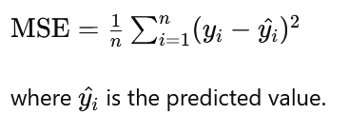

### Mathematical Representation

For a simple linear regression with one feature:

y=β0+β1X+ε

For multiple linear regression with multiple features:

y=β0+β1X1+β2X2+...+βnXn+ε

### Assumptions

1. **Linearity**: The relationship between the dependent and independent variables is linear.
2. **Independence**: Observations are independent.
3. **Homoscedasticity**: Constant variance of the errors.
4. **Normality**: Errors are normally distributed.

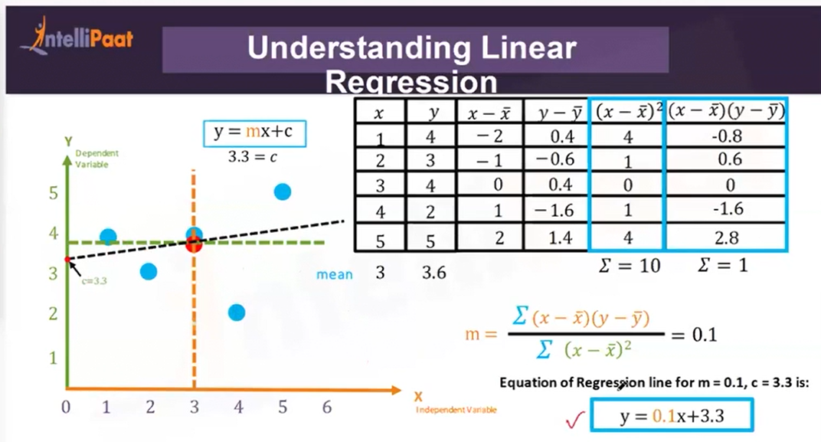

### Sum of Square Errors (SSEs)

In the context of linear regression, SSE stands for **Sum of Squared Errors**. It is a measure of the discrepancy between the data and the estimation model. Specifically, SSE is the sum of the squared differences between the observed values (the actual data points) and the values predicted by the model.

Mathematically, SSE is calculated as follows:

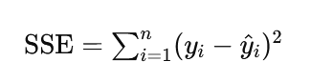

where:

* yi​ represents the actual value of the dependent variable for the i-th observation.
* y^​i​ represents the predicted value of the dependent variable for the i-th observation, obtained from the regression model.
* n is the total number of observations.

The lower the SSE, the better the model fits the data, as it indicates that the predicted values are close to the actual values. SSE is a crucial component in various metrics for evaluating model performance, such as the Mean Squared Error (MSE) and the Root Mean Squared Error (RMSE). It is also used in determining the coefficient of determination, R2, which measures the proportion of the variance in the dependent variable that is predictable from the independent variable(s).

### Mean Square Error (MSE)

It is a measure of the average squared differences between the observed actual outcomes and the outcomes predicted by the linear regression model. MSE is commonly used to evaluate the performance of a regression model and to compare the accuracy of different models.

Mathematically, MSE is calculated as follows:

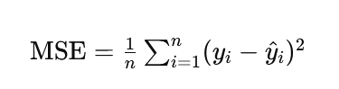

where:

* yi​ represents the actual value of the dependent variable for the i-th observation.
* y^​i​ represents the predicted value of the dependent variable for the i-th observation, obtained from the regression model.
* n is the total number of observations.

#### Why Use MSE?

* **Penalty for Large Errors**: By squaring the differences, MSE penalizes larger errors more heavily than smaller ones, which is useful for identifying models that might produce large outliers.
* **Differentiability**: The MSE function is differentiable, making it suitable for optimization techniques such as gradient descent used in training many types of regression models.

#### Interpretation of MSE

* **Lower MSE**: Indicates a better fit of the model to the data, as the average squared difference between the actual and predicted values is smaller.
* **Higher MSE**: Indicates a poorer fit, with larger discrepancies between actual and predicted values.

# 1st June

Have to go through with recording

# 2nd June

Have to go through with recording

# 8th June

This class is repetition of last classes as it requires more understanding on Linear Regression.

## Linear Regression

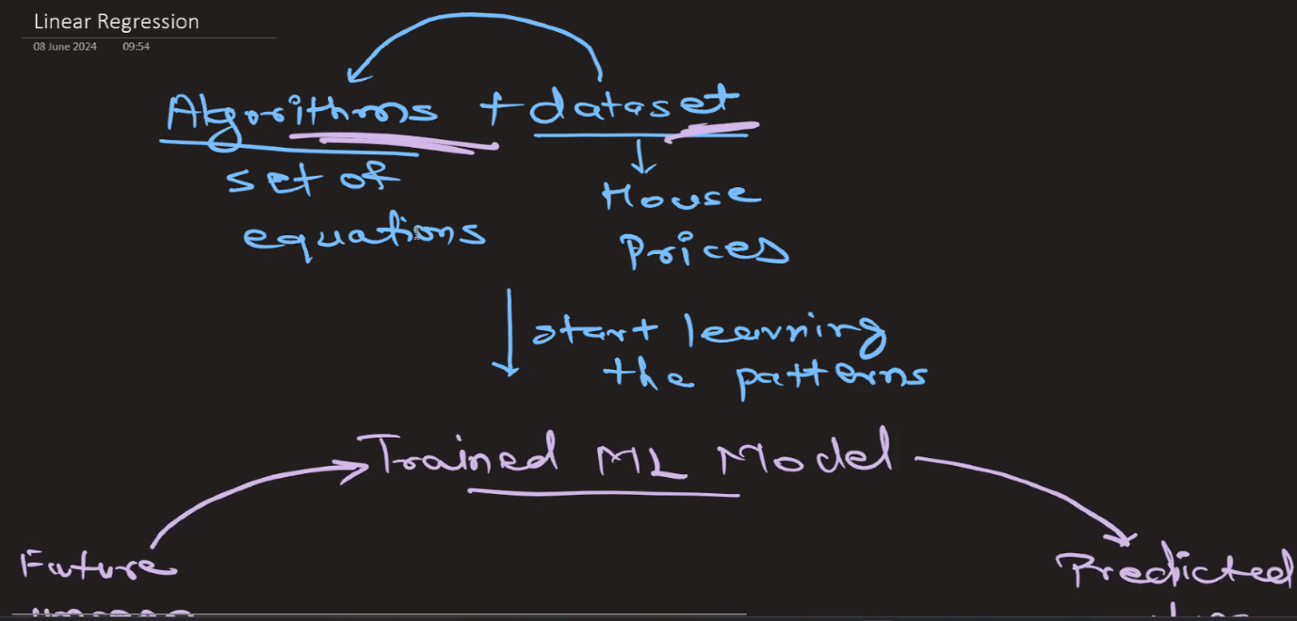

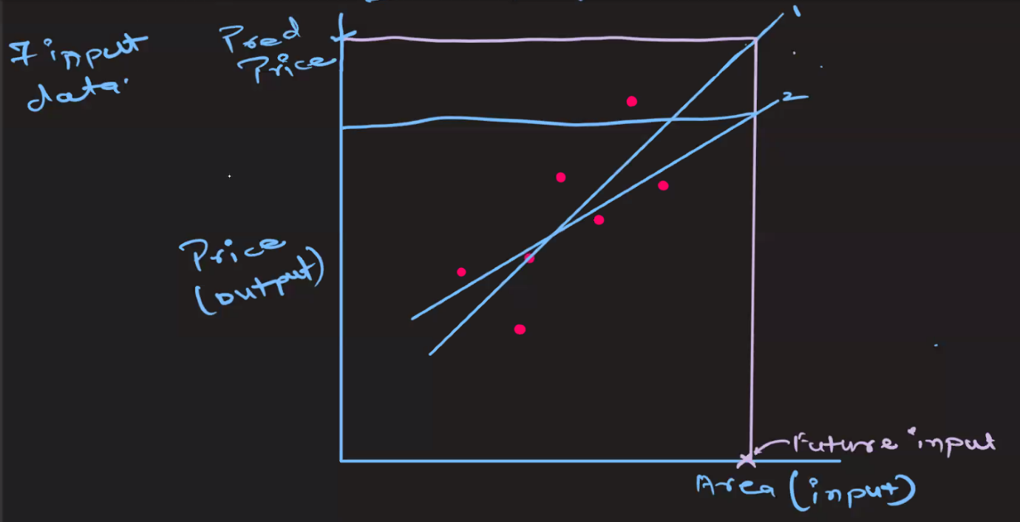

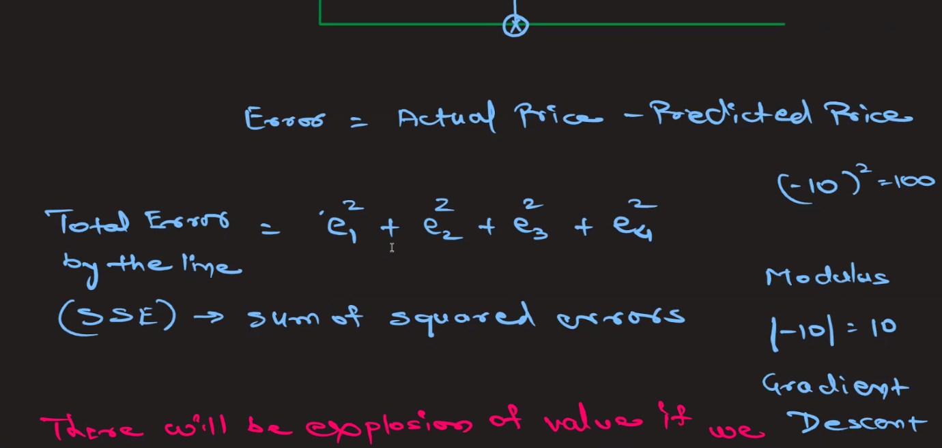

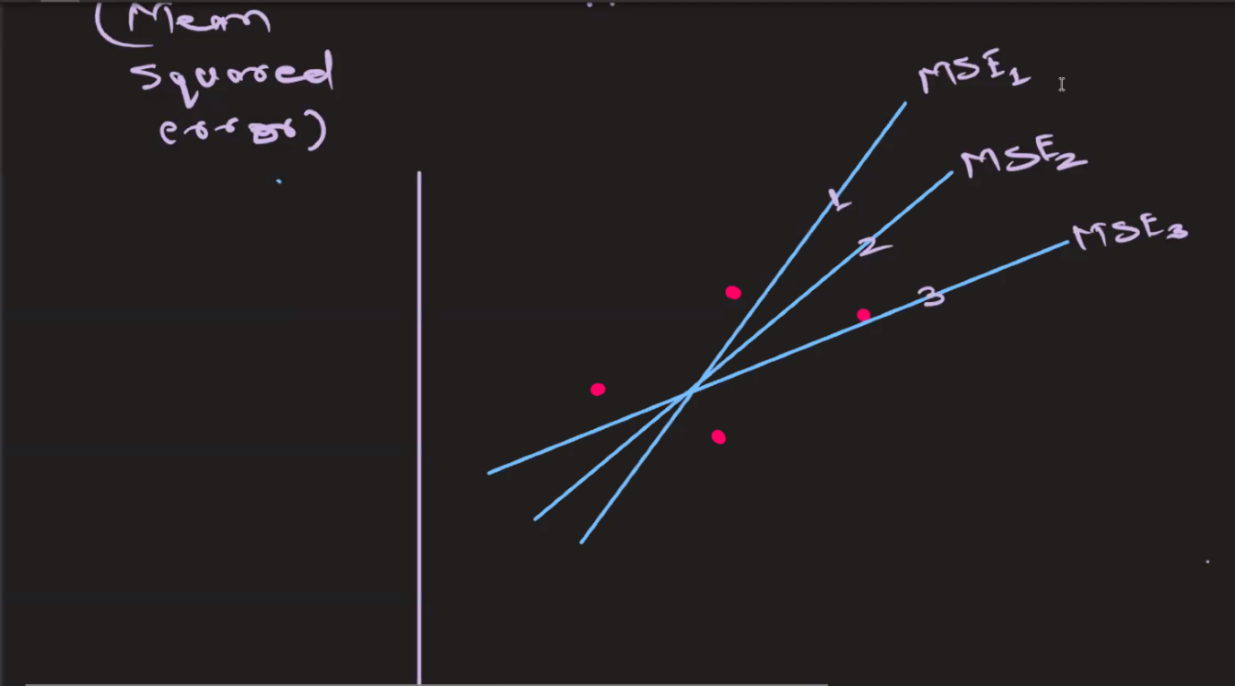

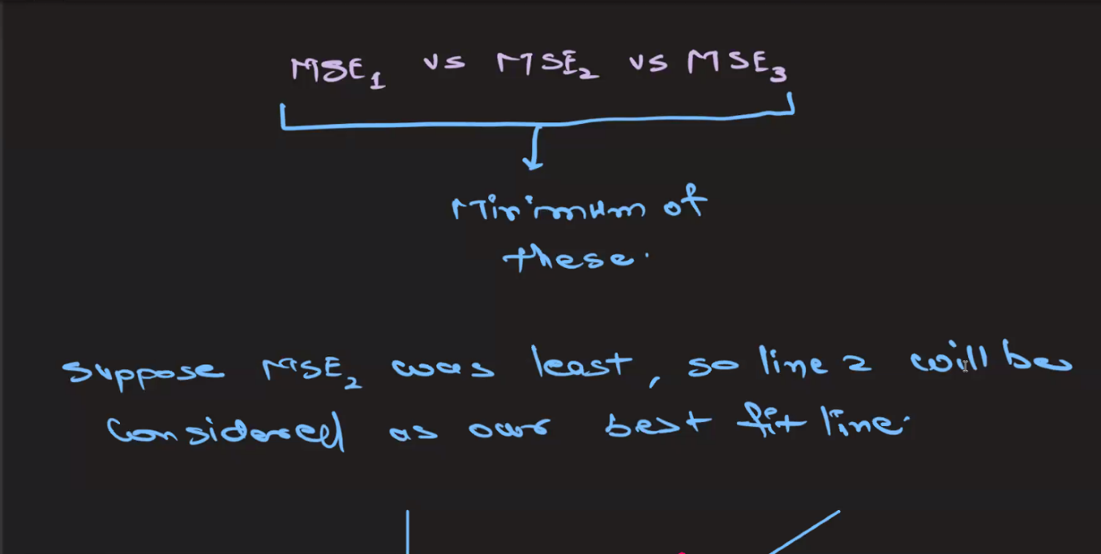

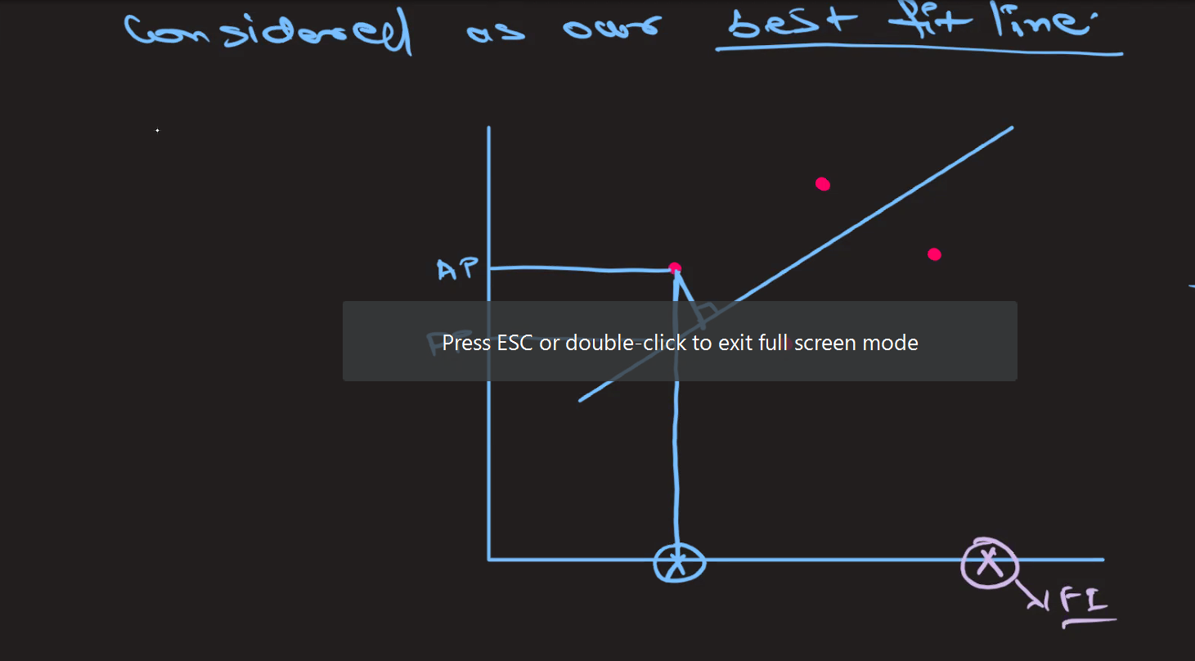

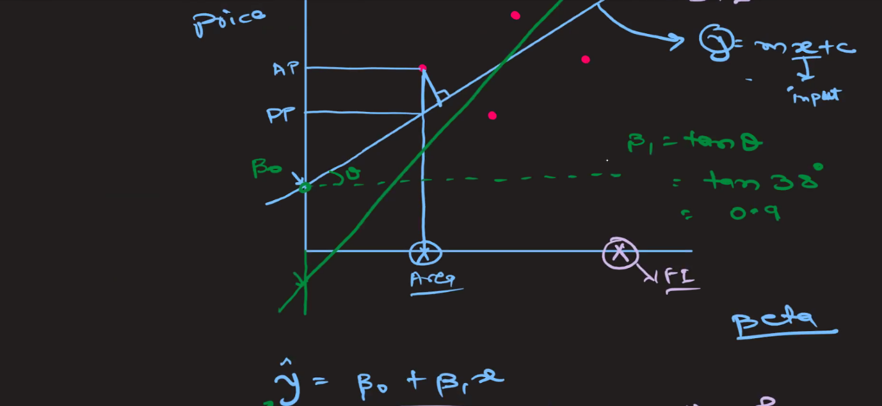

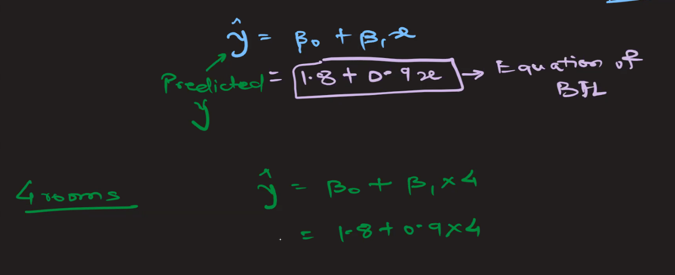

### **Homoscedasticity** and **Heteroscedasticity**

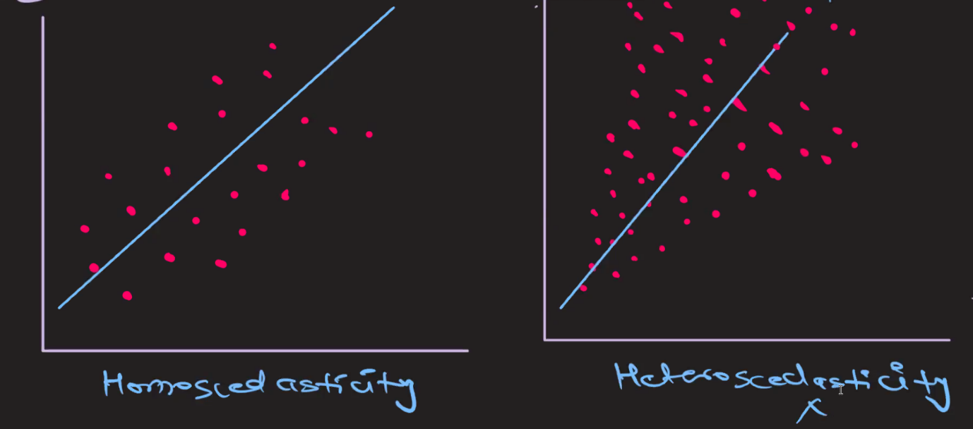

In the context of regression analysis, the terms **homoscedasticity** and **heteroscedasticity** refer to the nature of the variance of the errors (residuals) in a regression model.

#### Homoscedasticity

**Homoscedasticity** occurs when the variance of the errors is constant across all levels of the independent variables. In simpler terms, the spread or "scatter" of the residuals remains the same regardless of the value of the independent variable.

* **Graphical Representation**: When plotting the residuals against the predicted values or any independent variable, the residuals should form a horizontal band or scatter evenly around the horizontal axis. There should be no discernible pattern.
* **Implication for Regression**: Homoscedasticity is an assumption of ordinary least squares (OLS) regression. When this assumption holds, it means that the model's predictions are equally reliable across all values of the independent variables. It also ensures the validity of standard errors, confidence intervals, and hypothesis tests.

#### Heteroscedasticity

**Heteroscedasticity** occurs when the variance of the errors varies across different levels of the independent variables. In other words, the spread or "scatter" of the residuals changes (increases or decreases) with the value of the independent variable.

* **Graphical Representation**: When plotting the residuals against the predicted values or any independent variable, the residuals may fan out, form a cone shape, or show some other pattern indicating that the variance is not constant.
* **Implication for Regression**: Heteroscedasticity violates one of the key assumptions of OLS regression. This can lead to inefficient estimates of the coefficients and biased standard errors, making hypothesis tests and confidence intervals unreliable. It can also indicate that there are important variables missing from the model or that the functional form of the model is incorrect.

##### Diagnosing Heteroscedasticity

There are several methods to diagnose heteroscedasticity:

1. **Graphical Methods**:
   * **Residual Plot**: Plot the residuals versus the predicted values or versus an independent variable. Look for patterns that suggest changing variance.
   * **Scale-Location Plot**: Plot the square root of the absolute residuals versus the predicted values. A horizontal line suggests homoscedasticity, while a pattern indicates heteroscedasticity.
2. **Statistical Tests**:
   * **Breusch-Pagan Test**: Tests for linear forms of heteroscedasticity.
   * **White Test**: Tests for more general forms of heteroscedasticity.
   * **Goldfeld-Quandt Test**: Compares the variances of the residuals in two subsamples to test for heteroscedasticity.

##### Addressing Heteroscedasticity

If heteroscedasticity is detected, several strategies can be employed to address it:

1. **Transforming the Dependent Variable**: Applying a transformation such as the logarithm, square root, or Box-Cox transformation can stabilize the variance.
2. **Weighted Least Squares (WLS)**: Assigning different weights to observations based on the variance of their errors can account for heteroscedasticity.
3. **Robust Standard Errors**: Using heteroscedasticity-robust standard errors can make hypothesis tests more reliable without necessarily changing the coefficient estimates.

#### Example in Simple Linear Regression

##### Homoscedasticity Example:

* If you regress the height of a plant on the amount of sunlight it receives and the residuals have a constant spread irrespective of the amount of sunlight, your model demonstrates homoscedasticity.

##### Heteroscedasticity Example:

* If you regress the household expenditure on income and find that the residuals fan out as income increases, this suggests heteroscedasticity, indicating that the variability of household expenditure increases with income.

In summary, homoscedasticity and heteroscedasticity are concepts related to the variance of the residuals in a regression model. Homoscedasticity ensures that the regression model's predictions are equally reliable across all levels of the independent variables, while heteroscedasticity indicates a problem that can affect the efficiency and reliability of the model's estimates.

### Multicollinearity in Regression Analysis

**Multicollinearity** occurs in a regression analysis when two or more independent variables are highly correlated with each other. This means that one independent variable can be linearly predicted from the others with a substantial degree of accuracy.

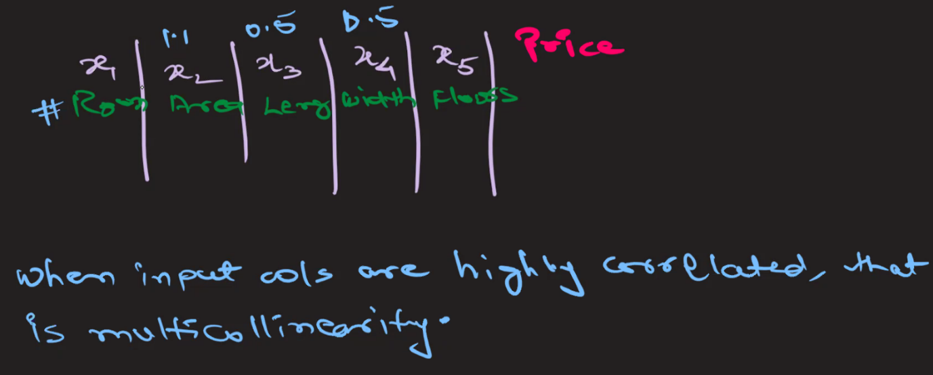

In above image, x3 and x4 can be removed as x2 itself represent those two columns.

#### Effects of Multicollinearity

Multicollinearity can lead to several problems in the interpretation of the regression model.

1. **Unstable Estimates**: The coefficients of the regression model can become very sensitive to changes in the model. Adding or removing a variable can cause large changes in the estimated coefficients.
2. **Inflated Standard Errors**: Multicollinearity increases the standard errors of the coefficients. This makes it harder to determine whether a coefficient is significantly different from zero.
3. **Reduced Predictive Power**: While the overall model might still have good predictive power, the reliability of individual coefficients diminishes.
4. **Difficulty in Assessing the Effect of Each Predictor**: It becomes challenging to ascertain the individual effect of each independent variable on the dependent variable because changes in one predictor are associated with changes in another.

#### Diagnosing Multicollinearity

There are several ways to diagnose multicollinearity:

* **Correlation Matrix**: A simple way to start is to look at the correlation matrix of the independent variables. High correlation coefficients (close to 1 or -1) between pairs of variables suggest multicollinearity.
* **Variance Inflation Factor (VIF)**: VIF quantifies how much the variance of a regression coefficient is inflated due to multicollinearity. A VIF value greater than 10 is often taken as an indication of significant multicollinearity, although some sources suggest a lower threshold

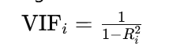

where Ri2​ is the coefficient of determination of the regression of the i-th independent variable on all other independent variables.

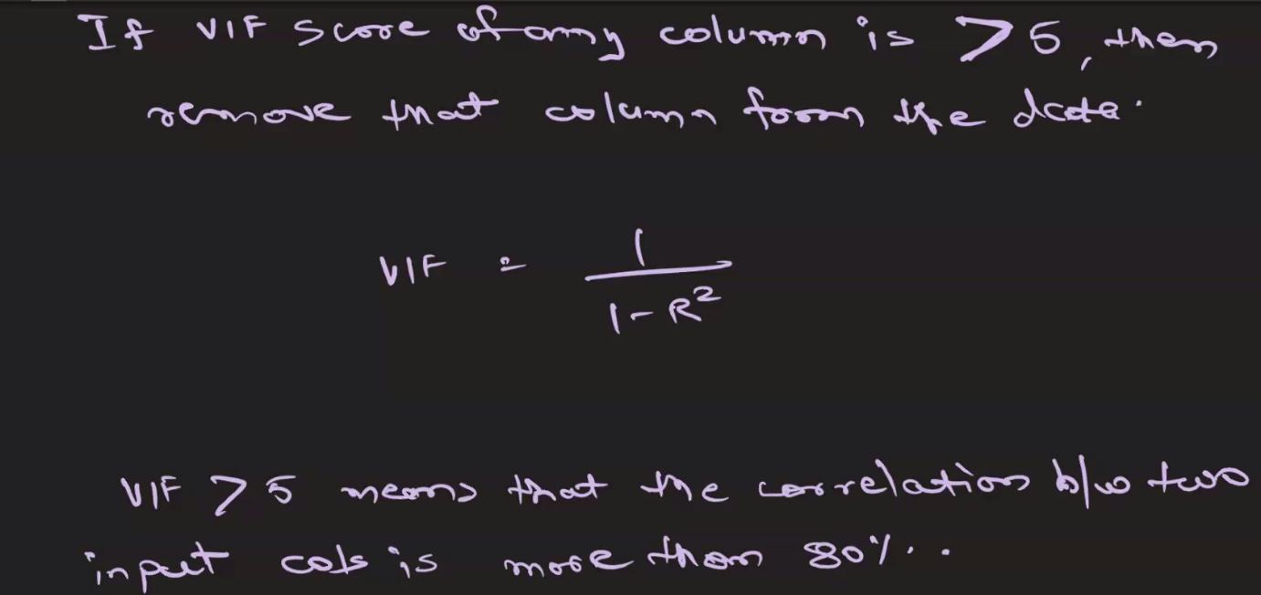

* **Tolerance**: Tolerance is the reciprocal of VIF. Low tolerance values (less than 0.1) indicate high multicollinearity.
  + Tolerancei=1−Ri2 ​

# 9th June

### Naive Model

In the context of evaluating predictive models using the R-squared (R2) score, a "naive model" refers to a simplistic baseline model that makes predictions without using any features or information from the dataset. Instead, it typically relies on basic summary statistics or simple algorithms to generate predictions.

Here's how a naive model relates to the R2 score:

1. **Simple Prediction Strategy**: A naive model often employs a straightforward prediction strategy, such as:
   * Using the mean, median, or mode of the target variable as the predicted value for all observations.
   * Using the last observed value as the predicted value for time-series data.
   * Assigning a constant value as the prediction.
2. **Lack of Information Utilization**: Since a naive model doesn't utilize any features or information from the dataset, its predictions are solely based on simplistic assumptions or generalizations. As a result, the predictions made by a naive model are typically very basic and may not capture the underlying patterns or relationships in the data.
3. **R2 Score Evaluation**: When evaluating a naive model using the R2 score, it serves as a baseline or reference point for comparison with more sophisticated models. The R2 score of a naive model can provide insights into the performance of more complex models relative to the simplest possible prediction strategy.
4. **Interpretation of R2 Score for Naive Model**: The R2 score of a naive model can help in understanding the degree to which more advanced models improve upon this basic prediction strategy. A higher R2 score for a more complex model indicates that it captures more variance in the target variable compared to the naive model. Conversely, a lower R2 score may suggest that the complex model doesn't offer significant improvements over the naive approach.
5. **Cautions**: It's essential to interpret the R2 score of a naive model within the context of the specific problem and dataset. While a low R2 score for a naive model indicates that the model doesn't capture much variance, achieving a higher R2 score with a more complex model doesn't necessarily guarantee its superiority without considering other factors such as model interpretability, generalization performance, and computational complexity.

In summary, a naive model provides a basic benchmark for evaluating the predictive performance of more sophisticated models, and the R2 score helps quantify the improvement achieved by these

### Adjusted R-squared

Adjusted R-squared is a modified version of the R-squared statistic that has been adjusted for the number of predictors in the model. It addresses one of the limitations of R-squared by penalizing excessive use of predictors that may not significantly improve the model's explanatory power.

Here's how it works:

1. **Adjustment for Complexity**: Adjusted R-squared takes into account the number of predictors in the model. As more predictors are added, R-squared tends to increase, even if those predictors don't add much explanatory power. Adjusted R-squared penalizes this increase in R-squared that might be due to chance or overfitting.
2. **Formula**: The formula for Adjusted R-squared is:

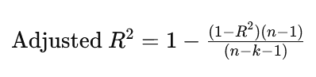

Where:

* R2R^2R2 is the R-squared value.
* nnn is the number of observations.
* kkk is the number of predictors (independent variables).

1. **Interpretation**: Like R-squared, Adjusted R-squared also ranges between 0 and 1. A higher Adjusted R-squared indicates a better fit of the model to the data. If the adjusted R-squared is close to 1, it means that a large proportion of the variability in the dependent variable is explained by the independent variables.
2. **Usefulness**: Adjusted R-squared is useful for comparing the goodness of fit of models with different numbers of predictors. It helps in selecting the most appropriate model among competing models by considering both the goodness of fit and model complexity.
3. **Limitation**: While Adjusted R-squared addresses the issue of model complexity, it still doesn't provide information about whether the model assumptions are met or whether the coefficients are biased.

In summary, Adjusted R-squared provides a more reliable measure of the goodness of fit, particularly when comparing models with different numbers of predictors.

## Logistic Regression

Logistic Regression is a statistical method used for binary classification tasks, where the dependent variable (or target variable) is categorical and has only two possible outcomes, typically labeled as 0 and 1. Despite its name, logistic regression is used for classification, not regression.

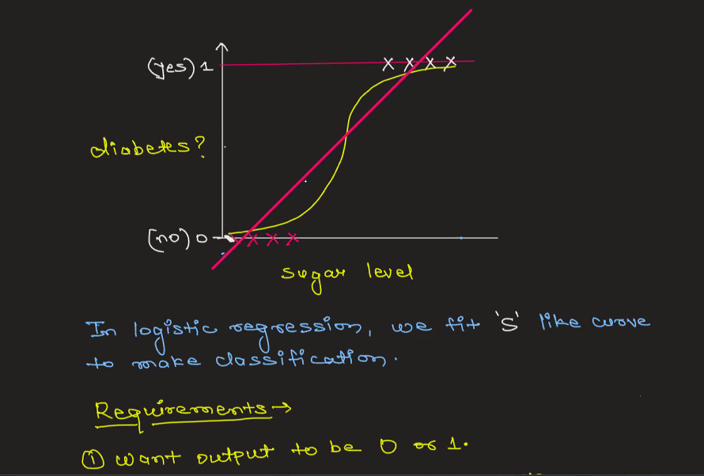

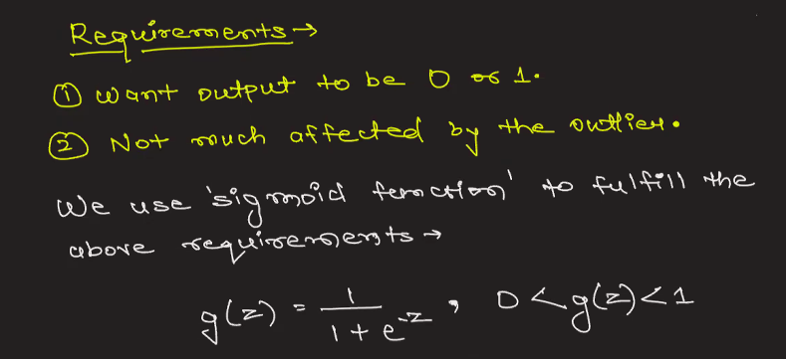

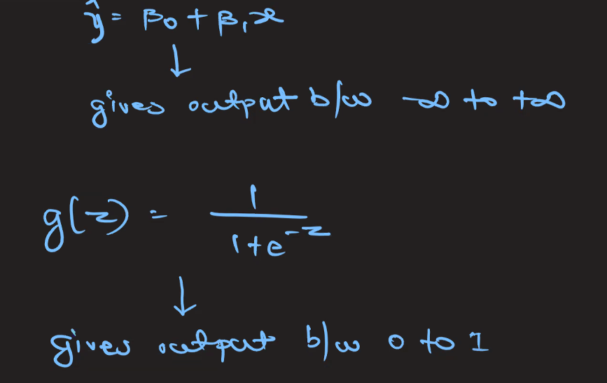

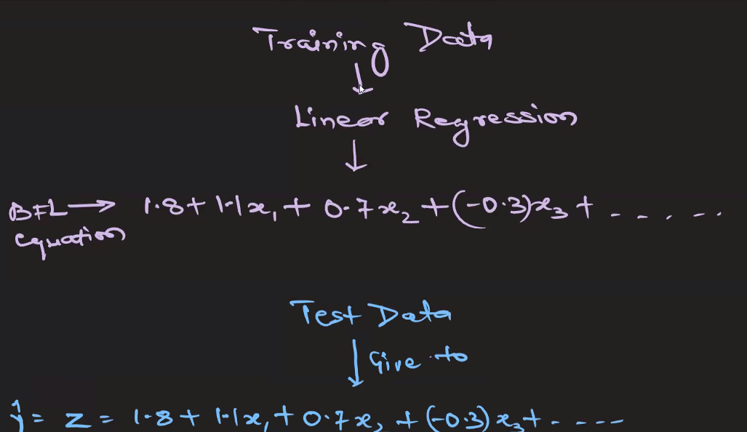

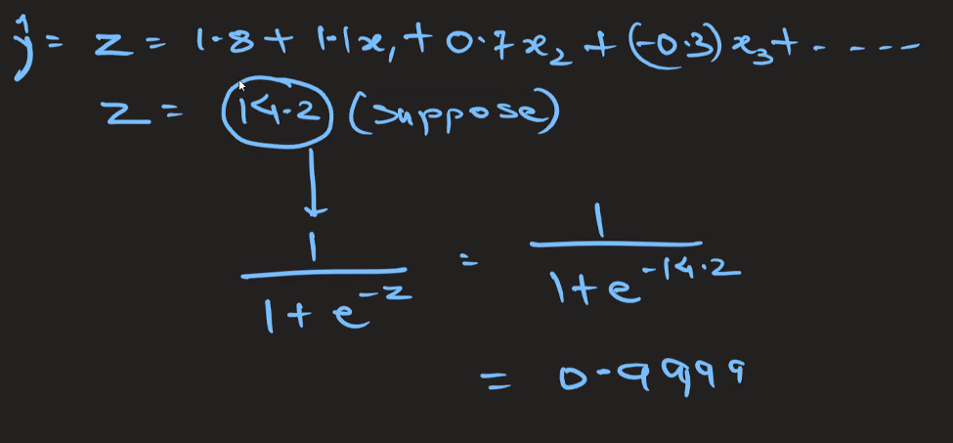

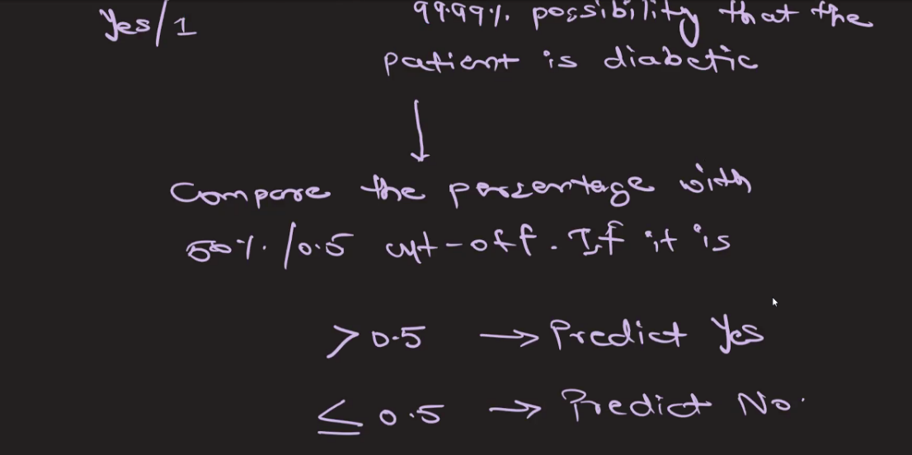

### Measure of Spread

In statistics, "spread" refers to the extent to which data values are dispersed or distributed across a dataset. It provides insights into the variability or dispersion of the data points around a central tendency measure, such as the mean or median. There are several measures of spread commonly used in statistics:

1. **Range**: The range is the simplest measure of spread and is calculated as the difference between the maximum and minimum values in the dataset. While it's easy to compute, it's sensitive to outliers and may not provide a robust measure of variability.
2. **Interquartile Range (IQR)**: The IQR is a robust measure of spread that is less affected by outliers compared to the range. It is calculated as the difference between the third quartile (Q3) and the first quartile (Q1) of the dataset. The IQR contains the middle 50% of the data.
3. **Variance**: Variance measures the average squared deviation of each data point from the mean of the dataset. It provides a measure of how much the data points are spread out around the mean. However, it is not in the same units as the original data, making it less interpretable.
4. **Standard Deviation**: The standard deviation is the square root of the variance and is expressed in the same units as the original data. It provides a measure of the average deviation of data points from the mean. Standard deviation is widely used due to its interpretability and ease of calculation.
5. **Mean Absolute Deviation (MAD)**: MAD measures the average absolute deviation of data points from the mean of the dataset. Unlike variance and standard deviation, MAD is less sensitive to extreme values and provides a robust measure of spread.
6. **Coefficient of Variation (CV)**: CV is the ratio of the standard deviation to the mean, expressed as a percentage. It provides a measure of relative variability, allowing comparison of variability between datasets with different units or scales.

These measures of spread are essential for understanding the distribution of data, identifying outliers, and making informed decisions in statistical analysis and data interpretation. The choice of measure depends on the characteristics of the dataset and the specific goals of the analysis.

# 15th June

### Startify attribute

The stratify attribute is used in the context of splitting data into training and testing sets to ensure that the distribution of classes in the target variable is preserved in both subsets. This is particularly useful in scenarios where you have an imbalanced dataset, meaning the number of instances in each class is not equal.

#### Importance of Stratification

In an imbalanced dataset, if you randomly split the data without stratification, you might end up with training and testing sets that do not accurately represent the overall distribution of classes. This can lead to biased model performance metrics, as the model might be trained on a skewed representation of the data and evaluated on another skewed representation.

#### How Stratification Works

Stratification ensures that the proportion of each class in the target variable is approximately the same in both the training and testing sets. For example, if your dataset has 70% instances of class 0 and 30% instances of class 1, stratified sampling will ensure that both the training and testing sets maintain this 70-30 ratio.

#### Usage Example in Python with train_test_split

In Python, you can use the stratify attribute in the train_test_split function from the sklearn.model_selection module to achieve stratified sampling.

Here's an example:

import numpy as np

from sklearn.model_selection import train_test_split

# Generate some sample data

np.random.seed(0)

X = np.random.rand(100, 2)

y = np.random.choice([0, 1], size=(100,), p=[0.7, 0.3]) # Imbalanced dataset: 70% of class 0, 30% of class 1

# Split the data into training and test sets with stratification

X_train, X_test, y_train, y_test = train_test_split(X, y, test_size=0.3, **stratify=y**, random_state=0)

# Check the distribution of classes in the original, training, and test sets

print('Original class distribution:', np.bincount(y) / len(y))

print('Training set class distribution:', np.bincount(y_train) / len(y_train))

print('Test set class distribution:', np.bincount(y_test) / len(y_test))

#### Output Explanation

The output of the above code will show that the class distribution in the original dataset is preserved in both the training and test sets:

Original class distribution: [0.7 0.3]

Training set class distribution: [0.7 0.3]

Test set class distribution: [0.7 0.3]

#### When to Use Stratification

* **Imbalanced Datasets**: When one class significantly outnumbers another.
* **Classification Problems**: Ensuring that both training and testing sets are representative of the overall class distribution is crucial for training robust classifiers.
* **Cross-Validation**: When performing cross-validation, stratified sampling ensures that each fold has a similar class distribution.

#### Summary

Stratification is a crucial technique to ensure that the model training and evaluation processes are not biased by an uneven distribution of classes in the target variable. It helps maintain the representativeness of the datasets and improves the reliability of model performance metrics.

### random_state attribute

The random_state parameter is used in various machine learning algorithms and functions, such as train_test_split, to ensure reproducibility of results. It controls the randomness involved in processes like data shuffling and splitting, random sampling, and initializing weights in machine learning models.

#### Why Use random_state?

1. **Reproducibility**: Setting a random_state ensures that the results are reproducible. This means that every time you run your code with the same random_state, you'll get the same results. This is crucial for debugging, comparing model performance, and sharing your work with others.
2. **Consistency**: It allows for consistent results across different runs, making it easier to track changes and understand the impact of modifications to the code or model.

#### How random_state Works

* **Integer**: When you pass an integer to random_state, it initializes the random number generator to a specific state. This ensures that the sequence of random numbers (and hence the results) is the same every time.
* **None**: If random_state is set to None, the random number generator is initialized based on the current system time. This results in different outcomes for each run.
* **Instance of numpy.random.RandomState**: You can also pass an instance of numpy.random.RandomState for more control over the random number generation.

### fit_transform vs transform

In the context of data preprocessing in machine learning, the methods fit_transform and transform are used for scaling, normalizing, or encoding data. These methods are often found in preprocessing classes in libraries such as scikit-learn. Understanding the difference between them is crucial for correctly applying transformations to your dataset.

#### fit_transform

The fit_transform method is a combination of two operations: fitting and transforming.

1. **Fit**: It calculates the necessary statistics (e.g., mean and standard deviation for scaling, or min and max for normalization) from the data provided. This step "learns" the parameters needed for the transformation.
2. **Transform**: It applies the transformation using the parameters learned during the fitting step.

#### When to Use fit_transform

* **Training Data**: You should use fit_transform on your training data. This ensures that the transformation is based on the training data only, which prevents data leakage from the test set.

#### transform

The transform method only applies the transformation using the parameters learned during the fit step. It does not calculate new parameters; it simply uses the existing ones.

#### When to Use transform

* **Test Data or New Data**: After fitting the transformer on the training data using fit_transform, you should use transform on the test data or any new data to ensure that it is transformed in the same way as the training data.

#### Summary

1. **fit_transform**:
   * Combines fitting and transforming.
   * Used on training data.
   * Learns parameters from the training data and then applies the transformation.
2. **transform**:
   * Only applies the transformation.
   * Used on test data or new data.
   * Uses the parameters learned from the training data.

## Decision Trees

Decision trees are a popular and versatile type of machine learning model used for both classification and regression tasks. They are intuitive to understand and interpret, and they can handle both numerical and categorical data. Here’s a detailed overview of decision trees:

### 1. **Concept and Structure**

A decision tree is a flowchart-like tree structure where:

* **Internal Nodes**: Represent tests on features (e.g., whether a feature value is greater than a threshold).
* **Branches**: Represent the outcome of the test.
* **Leaf Nodes**: Represent the final output (class label for classification, continuous value for regression).

### 2. **How Decision Trees Work**

1. **Splitting**: The tree splits the data at each node based on a feature that results in the best separation of the data points. The choice of the best feature and split can be based on various criteria:
   * **Classification Trees**: Use criteria like Gini impurity, information gain (entropy), or misclassification error.
   * **Regression Trees**: Use criteria like mean squared error (MSE) or mean absolute error (MAE).
2. **Stopping Criteria**: The tree continues to split until it reaches a stopping criterion, such as:
   * A maximum tree depth.
   * A minimum number of samples required to split a node.
   * A minimum number of samples required to be at a leaf node.
   * No further improvement in splitting criterion.
3. **Prediction**:
   * **Classification Trees**: Assign the most common class of the training samples in the leaf node.
   * **Regression Trees**: Assign the mean or median value of the training samples in the leaf node.

### 3. **Advantages and Disadvantages**

**Advantages**:

* **Easy to Understand and Interpret**: Trees can be visualized and are easy to explain to non-experts.
* **Non-linear Relationships**: Can capture non-linear relationships between features.
* **Feature Importance**: Can provide an estimate of the importance of different features in the prediction.

**Disadvantages**:

* **Overfitting**: Trees can become very complex and overfit the training data, especially if not pruned or regularized.
* **Instability**: Small changes in the data can result in completely different trees.
* **Bias**: Trees can be biased if some classes dominate.

### 4. **Pruning**

Pruning reduces the size of the tree by removing sections of the tree that provide little power in predicting target variables. It helps to avoid overfitting. There are two types of pruning:

* **Pre-pruning (Early Stopping)**: Stop growing the tree earlier based on predefined conditions.
* **Post-pruning**: Grow the full tree and then remove non-significant branches.

### 5. **Important Parameters**

* **Criterion**: The function to measure the quality of a split (e.g., "gini" for Gini impurity, "entropy" for information gain in classification; "mse" for mean squared error in regression).
* **Max Depth**: The maximum depth of the tree.
* **Min Samples Split**: The minimum number of samples required to split an internal node.
* **Min Samples Leaf**: The minimum number of samples required to be at a leaf node.
* **Max Features**: The maximum number of features considered for splitting a node.

### 6. **Ensemble Methods**

Decision trees are often used as the building blocks for more powerful ensemble methods:

* **Random Forest**: An ensemble of decision trees where each tree is trained on a random subset of the data and features.
* **Gradient Boosting Machines (GBM)**: Sequentially builds trees, each trying to correct the errors of the previous ones.

## Occam's Razor Principle

Occam's razor is a principle from philosophy and science that suggests when faced with competing hypotheses or explanations, the one that makes the fewest assumptions should be selected. In other words, the simplest explanation is usually the correct one.

### Origin and Explanation

Occam's razor is named after the English philosopher and theologian William of Ockham (1287–1347), who is credited with advocating this principle. The term "razor" refers to the "shaving away" of unnecessary assumptions to find the simplest path.

### Application in Science and Machine Learning

In science and machine learning, Occam's razor is used as a heuristic to guide the development of models and theories:

1. **Model Selection**: When comparing different models that explain the data equally well, the simpler model (with fewer parameters and assumptions) is generally preferred. This helps avoid overfitting, where a more complex model fits the training data very well but performs poorly on new, unseen data.
2. **Feature Selection**: In the context of machine learning, Occam's razor suggests selecting a model with fewer features if it achieves similar performance to a model with more features. This can lead to more interpretable and generalizable models.

### Examples

* **Linear Regression vs. Polynomial Regression**: For a given dataset, a simple linear regression model might be preferred over a higher-degree polynomial regression model if both have similar predictive performance on a validation set. The linear model is simpler and less likely to overfit.
* **Decision Trees**: When constructing decision trees, it's often beneficial to limit the depth of the tree. A simpler, shallower tree that generalizes well is preferred over a very deep tree that fits the training data perfectly but may overfit.

### Mathematical Formulation

While Occam's razor is more of a philosophical guideline, it can be formalized in various ways in machine learning, such as through regularization techniques that penalize model complexity:

* **L1 Regularization (Lasso)**: Encourages sparsity in the model parameters, effectively setting some coefficients to zero and thus simplifying the model.
* **L2 Regularization (Ridge)**: Penalizes large coefficients to prevent the model from becoming overly complex.

### Practical Considerations

Occam's razor should not be applied blindly. The simplest model is not always the best; sometimes, the complexity of the phenomenon being modeled justifies a more complex model. The key is to find a balance between simplicity and explanatory power, ensuring the model is as simple as possible without sacrificing accuracy and generalizability.

### Summary

Occam's razor is a valuable heuristic in the scientific method and machine learning, advocating for simplicity and the avoidance of unnecessary complexity. By adhering to this principle, researchers and practitioners can develop models that are not only easier to understand and interpret but also more likely to generalize well to new data.

# 16th June

### Overfitting vs Underfitting

#### Overfitting

**Definition:** Overfitting occurs when a model learns the training data too well, capturing noise and outliers along with the underlying pattern. This leads to a model that performs exceptionally well on the training data but poorly on new, unseen data.

**Causes:**

* **Complex Models:** Using models that are too complex relative to the amount of training data, such as deep neural networks with many layers or decision trees with many splits.
* **Too Many Features:** Including irrelevant or redundant features can lead to overfitting, as the model tries to account for these extra features in the training data.
* **Insufficient Training Data:** When the amount of training data is small, the model might not be able to generalize well.

**Symptoms:**

* **Low Training Error, High Validation/Test Error:** The model shows very low error on the training set but performs poorly on validation or test sets.
* **High Variance:** Model performance varies significantly across different training datasets.

**Solutions:**

* **Simpler Models:** Use simpler models that are less prone to capturing noise in the training data.
* **Regularization:** Techniques like L1 (Lasso) and L2 (Ridge) regularization add a penalty to the loss function to discourage overly complex models.
* **Cross-Validation:** Use cross-validation to ensure the model generalizes well to different subsets of the data.
* **More Training Data:** Increasing the amount of training data can help the model learn the underlying pattern without overfitting to noise.

#### Underfitting

**Definition:** Underfitting occurs when a model is too simple to capture the underlying pattern in the data. This leads to poor performance on both the training data and new, unseen data.

**Causes:**

* **Too Simple Models:** Using models that are too simple, such as linear regression for data that has a non-linear pattern.
* **Insufficient Features:** Not including enough features or using features that do not capture the underlying patterns in the data.
* **Too Much Regularization:** Excessive regularization can prevent the model from learning the underlying pattern in the data.

**Symptoms:**

* **High Training Error, High Validation/Test Error:** The model shows high error on both the training and validation/test sets.
* **High Bias:** The model makes strong assumptions about the data and cannot capture the underlying pattern.

**Solutions:**

* **More Complex Models:** Use more complex models that can capture the underlying patterns in the data.
* **Feature Engineering:** Add relevant features or transform existing features to better capture the underlying patterns.
* **Reduce Regularization:** If regularization is too high, decrease it to allow the model to learn more from the training data.

#### Balancing Overfitting and Underfitting

Achieving a balance between overfitting and underfitting is crucial for building effective machine learning models. Here are some strategies to find this balance:

* **Cross-Validation:** Use cross-validation techniques to tune hyperparameters and select models that perform well on unseen data.
* **Model Selection:** Start with simple models and gradually increase complexity, monitoring performance on validation data to avoid overfitting.
* **Regularization:** Apply regularization techniques judiciously to prevent overfitting while allowing the model to learn from the data.
* **Early Stopping:** In iterative learning algorithms like neural networks, use early stopping to halt training when performance on a validation set starts to degrade.

By understanding and addressing overfitting and underfitting, you can build models that generalize well and make accurate predictions on new data.

### Entropy

**Definition:** Entropy is a measure from information theory that quantifies the amount of disorder or randomness in a system. In the context of decision trees, it measures the impurity or disorder of a set of labels.

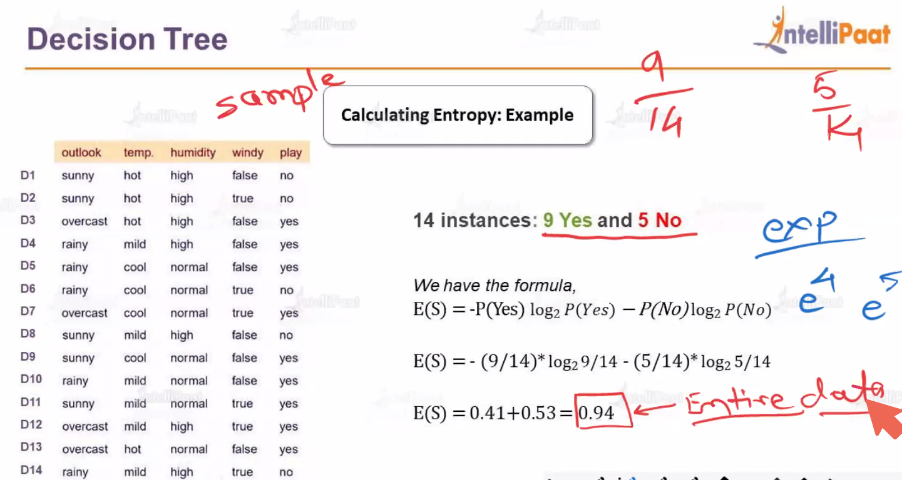

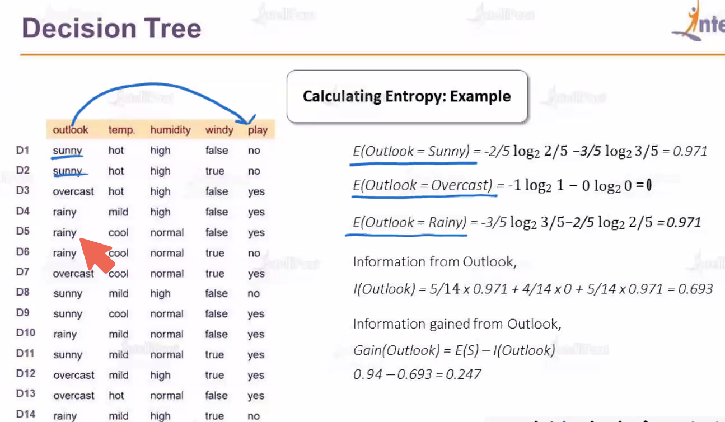

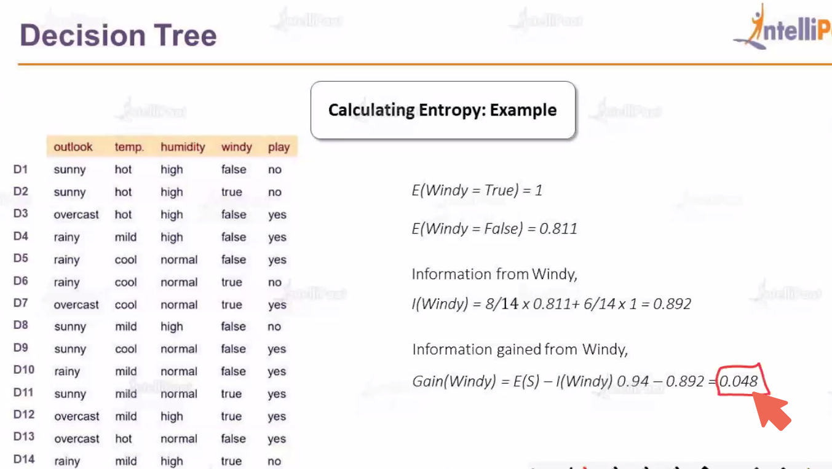

### Conclusion

Entropy is a fundamental concept in decision trees, used to measure the impurity of a node and to decide the best splits by maximizing information gain. By minimizing entropy at each split, decision trees create branches that lead to purer and more homogeneous subsets, improving the model's ability to classify new data.

## Random Forest

Random Forest is a versatile and powerful machine learning algorithm used for both classification and regression tasks. It operates by constructing multiple decision trees during training and outputs the mode of the classes (classification) or mean prediction (regression) of the individual trees.

### Key Concepts

1. **Ensemble Learning**: Random Forest is an ensemble learning method, meaning it combines the predictions of several base estimators (decision trees) to improve robustness and accuracy.
2. **Decision Trees**: A decision tree is a simple model that splits the data into branches to make predictions. Each split is based on a feature that maximizes some criterion (e.g., Gini impurity or entropy for classification).
3. **Bagging (Bootstrap Aggregating)**: Random Forest uses bagging, where each tree is trained on a random subset of the data with replacement. This means some data points are repeated, and some are left out, ensuring diversity among the trees.
4. **Random Feature Selection**: At each split in the decision tree, Random Forest considers a random subset of features. This decorrelates the trees, further improving the ensemble's performance.

### How Random Forest Works

1. **Training Phase**:
   * **Bootstrap Sampling**: Randomly sample n instances from the dataset with replacement to create a bootstrap sample.
   * **Tree Construction**: For each bootstrap sample, grow a decision tree. At each node, instead of considering all features for the best split, consider a random subset of features.
   * **Tree Growth**: Continue splitting nodes until a stopping criterion is met (e.g., maximum depth, minimum number of samples per leaf).
2. **Prediction Phase**:
   * **Classification**: Each tree in the forest votes for a class, and the final prediction is the majority vote.
   * **Regression**: Each tree predicts a value, and the final prediction is the average of all the tree predictions.

### Advantages

* **Improved Accuracy**: By combining multiple trees, Random Forest often achieves higher accuracy than individual decision trees.
* **Robustness**: It is less prone to overfitting compared to a single decision tree because it averages multiple trees.
* **Feature Importance**: It can provide estimates of feature importance, helping to understand the contribution of each feature to the model's predictions.
* **Versatility**: Works well for both classification and regression problems and can handle large datasets with higher dimensionality.

### Disadvantages

* **Complexity**: A Random Forest model with many trees can be computationally expensive and slow to train and predict.
* **Interpretability**: While individual decision trees are easy to interpret, the ensemble of trees in a Random Forest is more complex and less interpretable.

### Hyperparameters

1. **n_estimators**: The number of trees in the forest. More trees generally improve performance but increase computational cost.
2. **max_features**: The number of features to consider when looking for the best split. Options include:
   * 'auto' (default for classification, sqrt(features))
   * 'sqrt' (square root of the number of features)
   * 'log2' (logarithm base 2 of the number of features)
   * An integer value
   * A float representing a fraction of the total number of features
3. **max_depth**: The maximum depth of the trees. Limiting the depth can prevent overfitting.
4. **min_samples_split**: The minimum number of samples required to split an internal node.
5. **min_samples_leaf**: The minimum number of samples required to be at a leaf node.
6. **bootstrap**: Whether to use bootstrap samples when building trees. Default is True.

### Example in Python (scikit-learn)

import numpy as np

from sklearn.datasets import load_iris

from sklearn.model_selection import train_test_split

from sklearn.ensemble import RandomForestClassifier

from sklearn.metrics import accuracy_score

# Load dataset

data = load_iris()

X = data.data

y = data.target

# Split dataset into training and test sets

X_train, X_test, y_train, y_test = train_test_split(X, y, test_size=0.2, random_state=42)

# Initialize the model

rf = RandomForestClassifier(n_estimators=100, random_state=42)

# Fit the model

rf.fit(X_train, y_train)

# Make predictions

y_pred = rf.predict(X_test)

# Evaluate the model

accuracy = accuracy_score(y_test, y_pred)

print("Test Set Accuracy:", accuracy)

# Feature importance

importances = rf.feature_importances_

for feature, importance in zip(data.feature_names, importances):

print(f"Feature: {feature}, Importance: {importance}")

### Conclusion

Random Forest is a powerful and flexible machine learning algorithm that leverages the strengths of multiple decision trees to improve predictive performance and robustness. Its ability to handle large datasets, reduce overfitting, and provide feature importance makes it a popular choice for a wide range of applications. However, it requires careful tuning of hyperparameters and can be computationally intensive.

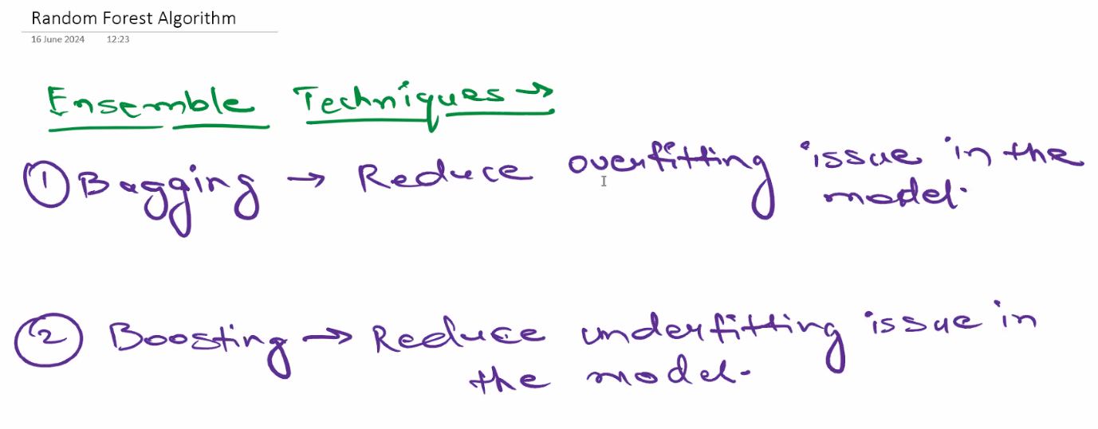

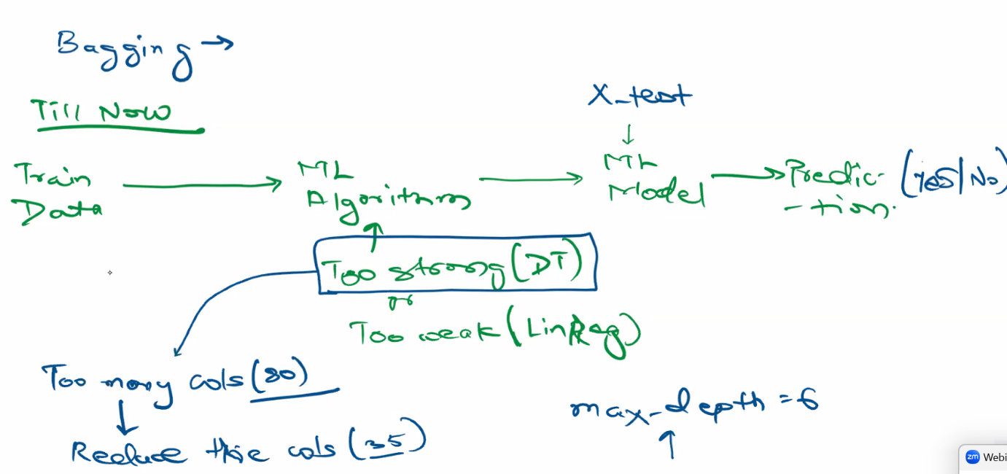

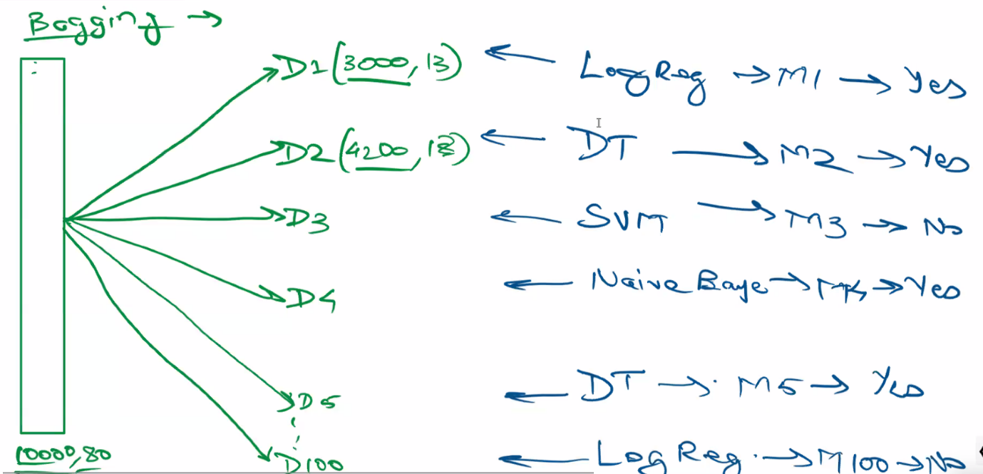

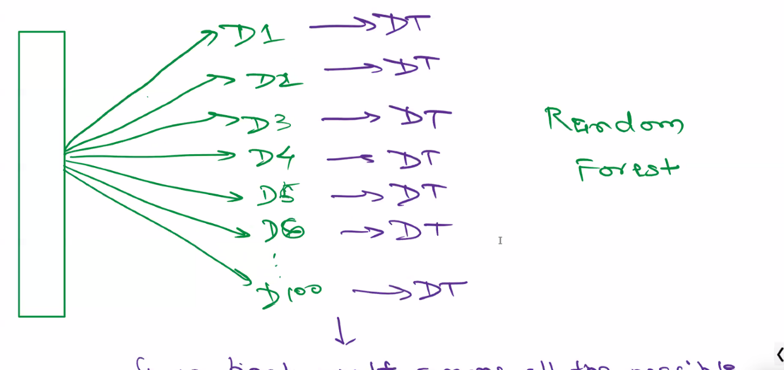 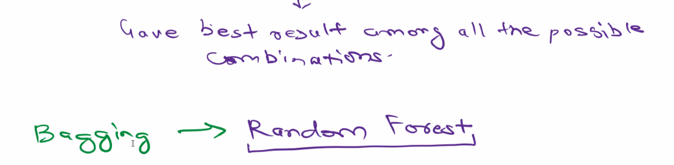

# 22nd June

## Bias vs variance Error

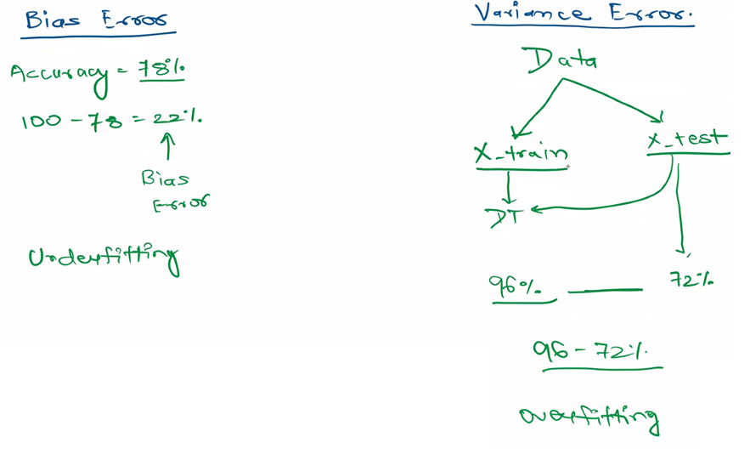

Bias error and variance error are two components of the total prediction error in machine learning models. Understanding the trade-off between bias and variance is crucial for developing models that generalize well to new data. Here's a detailed explanation of each:

### Bias Error

**Bias** refers to the error introduced by approximating a real-world problem, which may be complex, by a much simpler model. In other words, bias is the error due to overly simplistic assumptions in the learning algorithm.

* **High Bias**: A model with high bias pays very little attention to the training data and oversimplifies the model. It leads to high training error and high error on the validation/test set. Such models are said to underfit the data. Examples include linear regression for a non-linear problem or a very shallow decision tree.
* **Low Bias**: A model with low bias closely follows the training data and captures the underlying patterns. However, this does not necessarily mean it will generalize well, as it could be overfitting the training data.

### Variance Error

**Variance** refers to the model's sensitivity to small fluctuations in the training data. A model with high variance pays a lot of attention to the training data, including noise, and as a result, it can model the random noise in the training data rather than the intended outputs.

* **High Variance**: A model with high variance can perform very well on the training data but poorly on unseen data because it captures the noise in the training data. This leads to overfitting. Examples include a very deep decision tree or a highly complex neural network with many parameters.
* **Low Variance**: A model with low variance is less sensitive to the specific training data and captures the underlying distribution well, leading to better generalization to new data.

### Techniques to Address Bias and Variance

* **For High Bias (Underfitting)**:
  + Use more complex models
  + Increase the number of features
  + Reduce regularization
* **For High Variance (Overfitting)**:
  + Use simpler models
  + Reduce the number of features
  + Increase regularization
  + Use more training data
  + Implement cross-validation techniques

In summary, balancing bias and variance is crucial for building models that generalize well. This often involves iterative experimentation and validation to find the optimal model complexity for a given problem.

## Synthetic Data

Synthetic data plays a significant role in machine learning (ML) for various reasons. Here are some key aspects:

### 1. **What is Synthetic Data?**

Synthetic data is artificially generated data that mimics the statistical properties of real-world data. It can be created using various techniques, including simulations, generative models, and rule-based methods.

### 2. **Uses of Synthetic Data in ML**

* **Training Data:** Used when real data is scarce, expensive to collect, or subject to privacy constraints.
* **Testing and Validation:** Helps in testing models more rigorously by providing diverse and challenging scenarios.
* **Data Augmentation:** Enhances the size and diversity of the training set, improving model robustness and performance.
* **Anonymization:** Maintains privacy by using synthetic data instead of real, sensitive data.
* **Scenario Testing:** Allows testing models in controlled conditions and edge cases.

### 3. **Generating Synthetic Data**

* **Random Sampling:** Simple statistical methods to generate data points from a known distribution.
* **Simulations:** Creating data based on complex models or simulations of real-world processes.
* **Generative Adversarial Networks (GANs):** Neural networks designed to generate realistic data by learning the distribution of the training data.
* **Variational Autoencoders (VAEs):** Another type of neural network used for generating data by learning latent representations.
* **Rule-Based Systems:** Generating data based on predefined rules or heuristics.

### 4. **Advantages of Synthetic Data**

* **Cost-Effective:** Reduces the need for expensive data collection and labeling processes.
* **Scalability:** Easy to generate large volumes of data.
* **Privacy:** Avoids the use of sensitive or personal data, thus mitigating privacy concerns.
* **Customization:** Allows creating specific scenarios and edge cases that may not be present in real data.

### 5. **Challenges and Considerations**

* **Quality:** Ensuring that synthetic data accurately represents real-world data distributions.
* **Bias:** Avoiding the introduction of biases present in the synthetic data.
* **Complexity:** Generating high-quality synthetic data can be computationally intensive and require sophisticated models.
* **Validation:** Ensuring the synthetic data leads to models that generalize well to real-world data.

### Summary

Synthetic data is a valuable resource in machine learning, providing numerous benefits such as cost reduction, scalability, and privacy. However, its effective use requires careful consideration of data quality, bias, and validation to ensure robust and generalizable ML models.

## Oversampling and Undersampling

Oversampling and undersampling are techniques used to address class imbalance in datasets, particularly in the context of classification problems. Here's a detailed explanation of both techniques, their purposes, and their respective advantages and disadvantages:

### Oversampling

**Oversampling** involves increasing the number of instances in the minority class to match the number of instances in the majority class. This can be done through various methods:

#### Methods of Oversampling

1. **Random Oversampling**: Simply duplicates random instances from the minority class until the classes are balanced.
2. **SMOTE (Synthetic Minority Over-sampling Technique)**: Generates synthetic samples by interpolating between existing minority class instances. SMOTE creates new instances that are combinations of nearby minority instances.
3. **ADASYN (Adaptive Synthetic Sampling)**: Similar to SMOTE but focuses on generating more synthetic data in regions where the minority class is sparsely represented.

#### Advantages of Oversampling

* **Balances the Dataset**: Helps create a balanced dataset, making it easier for machine learning models to learn from the minority class.
* **Improves Model Performance**: Can improve the performance of classifiers by providing more examples of the minority class, leading to better generalization.
* **Preserves All Majority Class Data**: No information is lost from the majority class, as new instances are added to balance the dataset.

#### Disadvantages of Oversampling

* **Overfitting Risk**: Random oversampling can lead to overfitting, especially if duplicates of minority instances are created.
* **Increased Computational Load**: Adding more instances to the dataset increases the computational cost of training the model.

### Undersampling

**Undersampling** involves reducing the number of instances in the majority class to balance the dataset with the minority class. This can also be done through various methods:

#### Methods of Undersampling

1. **Random Undersampling**: Randomly removes instances from the majority class until the classes are balanced.
2. **Tomek Links**: Removes instances from the majority class that are close to minority class instances, aiming to make the classes more separable.
3. **Cluster-Based Undersampling**: Uses clustering techniques to identify and remove redundant or similar instances from the majority class.

#### Advantages of Undersampling

* **Balances the Dataset**: Helps create a balanced dataset, making it easier for machine learning models to learn from both classes.
* **Reduces Training Time**: By reducing the size of the dataset, it can decrease the computational load and training time for the model.
* **Prevents Overfitting**: Less risk of overfitting compared to oversampling, especially with sophisticated undersampling techniques.

#### Disadvantages of Undersampling

* **Information Loss**: Potentially valuable information from the majority class can be lost, which may lead to a less robust model.
* **Lower Performance**: If not done carefully, undersampling can lead to a model that does not generalize well, especially if important majority class instances are removed.

### Choosing Between Oversampling and Undersampling

The choice between oversampling and undersampling depends on several factors, including the dataset, the machine learning algorithm being used, and the specific problem being addressed.

1. **Dataset Size**: If the dataset is small, undersampling might remove too much information, making oversampling a better choice. Conversely, if the dataset is very large, undersampling can reduce computational costs.
2. **Model Type**: Some models are more sensitive to class imbalance than others. For instance, tree-based models like Random Forests can handle imbalanced data better than models like logistic regression.
3. **Computational Resources**: Oversampling increases the size of the dataset, which can be computationally expensive. Undersampling reduces the size of the dataset, saving computational resources.

### Practical Tips

* **Combination Approaches**: Sometimes, a combination of both techniques works best. For example, using SMOTE to generate synthetic minority instances and then applying undersampling to reduce the majority class.
* **Cross-Validation**: Always use cross-validation to evaluate the impact of oversampling and undersampling techniques on model performance.
* **Feature Engineering**: Sometimes, improving feature engineering can help mitigate class imbalance without the need for extensive sampling techniques.

In summary, both oversampling and undersampling are valuable techniques for handling class imbalance, each with its own strengths and limitations. The choice between them should be guided by the specific context of the problem, dataset characteristics, and computational constraints.

## Confusion Matrix

A **confusion matrix** is a table used to evaluate the performance of a classification model. It provides a comprehensive summary of how well the classification model is performing by showing the correct and incorrect predictions broken down by each class. This matrix helps in understanding the types of errors being made by the model.

### Structure of a Confusion Matrix

A confusion matrix for a binary classification problem typically has the following structure:

|  | **Predicted Positive** | **Predicted Negative** |
| --- | --- | --- |
| **Actual Positive** | True Positive (TP) | False Negative (FN) |
| **Actual Negative** | False Positive (FP) | True Negative (TN) |

For multiclass classification, the matrix is extended accordingly, with rows and columns representing the actual and predicted classes respectively.

### Key Terms

1. **True Positive (TP)**: The model correctly predicts the positive class.
2. **True Negative (TN)**: The model correctly predicts the negative class.
3. **False Positive (FP)**: The model incorrectly predicts the positive class (Type I error).
4. **False Negative (FN)**: The model incorrectly predicts the negative class (Type II error).

### Metrics Derived from the Confusion Matrix

From the confusion matrix, several performance metrics can be calculated to evaluate the effectiveness of the classification model:

#### **Accuracy**

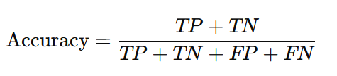

Accuracy measures the proportion of correct predictions among the total number of cases processed.

#### **Precision** (Positive Predictive Value)

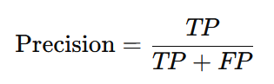

Precision measures the proportion of true positive predictions among all positive predictions made by the model.

#### **Recall** (Sensitivity or True Positive Rate)

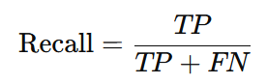

Recall measures the proportion of actual positives that were correctly identified by the model.

#### F1 Score

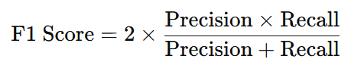

The F1 Score is the harmonic mean of precision and recall, providing a single metric that balances both concerns.

#### **Specificity** (True Negative Rate)

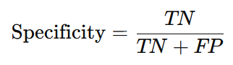

Specificity measures the proportion of actual negatives that were correctly identified by the model.

#### False Positive Rate (FPR)

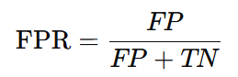

FPR indicates the proportion of actual negatives that were incorrectly classified as positive.

#### False Negative Rate (FNR)

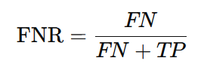

FNR indicates the proportion of actual positives that were incorrectly classified as negative.

### Example

Consider a binary classification model predicting whether emails are spam or not. Here's an example of a confusion matrix for this model:

|  | **Predicted Spam** | **Predicted Not Spam** |
| --- | --- | --- |
| **Actual Spam** | 80 | 20 |
| **Actual Not Spam** | 10 | 90 |

From this matrix, we can derive:

* **True Positives (TP)** = 80 (correctly predicted spam emails)
* **True Negatives (TN)** = 90 (correctly predicted non-spam emails)
* **False Positives (FP)** = 10 (non-spam emails incorrectly predicted as spam)
* **False Negatives (FN)** = 20 (spam emails incorrectly predicted as non-spam)

Using these values, we can calculate the performance metrics like accuracy, precision, recall, and F1 score.

### Importance of the Confusion Matrix

The confusion matrix is a crucial tool for:

* Identifying types of errors made by the classification model.
* Understanding the performance of a model beyond simple accuracy, especially in cases of imbalanced datasets.
* Guiding improvements to the model by highlighting areas where it may be underperforming.

In summary, the confusion matrix provides a detailed breakdown of model performance, offering insights into both correct and incorrect predictions, which is essential for thorough model evaluation and improvement.

## Accuracy Score vs ROC_AUC_Score

**Accuracy Score** and **ROC AUC Score** are two different metrics used to evaluate the performance of classification models, and they provide different insights into the model's effectiveness. Here's a detailed comparison of both:

### Accuracy Score

**Accuracy** measures the proportion of correct predictions (both true positives and true negatives) out of the total number of predictions. It is a straightforward metric that gives an overall sense of how often the classifier is correct.



#### Advantages

* **Simplicity**: Easy to understand and compute.
* **General Performance**: Provides a quick overview of the model's general performance.

#### Disadvantages

* **Class Imbalance**: Can be misleading in cases of class imbalance. For example, in a dataset with 95% negative instances and 5% positive instances, a model that always predicts the negative class will have high accuracy but is not useful.

### ROC AUC Score

**ROC AUC Score** (Receiver Operating Characteristic - Area Under the Curve) is a performance measurement for classification problems at various threshold settings. ROC is a probability curve, and AUC represents the degree or measure of separability. It tells how much the model is capable of distinguishing between classes.

#### Components

1. **True Positive Rate (TPR)** or **Recall**:



1. **False Positive Rate (FPR)**:



The ROC curve plots TPR against FPR at various threshold settings. The AUC is the area under the ROC curve and provides a single value summary of the model's performance across all thresholds.

#### Advantages

* **Threshold Independence**: Measures the model's performance across all classification thresholds.
* **Class Imbalance**: More informative in the presence of class imbalance, as it considers both TPR and FPR.

#### Disadvantages

* **Interpretability**: Less intuitive than accuracy for those unfamiliar with ROC curves and AUC.
* **Computation**: Requires computation of the model’s performance at various thresholds, which can be more complex.

### When to Use Each Metric

* **Accuracy Score**: Use this when the classes are balanced and you need a simple measure of overall performance.
* **ROC AUC Score**: Use this when you have imbalanced classes or need to evaluate the model’s performance across different classification thresholds.

### Summary

* **Accuracy Score** is simple and gives a general performance measure but can be misleading with imbalanced data.
* **ROC AUC Score** provides a comprehensive evaluation by considering all threshold settings, making it more robust in the presence of class imbalance.

In summary, the choice between accuracy and ROC AUC depends on the specific context and nature of the classification problem you are dealing with.

## Naive Bayes algorithm

Use case: This algorithm is used to detect the spam messages.

# 23rd June

## CountVectorizer

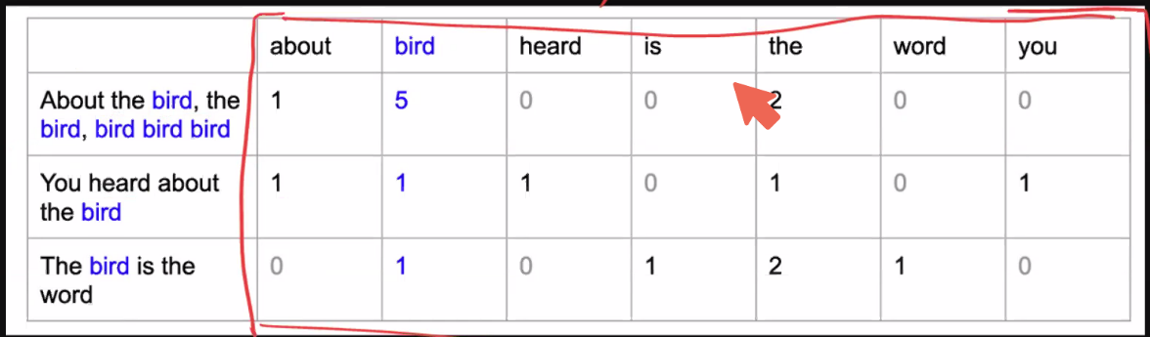

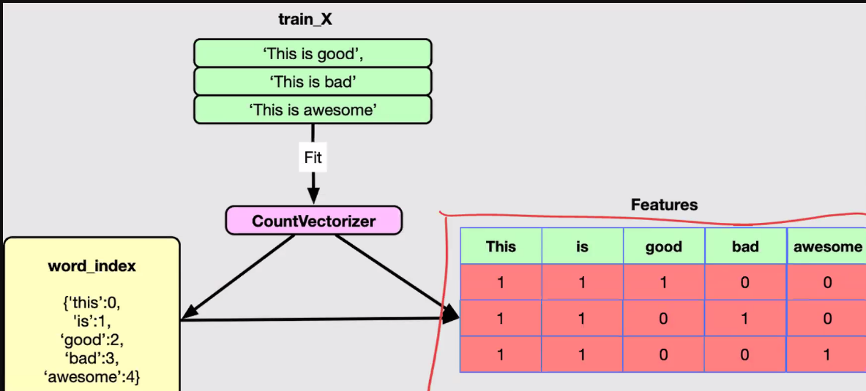

CountVectorizer is a common technique used in Natural Language Processing (NLP) and Machine Learning to convert a collection of text documents into a matrix of token counts. This transformation is essential for turning text data into numerical data that can be used by machine learning algorithms.

## K-Means algorithm

The K-Means algorithm is a popular and widely used clustering technique in machine learning. It aims to partition a set of data points into kkk clusters, where each data point belongs to the cluster with the nearest mean (centroid). This results in a partitioning of the data space into Voronoi cells.

### How K-Means Algorithm Works

The K-Means algorithm follows these steps:

1. **Initialization**: Choose kkk initial centroids randomly or using some heuristic.
2. **Assignment**: Assign each data point to the nearest centroid, forming kkk clusters.
3. **Update**: Calculate the new centroids as the mean of all the data points assigned to each cluster.
4. **Repeat**: Repeat the assignment and update steps until the centroids do not change significantly or a maximum number of iterations is reached.

### Detailed Steps

1. **Initialization**: Randomly initialize kkk centroids.
2. **Assignment Step**:
   * For each data point xix_ixi​, compute the distance to each centroid.
   * Assign xix_ixi​ to the cluster with the nearest centroid.
3. **Update Step**:
   * Calculate the new centroid of each cluster by taking the mean of all points assigned to that cluster
4. **Convergence**: Repeat the assignment and update steps until the centroids stabilize (do not change significantly) or a predetermined number of iterations is reached.

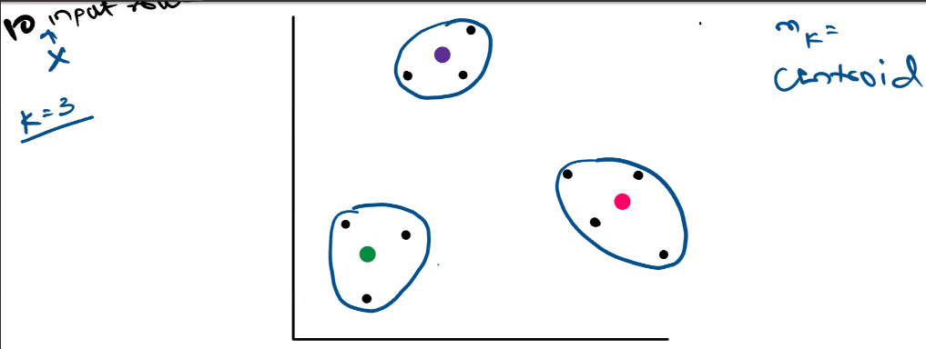

### Choosing the Number of Clusters (k)

Choosing the right number of clusters k is crucial for the performance of the K-Means algorithm. Common methods for determining k include:

#### **Elbow Method**

* **This is the widely used method.**
* Plot the **sum of squared distances** from each point to its assigned centroid (within-cluster sum of squares) for different values of k. The "elbow point," where the rate of decrease sharply slows, suggests a good value for k.

##### How the Elbow Method Works

1. **Fit the K-Means algorithm**: Run the K-Means algorithm for different values of kkk (e.g., from 1 to 10).
2. **Calculate the Within-Cluster Sum of Squares (WCSS)**: For each kkk, compute the sum of squared distances between data points and their respective cluster centroids. This is also known as inertia.
3. **Plot WCSS vs. kkk**: Create a plot with the number of clusters kkk on the x-axis and the WCSS on the y-axis.

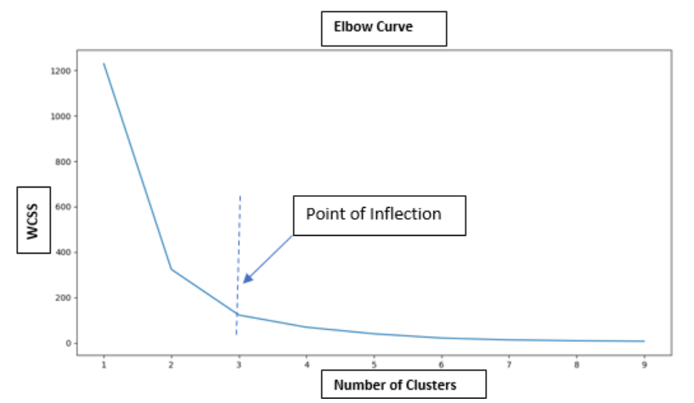

1. **Identify the "elbow" point**:
   * Look for the point on the plot where the WCSS starts to decrease at a slower rate. This point resembles an "elbow" and indicates the optimal number of clusters.
   * In above graph, we can consider 3 as elbow point
   * In Below graph, we can consider 7 as elbow point

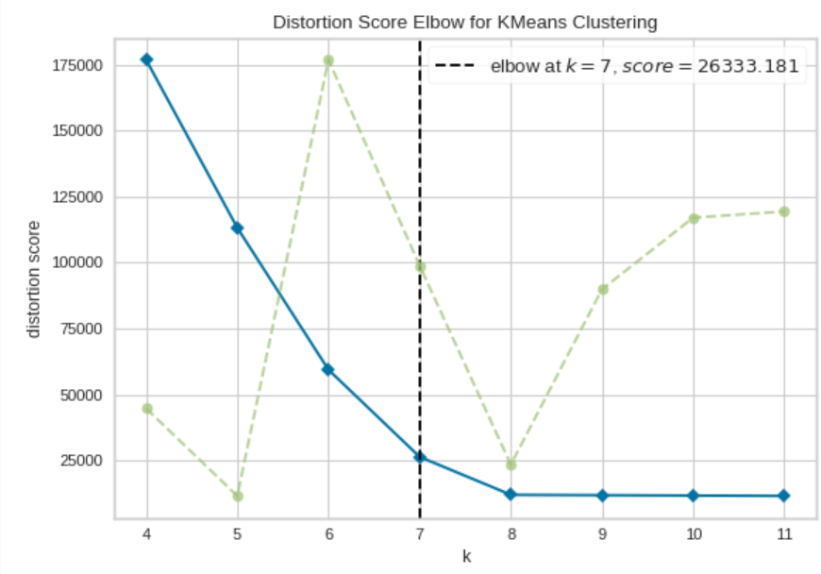

#### **Silhouette Score**

* Measures the quality of the clustering by calculating the average silhouette coefficient for each sample, which considers both the cohesion within clusters and the separation between clusters.

### Advantages and Disadvantages

#### Advantages:

* Simple and easy to implement.
* Computationally efficient for small to medium-sized datasets.
* Works well with spherical (convex) cluster shapes.

#### Disadvantages:

* Requires specifying the number of clusters kkk in advance.
* Sensitive to the initial placement of centroids (may converge to local minima).
* Assumes clusters are spherical and equally sized, which may not always be the case.
* Not suitable for identifying non-convex clusters.

### Conclusion

The K-Means algorithm is a powerful tool for clustering data into distinct groups. Its simplicity and efficiency make it a popular choice for many clustering tasks. However, care must be taken in choosing the appropriate number of clusters and interpreting the results, as well as in cases where the data may not meet the algorithm's assumptions.

## K-Means++

K-Means++ is an enhanced version of the standard K-Means clustering algorithm. The main improvement in K-Means++ is the way it initializes the cluster centroids, which helps to avoid poor initializations that can lead to suboptimal clustering results and slower convergence.

### How K-Means++ Works

K-Means++ improves the initialization of the centroids by using a probabilistic method that spreads out the initial cluster centers. Here are the steps of the K-Means++ initialization:

1. **Random Initialization**: Choose the first centroid randomly from the data points.
2. **Distance Calculation**: Compute the distance D(x)D(x)D(x) from each data point xxx to the nearest centroid that has already been chosen.
3. **Probabilistic Selection**: Select the next centroid from the data points with a probability proportional to D(x)2D(x)^2D(x)2. This means that points further away from the already chosen centroids have a higher probability of being selected as the next centroid.
4. **Repeat**: Repeat steps 2 and 3 until kkk centroids have been chosen.

### Benefits of K-Means++

1. **Better Initial Centroids**: The probabilistic selection ensures that the initial centroids are spread out, leading to better clustering results.
2. **Improved Convergence**: The initialization reduces the likelihood of poor clusters and helps the algorithm converge more quickly.
3. **Reduced Sensitivity**: It reduces the sensitivity to the initial placement of centroids, which is a common issue in the standard K-Means algorithm.

### Conclusion

K-Means++ is a significant improvement over the standard K-Means algorithm, mainly because of its superior method for initializing centroids. By choosing initial centroids that are spread out, K-Means++ leads to more accurate and faster convergence of the clustering process, making it a preferred choice in many practical applications of clustering.

# 29th June

### K-Means Algorithm Applications

Here is the list of applications of the K-Means algorithm:

1. Customer Segmentation
2. Image Segmentation
3. Document Clustering
4. Anomaly Detection
5. Biological Data Analysis
6. Market Basket Analysis
7. Social Network Analysis
8. Recommendation Systems
9. Climate and Weather Analysis
10. Healthcare
11. Finance
12. Urban Planning
13. Sports Analytics

### K-Means Clustering Drawbacks

Here are the drawbacks of the K-Means algorithm:

1. Choosing the Number of Clusters (K)
2. Sensitivity to Initialization
3. Assumption of Spherical Clusters
4. Sensitivity to Outliers
5. Scalability Issues
6. Cluster Assumption (Equal Variance)
7. Interpretability Challenges
8. Data Preprocessing Requirements (Feature Scaling)
9. Cluster Size Imbalance
10. Non-deterministic Results
11. Computational Complexity

#### 1. **Choosing the Number of Clusters (K)**

* **Predefined K**: The number of clusters KKK must be specified in advance, which is not always intuitive or easy to determine.
* **Trial and Error**: Determining the optimal KKK often involves running the algorithm multiple times with different KKK values and using methods like the elbow method or silhouette score.

#### 2. **Sensitivity to Initialization**

* **Local Minima**: K-Means can converge to different solutions depending on the initial positions of the centroids. Poor initialization can lead to suboptimal clustering.
* **K-Means++**: Although K-Means++ improves the initialization process, it does not completely eliminate the sensitivity issue.

#### 3. **Assumption of Spherical Clusters**

* **Shape Limitation**: K-Means assumes that clusters are spherical and equally sized. It does not perform well with clusters of arbitrary shapes, varying sizes, or densities.
* **Distance Metric**: The algorithm uses the Euclidean distance metric, which may not be appropriate for all types of data, especially if the data is not isotropic.

#### 4. **Sensitivity to Outliers**

* **Outliers and Noise**: K-Means is highly sensitive to outliers and noise. Outliers can distort the cluster centroids significantly.
* **Preprocessing**: Preprocessing steps like removing outliers or using robust clustering methods can help mitigate this issue.

#### 5. **Scalability**

* **Large Datasets**: Although K-Means is relatively efficient, it may struggle with very large datasets or high-dimensional data without optimization techniques.

#### 6. **Cluster Assumption**

* **Equal Variance**: K-Means assumes that all clusters have the same variance, which may not be the case in real-world data.
* **Non-convex Clusters**: K-Means is not suitable for detecting non-convex clusters. For example, it would struggle with clusters in the shape of moons or spirals.

#### 7. **Interpretability**

* **Cluster Interpretation**: While K-Means provides cluster assignments, interpreting the clusters and understanding what each cluster represents can be challenging.

#### 8. **Data Preprocessing Requirements**

* **Feature Scaling**: The performance of K-Means is affected by the scale of the features. Features should be normalized or standardized to ensure that no single feature dominates the distance computation.

#### 9. **Cluster Size Imbalance**

* **Uneven Cluster Sizes**: K-Means tends to produce clusters of similar sizes, which can be problematic if the actual clusters vary significantly in size.

#### 10. **Non-deterministic Results**

* **Random Initialization**: Due to its reliance on random initialization, K-Means can produce different results on different runs. Running the algorithm multiple times and averaging results or using consensus clustering can help achieve more stable results.

#### 11. **Computational Complexity**

* **Complexity**: The time complexity of K-Means is O(n⋅K⋅d⋅t)O(n \cdot K \cdot d \cdot t)O(n⋅K⋅d⋅t), where nnn is the number of data points, ddd is the dimensionality of the data, and ttt is the number of iterations. This can be computationally intensive for large datasets or high-dimensional data.

Despite these drawbacks, K-Means remains a valuable and widely used clustering algorithm. Its simplicity and efficiency make it suitable for many applications, especially when the limitations are understood and appropriately addressed.

## Hierarchical Clustering

Hierarchical clustering is a clustering algorithm that builds a hierarchy of clusters. It is often represented in a tree structure called a dendrogram. The two main types of hierarchical clustering are:

1. **Agglomerative (Bottom-Up)**
2. **Divisive (Top-Down)**

### Agglomerative Hierarchical Clustering

This is the most common type of hierarchical clustering, where each data point starts as its own cluster, and pairs of clusters are merged as one moves up the hierarchy.

#### Steps:

1. **Start with each data point as a single cluster.**
2. **Compute the distance (or similarity) matrix for all clusters.**
3. **Merge the two closest clusters.**
4. **Update the distance matrix to reflect the merge.**
5. **Repeat steps 3 and 4 until only one cluster remains or a stopping criterion is met.**

### Divisive Hierarchical Clustering

This method starts with all data points in one cluster and splits them recursively.

#### Steps:

1. **Start with all data points in one cluster.**
2. **Select the cluster to split.**
3. **Perform the split (often using a flat clustering algorithm like K-Means).**
4. **Repeat steps 2 and 3 until each data point is its own cluster or a stopping criterion is met.**

### Proximity Matrix

A proximity matrix, also known as a distance matrix, is a square matrix used to represent the pairwise distances or similarities between a set of data points. In the context of clustering, a proximity matrix helps to quantify how close or similar the data points are to each other.

#### Construction of a Proximity Matrix

**Ex:**

|  |  |  |  |  |  |
| --- | --- | --- | --- | --- | --- |
|  | 2 | 6 | 9 | 11 | 3 |
| 2 | 0 | 4 | 7 | 9 | **1** |
| 6 | 4 | 0 | 3 | 5 | 3 |
| 9 | 7 | 3 | 0 | 2 | 6 |
| 11 | 9 | 5 | 2 | 0 | 8 |
| 3 | **1** | 3 | 6 | 8 | 0 |

The minimum path distance is between the nodes 2 and the 3 and the distance between them is: 1. Hence make them as Cluster.

In below table while making the (2, 3) clustering, followed below steps:

* Get the distance between 2,6 which is 4
* Get the distance between 3,6 which is 3
* Consider maximum value for (2,3) to 6 nodes
* Follow similarly for nodes 9 and 11 also.

|  |  |  |  |  |
| --- | --- | --- | --- | --- |
|  | 2,3 | 6 | 9 | 11 |
| 2,3 | 0 | 4 | 7 | 9 |
| 6 | 4 | 0 | 3 | 5 |
| 9 | 7 | 3 | 0 | 2 |
| 11 | 9 | 5 | 2 | 0 |

The minimum path distance is between the nodes 9 and the 11 and the distance between them is: 2. Hence make them as Cluster.

|  |  |  |  |
| --- | --- | --- | --- |
|  | 2,3 | 6 | 9,11 |
| 2,3 | 0 | 4 | 9 |
| 6 | 4 | 0 | 5 |
| 9,11 | 9 | 5 | 0 |

4 is the minimum path distance is between the nodes (2,3) and the 6. Hence make them as Cluster.

|  |  |  |
| --- | --- | --- |
|  | (2,3), 6 | 9,11 |
| (2,3), 6 | 0 | 9 |
| 9,11 | 9 | 0 |

### Dendrogram

A dendrogram is a tree-like diagram that records the sequences of merges or splits. The height of the branches represents the distance or dissimilarity at which clusters are merged or split.

Below is the Dendogram for the above data points

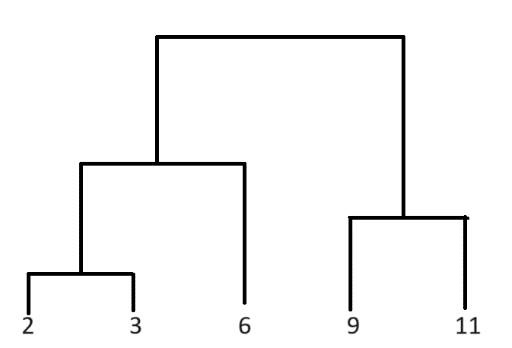

### Advantages

* **No Need to Specify the Number of Clusters**: The dendrogram can be cut at any level to produce the desired number of clusters.
* **Hierarchy of Clusters**: Provides a multilevel hierarchy, which can be useful for understanding the structure of the data.

### Disadvantages

* **Computational Complexity**: Generally, hierarchical clustering has a higher computational cost compared to K-Means, especially for large datasets.
* **Sensitivity to Noise and Outliers**: Can be sensitive to noise and outliers, which can affect the merging or splitting process.
* **Irreversible Merges**: In agglomerative clustering, once two clusters are merged, they cannot be split again. This can lead to suboptimal clustering if early merges are incorrect.

### Applications

* **Bioinformatics**: Gene expression data analysis, protein interaction analysis.
* **Text Mining**: Document clustering, topic modeling.
* **Market Research**: Customer segmentation, market basket analysis.
* **Image Analysis**: Image segmentation, pattern recognition.
* **Social Network Analysis**: Community detection, influencer identification.

# 30th June

### Linkage

The proximity between clusters is defined by a linkage criterion, which specifies the distance between sets of observations. Common linkage criteria include:

* **Single linkage (minimum linkage)**: the distance between the closest points of the clusters.
* **Complete linkage (maximum linkage)**: the distance between the farthest points of the clusters.
* **Average linkage**: the average distance between points in the clusters.
* **Centroid linkage**: the distance between the centroids of the clusters.
* **Ward's linkage**: minimizes the total within-cluster variance (also known as the error sum of squares, ESS).

### Metric

default=”euclidean”

The metric parameter specifies the distance metric used to compute the linkage. This distance metric is used to determine the proximity between clusters at each step of the clustering process.

Note:

* If linkage is “ward”, only “euclidean” is accepted.

Here are some commonly used distance metrics that can be specified using the metric parameter:

1. **Euclidean**: The standard straight-line distance between two points in Euclidean space.
2. **Manhattan** (or Cityblock): The sum of the absolute differences of their coordinates.
3. **Cosine**: Measures the cosine of the angle between two vectors.
4. **L1**: Another term for the Manhattan distance.
5. **L2**: Another term for the Euclidean distance.
6. **Precomputed**: Use a precomputed distance matrix.

## Association Rule Mining

Association rule mining is a technique used in data mining and machine learning to discover interesting relationships, patterns, or associations among a set of items in large datasets. It is commonly used in market basket analysis to find associations between items purchased together by customers.

### Key Concepts

1. **Itemset**: A collection of one or more items.
2. **Support**: The frequency or proportion of transactions in the dataset that contain a particular itemset. It indicates **how often an itemset appears** in the dataset.

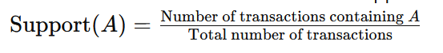

1. **Confidence**: The likelihood that a particular rule is correct. It is defined as the proportion of transactions that contain itemset AAA which also contain itemset BBB.

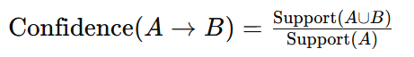

1. **Lift**: The ratio of the observed support to that expected if AAA and BBB were independent. It measures how much more likely BBB is to be purchased when AAA is purchased.

**Lift value will be:**

* + 1. **> 1, means very strongly associated between the products**
    2. **= 1, means association is by chance.**
    3. **<1, means those two items will never purchased together.**

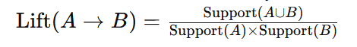

### Example

Suppose we have a dataset of transactions with the following items:

1. Bread
2. Milk
3. Butter
4. Eggs

An example rule might be: Bread→Butter\text{Bread} \rightarrow \text{Butter}Bread→Butter This means that if a customer buys bread, they are likely to also buy butter.

### Process of Association Rule Mining

1. **Frequent Itemset Generation**: Identify all itemsets that meet a minimum support threshold.
2. **Rule Generation**: From the frequent itemsets, generate all rules that meet a minimum confidence threshold.

### Algorithms

* **Apriori Algorithm**: One of the earliest and most widely used algorithms for **mining frequent itemsets** and generating association rules. It uses a bottom-up approach, where frequent subsets are extended one item at a time.
* **FP-Growth (Frequent Pattern Growth)**: An efficient algorithm that uses a divide-and-conquer strategy and a data structure called the FP-tree to mine frequent itemsets without candidate generation.

# 6th July

## Dimensionality Reduction

To mitigate overfitting or overloading in a Decision Tree, we use the max_depth parameter. However, using max_depth can result in the loss of some columns while calculating the accuracy score, potentially losing important data. To address this, we can use Dimensionality Reduction techniques, which can be applied in two ways:

1. PCA – Principal Component Analysis
2. LDA – Linear Discriminant Analysis

## Principal Component Analysis

Principal Component Analysis (PCA) is a statistical technique used in machine learning and data analysis **to reduce the dimensionality of a dataset** while preserving as much variability as possible. It transforms the data into a new coordinate system where the greatest variances are projected onto the first coordinates (principal components).

### Key Concepts

1. **Dimensionality Reduction**: PCA reduces the number of dimensions (features) in a dataset while retaining the essential information. This makes it easier to visualize and analyze the data.
2. **Principal Components**: New variables created by PCA, which are linear combinations of the original variables. The first principal component captures the maximum variance in the data, the second captures the second most variance, and so on.
3. **Variance**: PCA aims to maximize the variance captured by the principal components. The **more variance a principal component** captures, the more information it retains from the original dataset.
4. **Orthogonality**: Principal components are orthogonal (uncorrelated) to each other, ensuring that each component captures unique information.

### Steps in PCA

1. **Standardize the Data**: Ensure the data is centered (mean of zero) and scaled (standard deviation of one) if the features have different units or variances.
2. **Compute the Covariance Matrix**: Calculate the covariance matrix to understand the relationships between different features.
3. **Compute the Eigenvalues and Eigenvectors**: Calculate the eigenvalues and eigenvectors of the covariance matrix. Eigenvectors represent the directions of maximum variance (principal components), and eigenvalues represent the magnitude of variance in those directions.
4. **Sort and Select Principal Components**: Sort the eigenvalues in descending order and select the top k eigenvectors corresponding to the k largest eigenvalues to form a new feature space.
5. **Transform the Data**: Project the original data onto the new feature space formed by the top k eigenvectors.

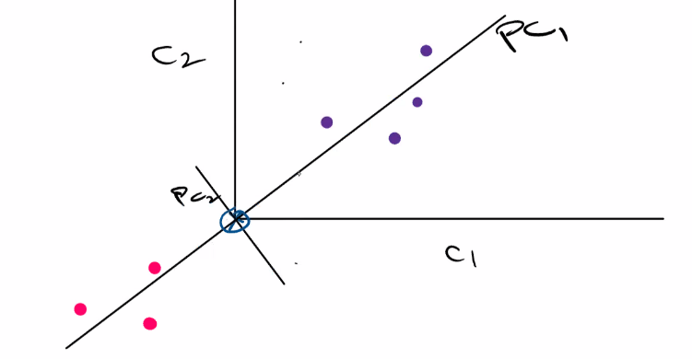

### Applications of PCA

1. **Data Visualization**: Reducing high-dimensional data to 2 or 3 dimensions for visualization.
2. **Noise Reduction**: Removing noise from data by keeping only the components that capture significant variance.
3. **Feature Extraction**: Creating new features (principal components) that summarize the original features.
4. **Data Compression**: Reducing the size of data while retaining important information.
5. **Preprocessing for Other Algorithms**: Simplifying the data for use in other machine learning algorithms, which might perform better with fewer, uncorrelated features.

### Advantages and Disadvantages

**Advantages:**

* Reduces the complexity of data and helps in better visualization.
* Removes multicollinearity by transforming correlated features into uncorrelated principal components.
* Improves the performance of machine learning models by eliminating noise and redundant features.

**Disadvantages:**

* PCA is a linear method and may not capture complex nonlinear relationships.
* The principal components may be difficult to interpret in terms of the original features.
* PCA assumes that the directions with the largest variances are the most important, which may not always be the case.

PCA is a powerful technique for dimensionality reduction, feature extraction, and data visualization, making it a fundamental tool in the data scientist’s toolkit.

### Projection of a Data Point

The projection of a data point in the context of Principal Component Analysis (PCA) involves transforming the original data point from the original feature space to the new feature space defined by the principal components. This is achieved by a linear transformation using the principal components' eigenvectors.

#### Steps to Project a Data Point

1. **Standardize the Data**: Center and scale the data so that each feature has a mean of zero and a standard deviation of one.
2. **Compute Principal Components**: Perform PCA to compute the principal components (eigenvectors of the covariance matrix).
3. **Project Data Point**: Multiply the original data point by the matrix of principal components to get the coordinates of the data point in the new principal component space.

# 7th July

Practical Demo on PCA

## Linear Discriminant Analysis

LDA is a dimensionality reduction algorithm.

This is only used with classification data, can’t use with unsupervised, regression or any other data.

LDA will project the data on to new axis to make proper separation among the data. Hence we will be able to make clear decision boundaries. While doing so, it also reduces the dimension of the data.

Linear Discriminant Analysis (LDA) is a classification and dimensionality reduction technique used in machine learning and statistics. It finds the linear combinations of features that best separate two or more classes of objects or events. Here’s a quick overview and example of how to use LDA in Python with the scikit-learn library.

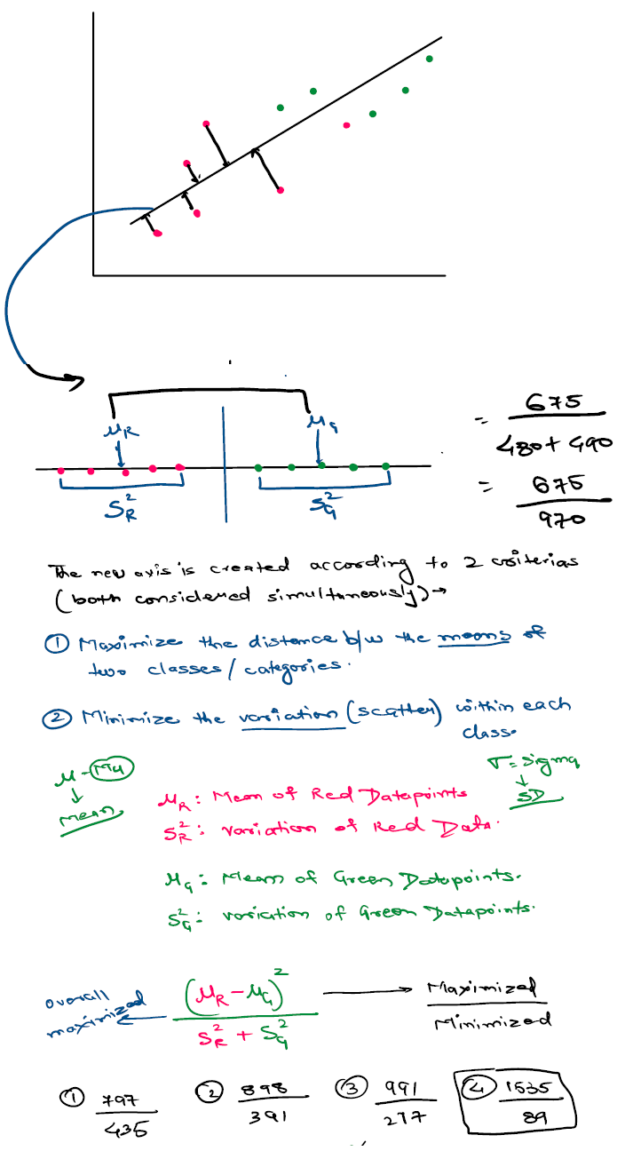

### Overview of LDA

1. **Classification**: LDA can be used as a classifier, predicting the class of a given input based on the linear combinations of features.
2. **Dimensionality Reduction**: LDA can also be used to reduce the dimensionality of the dataset while preserving as much of the class discriminatory information as possible.

### How LDA Works

* **Compute the mean vectors**: Calculate the mean vectors for each class.
* **Compute the within-class scatter matrix**: Sum the covariance matrices of each class.
* **Compute the between-class scatter matrix**: Calculate the covariance of the mean vectors.
* **Compute the eigenvectors and eigenvalues**: Solve the generalized eigenvalue problem for the scatter matrices.
* **Select the top eigenvectors**: Choose the eigenvectors corresponding to the largest eigenvalues to form a transformation matrix.
* **Transform the data**: Project the data onto the new feature space using the transformation matrix.

## PCA vs LDA

| **Aspect** | **PCA** | **LDA** |
| --- | --- | --- |
| Type | Unsupervised | Supervised |
| Objective | Maximize variance | Maximize class separability |
| Data Utilization | Uses all data to find principal components | Uses class labels to find discriminant axes |
| Scatter Matrix | Covariance matrix | Within-class and between-class scatter matrices |
| Applications | Data compression, noise reduction, visualization | Classification, dimensionality reduction, visualization |
| Dimensionality | Can reduce to any number of dimensions | Can reduce to (number of classes - 1) dimensions |

# 13th July

## Covariance

Covariance is a statistical measure that indicates the extent to which two variables change together. It is used to determine the relationship between two variables and whether they tend to increase or decrease simultaneously.

Here are some key points about covariance:

1. **Positive Covariance**: If the covariance is positive, it means that as one variable increases, the other variable tends to increase as well. Similarly, if one variable decreases, the other variable tends to decrease.
2. **Negative Covariance**: If the covariance is negative, it indicates that as one variable increases, the other variable tends to decrease, and vice versa.
3. **Zero Covariance**: If the covariance is close to zero, it suggests that there is no linear relationship between the variables.

The formula for covariance between two variables X and Y is:

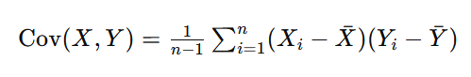

where:

* Xi​ and Yi​ are the individual data points.
* Xˉ and Yˉ are the means of the X and Y data sets, respectively.
* n is the number of data points.

Covariance is a measure used in varius fields such as finance (to measure how two stocks move together), machine learning, and data analysis. However, it is important to note that covariance is sensitive to the scale of the variables. To address this, the correlation coefficient is often used, which normalizes the covariance by the product of the standard deviations of the variables, resulting in a dimensionless measure that ranges between -1 and 1.

## Eigenvalues and Eigenvectors in PCA

Ex to understand :

if a vehicle moving to east side with a speed of 60 KMPH then

--> eigen value is 60 KMPH

--> eigen vector is east side

Principal Component Analysis (PCA) is a technique used to reduce the dimensionality of data while preserving as much variability as possible. Eigenvalues and eigenvectors play a crucial role in PCA. Here's a simple explanation of how they are used:

### Step-by-Step Explanation

1. **Data Preparation**:
   * Start with a dataset that has multiple features (variables).
   * Standardize the data (mean = 0 and variance = 1 for each feature) to ensure that each feature contributes equally to the analysis.
2. **Covariance Matrix**:
   * Compute the covariance matrix of the standardized data. This matrix shows how each pair of features varies together.
3. **Eigenvalues and Eigenvectors**:
   * Calculate the eigenvalues and eigenvectors of the covariance matrix.
   * **Eigenvectors**: These represent the directions of the new feature space. Each eigenvector is a principal component.
   * **Eigenvalues**: These indicate the amount of variance captured by each eigenvector (principal component). A higher eigenvalue means that the corresponding eigenvector captures more of the data’s variability.
4. **Sorting**:
   * Sort the eigenvalues and their corresponding eigenvectors in descending order of eigenvalues. This way, the first principal component will capture the most variance, the second will capture the next most, and so on.
5. **Dimensionality Reduction**:
   * Select the top kkk eigenvectors (principal components) based on their eigenvalues. This choice is often made by deciding how much of the total variance you want to retain (e.g., 95%).
   * Transform the original data to this new feature space using these top kkk eigenvectors. The resulting data set will have kkk features instead of the original number.

### Example

* **Original Data**:
  + Imagine you have a dataset with 3 features (like height, weight, and age).
* **Standardization**:
  + Standardize the data so that each feature has a mean of 0 and a variance of 1.
* **Covariance Matrix**:
  + Calculate the covariance matrix, which might look like this:

( 1.0 0.5 0.3

0.5 1.0 0.4

0.3 0.4 1.0 )

* **Eigenvalues and Eigenvectors**:
* Compute the eigenvalues and eigenvectors of this covariance matrix. Suppose the eigenvalues are 1.5, 1.0, and 0.5.
* The eigenvectors might be:

( 0.6 0.7 0.4

0.5 −0.2 −0.8

0.6 −0.6 0.5 )

* **Sorting**:
* Sort the eigenvalues and eigenvectors. The eigenvector corresponding to the highest eigenvalue (1.5) captures the most variance, so it becomes the first principal component.
* **Dimensionality Reduction**:
* Choose the top 2 eigenvectors (if you want to reduce to 2 dimensions).
* Transform the original data into this new 2-dimensional space.

### Why This Matters

* **Data Visualization**: Reducing data to 2 or 3 dimensions makes it easier to visualize.
* **Noise Reduction**: By keeping only the components with the highest variance, you often reduce noise.
* **Computational Efficiency**: Working with fewer dimensions can make machine learning algorithms faster and more efficient.

In essence, in PCA, eigenvalues help you decide which directions (principal components) are the most important, and eigenvectors tell you what those directions are.

# 14th July

## Variance

In simple words variance is a how max the data is spread.

Variance in Artificial Intelligence and Machine Learning (AIML) refers to the variability of a model's predictions. It indicates how much the predictions for a given data point differ between different training sets. Variance measures how sensitive a model is to the specific data it was trained on. Here's a more detailed breakdown:

1. **Definition**: Variance is a metric that captures the amount by which the predictions of a model would change if it were trained on a different dataset. High variance means the model's predictions fluctuate significantly when trained on different data, while low variance means the predictions are relatively stable.
2. **Bias-Variance Tradeoff**: Variance is a key component of the bias-variance tradeoff, which is a fundamental concept in machine learning. The tradeoff describes the relationship between:
   * **Bias**: The error introduced by approximating a real-world problem, which may be complex, by a simplified model.
   * **Variance**: The error introduced by the model's sensitivity to the fluctuations in the training set. A good model aims to achieve a balance between bias and variance, minimizing the total error.
3. **Impact on Model Performance**:
   * **High Variance**: Models with high variance are typically **overfitted**. They perform well on the training data but poorly on new, unseen data because they capture noise and fluctuations in the training data.
   * **Low Variance**: Models with low variance are generally more **generalizable** and perform consistently across different datasets. However, if the variance is too low, the model might be underfitting, not capturing the underlying trends in the data.
4. **Examples**:
   * **High Variance Model**: A very complex model like a deep neural network with many layers might have high variance if not properly regularized.
   * **Low Variance Model**: A simple linear regression model might have low variance but could potentially have high bias if the true relationship is non-linear.
5. **Reducing Variance**: Techniques to reduce variance in models include:
   * **Cross-validation**: Using k-fold cross-validation to ensure that the model's performance is consistent across different subsets of the data.
   * **Regularization**: Applying regularization techniques such as L1 (Lasso) or L2 (Ridge) regularization to penalize large coefficients and prevent overfitting.
   * **Ensemble Methods**: Combining predictions from multiple models (e.g., bagging, boosting) to reduce the variance of the final prediction.

Understanding and managing variance is crucial for building robust and reliable machine learning models that perform well on new, unseen data.

## Classification Report

A classification report provides a comprehensive summary of the performance of a classification model. It typically includes metrics such as precision, recall, F1-score, and support for each class.

### Generating a Classification Report

First, ensure you have the necessary libraries installed. If not, you can install scikit-learn using:

pip install scikit-learn

Then, you can generate a classification report as follows:

from sklearn.metrics import classification_report

# Assume y_test are the true labels and y_pred are the predicted labels

y_test = [0, 1, 2, 2, 0, 1]

y_pred = [0, 2, 1, 2, 0, 1]

report = classification_report(y_test, y_pred)

print(report)

### Example Output

Here’s an example of what the output might look like:

precision recall f1-score support

0 0.67 1.00 0.80 2

1 0.50 0.50 0.50 2

2 1.00 0.50 0.67 2

accuracy 0.67 6

macro avg 0.72 0.67 0.66 6

weighted avg 0.72 0.67 0.66 6

### Interpretation

1. **Precision**: The number of true positive results divided by the number of all positive results (true positive + false positive). It measures the accuracy of the positive predictions.

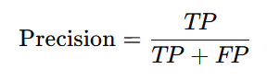

* + Example: For class 0, precision is 0.67, meaning 67% of the items predicted as class 0 were actually class 0.

1. **Recall (Sensitivity)**: The number of true positive results divided by the number of positive samples. It measures the ability of the model to find all the relevant cases within a dataset.

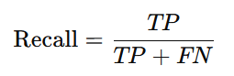

* + Example: For class 0, recall is 1.00, meaning the model found all actual class 0 samples.

1. **F1-Score**: The harmonic mean of precision and recall. It gives a balance between precision and recall.

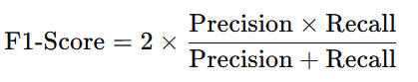

* + Example: For class 0, the F1-score is 0.80.

1. **Support**: The number of actual occurrences of the class in the dataset.
   * Example: For class 0, support is 2, meaning there are 2 actual instances of class 0 in the dataset.
2. **Accuracy**: The ratio of correctly predicted instances to the total instances.

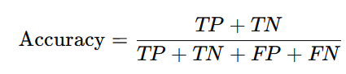

* + Example: Accuracy is 0.67, meaning the model correctly predicted 67% of the instances.

1. **Macro Average**: The unweighted mean of the precision, recall, and F1-score for each class. It does not consider the class imbalance.
   * Example: The macro average F1-score is 0.66.
2. **Weighted Average**: The mean of the precision, recall, and F1-score weighted by the number of true instances for each class. It considers class imbalance.
   * Example: The weighted average F1-score is 0.66.

### Full Code Example

Here’s a complete example including the model training part:

from sklearn.datasets import load_iris

from sklearn.model_selection import train_test_split

from sklearn.ensemble import RandomForestClassifier

from sklearn.metrics import classification_report

# Load dataset

data = load_iris()

X = data.data

y = data.target

# Split the dataset into training and testing sets

X_train, X_test, y_train, y_test = train_test_split(X, y, test_size=0.3, random_state=42)

# Train a classifier

clf = RandomForestClassifier(random_state=42)

clf.fit(X_train, y_train)

# Predict the labels for the test set

y_pred = clf.predict(X_test)

# Generate and print the classification report

report = classification_report(y_test, y_pred)

print(report)

This example demonstrates loading the Iris dataset, splitting it into training and testing sets, training a Random Forest classifier, making predictions, and generating a classification report to evaluate the model's performance.

## Confusion Matrix

A confusion matrix is a table used to evaluate the performance of a classification model. It summarizes the number of correct and incorrect predictions broken down by each class. This matrix provides insight into not only the accuracy of a model but also the types of errors it is making.

### Structure of a Confusion Matrix

For a binary classification problem, the confusion matrix has a 2x2 structure:

|  |  |  |
| --- | --- | --- |
|  | Predicted Positive | Predicted Negative |
| Actual Positive | TP | FN |
| Actual Negative | FP | TN |

* **TP (True Positive)**: The model correctly predicted the positive class.
* **FN (False Negative)**: The model incorrectly predicted the negative class for an actual positive instance.
* **FP (False Positive)**: The model incorrectly predicted the positive class for an actual negative instance.
* **TN (True Negative)**: The model correctly predicted the negative class.

Note:

For a multi-class classification problem (i.e. n problems/column), the confusion matrix extends to an **NxN** matrix, where N is the number of classes.

## Precision

It explain the correct true prediction ratio

Precision is a metric used to evaluate the performance of a classification model, particularly in binary classification. It measures the accuracy of the positive predictions made by the model. Precision is defined as the ratio of true positive (TP) predictions to the total number of positive predictions (both true positives and false positives (FP)).

### Formula

The formula for precision is:



### Interpretation

* **High Precision**: Indicates that the model has a low false positive rate, meaning it makes very few mistakes when predicting the positive class.
* **Low Precision**: Indicates that the model has a high false positive rate, meaning it often incorrectly predicts the positive class.

### Summary

Precision is particularly important in scenarios where the cost of false positives is high. For example, in spam detection, a high precision means that the emails classified as spam are indeed spam, reducing the chance of legitimate emails being incorrectly marked as spam.

## Recall

Recall, also known as **sensitivity** or **true positive rate**, is a metric used to evaluate the performance of a classification model. It measures the ability of the model to correctly identify all relevant instances of the positive class. Recall is particularly important in scenarios where it is crucial to capture as many positive instances as possible, even if it means having more false positives.

### Formula

The formula for recall is:



### Interpretation

* **High Recall**: Indicates that the model correctly identifies a high proportion of actual positives, meaning it misses few positive instances.
* **Low Recall**: Indicates that the model misses a significant number of actual positives.

Recall is particularly important in scenarios where missing a positive instance has a high cost. For example, in medical diagnosis, a high recall means that most patients with the disease are correctly identified, which is crucial for early treatment.

### Summary

Recall is a crucial metric for evaluating the performance of classification models, especially in cases where it is important to identify as many positive instances as possible. Understanding and optimizing for recall is essential in domains such as healthcare, fraud detection, and any field where missing positive instances carries significant consequences.

## Accuracy

Accuracy is a common metric used to evaluate the performance of a classification model. It measures the proportion of correct predictions (both true positives and true negatives) out of the total number of predictions made. Accuracy is simple to understand and compute, but it may not always be the best metric, especially in cases of imbalanced datasets.

### Formula

The formula for accuracy is:



### Interpretation

* **High Accuracy**: Indicates that the model makes correct predictions most of the time.
* **Low Accuracy**: Indicates that the model makes incorrect predictions frequently.

### Summary

Accuracy is a straightforward and widely used metric for evaluating the performance of classification models. While it provides a quick snapshot of how well a model is performing, it is important to consider other metrics such as precision, recall, and F1-score, especially when dealing with imbalanced datasets. Using multiple evaluation metrics helps to get a more comprehensive understanding of the model's performance.

# 20th July

Hands on Session on LDA

# 21st July

Hand on the Netflix project

# 27th July

## Time Series Data

Time series data is a sequence of data points collected or recorded at successive points in time, often at equally spaced intervals. This type of data captures the changes in values of a variable over time, making it crucial for analyzing trends, patterns, and forecasting future values.

Key characteristics of time series data include:

1. **Temporal Ordering**: The data points are ordered chronologically.
2. **Equidistant Intervals**: The measurements are usually taken at regular time intervals, such as daily, monthly, or annually.
3. **Dependency**: Current values can depend on past values, which is a critical aspect for analysis.

**Examples of Time Series Data:**

* Stock prices recorded daily.
* Monthly sales revenue of a company.
* Daily temperature readings.
* Hourly website traffic.

**Uses of Time Series Data:**

* **Forecasting**: Predicting future values based on past trends, like weather forecasting or stock market prediction.
* **Seasonality Analysis**: Identifying repeating patterns over time, such as higher ice cream sales in summer.
* **Trend Analysis**: Understanding long-term movements or trends, like an upward trend in sales over several years.
* **Anomaly Detection**: Identifying unusual patterns or outliers, such as sudden drops in website traffic.

**Methods for Analyzing Time Series Data:**

* **Moving Averages**: Smoothing out short-term fluctuations to identify longer-term trends.
* **Exponential Smoothing**: Applying weighted averages where more recent data points are given more significance.
* **ARIMA (AutoRegressive Integrated Moving Average)**: Combining autoregression, differencing, and moving averages to model and forecast time series data.
* **Seasonal Decomposition of Time Series (STL)**: Decomposing the data into seasonal, trend, and residual components.

Understanding and analyzing time series data is essential for making informed decisions in various fields, including finance, economics, environmental science, and business analytics.

### Data Patterns

Time series data can exhibit various patterns that help in understanding the underlying structure and making accurate forecasts. The primary patterns include:

1. **Trend**: A long-term movement or direction in the data, which can be upward, downward, or flat. Trends indicate the overall direction of the data over a significant period.
   * **Upward Trend**: When the data shows a general increase over time.
   * **Downward Trend**: When the data shows a general decrease over time.
   * **No Trend**: When the data fluctuates around a constant level without a clear direction.
2. **Seasonality**: Regular, repeating patterns or cycles in the data that occur at specific intervals, such as daily, weekly, monthly, or yearly. Seasonal patterns are influenced by seasonal factors, such as holidays or weather conditions.
   * **Example**: Increased retail sales during the holiday season every year.
3. **Cyclic Patterns**: Long-term fluctuations that are not of fixed frequency, often associated with economic or business cycles. Unlike seasonality, cyclic patterns do not have a fixed period and can vary in length.
   * **Example**: Economic booms and recessions.
4. **Irregular/Random Patterns**: Unpredictable, random variations that do not follow any specific trend, seasonality, or cyclic pattern. These are often caused by unexpected events or noise in the data.
   * **Example**: Sudden spikes in sales due to a viral marketing campaign.
5. **Stationarity**: A property of time series data where the statistical properties (mean, variance, autocorrelation) do not change over time. Stationary data does not exhibit trends or seasonality.
   * **Non-stationary Data**: Data with trends, seasonality, or other patterns that change over time.
   * **Stationary Data**: Data where fluctuations occur around a constant mean and variance.
6. **Autocorrelation**: The correlation of a time series with its own past values. High autocorrelation indicates that past values have a strong influence on current values.
   * **Lag**: The interval at which the correlation is measured. For example, a lag of 1 means correlating the time series with its immediately previous value.

**Identifying and understanding these patterns is crucial for effective time series analysis and forecasting. Techniques such as decomposition, differencing, and various statistical tests (like the Augmented Dickey-Fuller test for stationarity) are used to analyze and model these patterns.**

### Rolling Mean

A rolling mean, also known as a moving average, is a statistical method used to analyze time series data by calculating the average of data points over a specified number of periods, which rolls or moves through the data set. This technique helps smooth out short-term fluctuations and highlight longer-term trends or cycles.

#### Types of Rolling Mean

1. **Simple Moving Average (SMA)**:
   * The average of a fixed number of consecutive periods.
   * As each new data point becomes available, the oldest data point is dropped, and the newest one is added.
2. **Exponential Moving Average (EMA)**:
   * Places more weight on recent data points, making it more responsive to recent changes.
   * Formula: EMA(t)=α⋅yt+(1−α)⋅EMA(t−1)\text{EMA}(t) = \alpha \cdot y_t + (1 - \alpha) \cdot \text{EMA}(t-1)EMA(t)=α⋅yt​+(1−α)⋅EMA(t−1)
     + α\alphaα: Smoothing factor, 0<α<10 < \alpha < 10<α<1

#### Purpose and Applications

* **Trend Analysis**: Helps identify the underlying trend by smoothing out the noise.
* **Forecasting**: Used as a basis for more complex forecasting models.
* **Anomaly Detection**: Helps detect outliers by comparing actual values against the rolling mean.
* **Signal Processing**: Used in technical analysis of financial markets to identify buy/sell signals.

### Rolling Standard Deviation

A rolling standard deviation, also known as a moving standard deviation, is a statistical method used to measure the variability or dispersion of a set of data points over a specified number of periods, which moves through the data set. This technique helps to analyze the stability or volatility of a time series by smoothing out short-term fluctuations and highlighting longer-term patterns.

#### Purpose and Applications

* **Volatility Analysis**: Commonly used in financial markets to measure the volatility of asset prices.
* **Risk Management**: Helps in understanding and managing the risk associated with time series data.
* **Quality Control**: Used in manufacturing and other industries to monitor the stability of processes.

#### Calculation

To calculate the rolling standard deviation, follow these steps:

1. **Select Window Size (n)**: Choose the number of periods over which the standard deviation will be calculated.
2. **Calculate Mean**: Compute the rolling mean for the selected window size.
3. **Compute Variance**: Calculate the variance for each window by taking the average of the squared differences between each data point and the rolling mean.
4. **Take Square Root**: The rolling standard deviation is the square root of the variance.

##### Example

Consider a time series representing daily stock prices over 10 days:

| **Day** | **Price** |
| --- | --- |
| 1 | 100 |
| 2 | 102 |
| 3 | 101 |
| 4 | 105 |
| 5 | 107 |
| 6 | 110 |
| 7 | 108 |
| 8 | 112 |
| 9 | 115 |
| 10 | 118 |

To calculate a 3-day rolling standard deviation:

* **Day 3**:
  + Mean: (100+102+101)/3=101
  + Variance: ((100−101)^2+(102−101)^2+(101−101)^2) / 3=0.6667
  + Std: sqrt(0.6667) ≈ 0.82 (≈ means ‘ approx. equal value)
* **Day 4**:
  + Mean: (102+101+105)/3=102.67
  + Variance: ((102−102.67)^2+(101−102.67)^2+(105−102.67)^2)/3=2.89
  + Std: sqrt(2.89) ≈ 1.7
* **Day 5**:
* Mean: (101+105+107)/3=104.33
* Variance: ( (101-104.33)^2 + (105-104.33)^2 + (107-104.33)^2 ) / 3 = 6.22
* Std: sqrt(6.22) ≈ 2.49

This process continues for the entire series, providing a smoothed line that shows how the variability of the data changes over time.

### ARIMA model

The ARIMA (AutoRegressive Integrated Moving Average) model is a popular statistical method used for analyzing and forecasting time series data. It combines three components—autoregression (AR), differencing (I for Integrated), and moving average (MA)—to model the data. ARIMA models are particularly useful for non-stationary data that can be made stationary through differencing.

#### Components of ARIMA

1. **Autoregressive (AR) Component**:
   * Refers to a model that uses the dependency between an observation and a number of lagged observations (previous time steps).
   * AR(p): The order of the autoregressive part indicates the number of lagged observations included in the model.
2. **Integrated (I) Component**:
   * Refers to the differencing of raw observations to make the time series stationary.
   * I(d): The order of differencing needed to make the series stationary.
3. **Moving Average (MA) Component**:
   * Refers to a model that uses dependency between an observation and a residual error from a moving average model applied to lagged observations.
   * MA(q): The order of the moving average part indicates the number of lagged forecast errors included in the model.

#### ARIMA Model Notation

The ARIMA model is typically denoted as ARIMA(p, d, q), where:

* p is the order of the autoregressive part.
* d is the order of differencing.
* q is the order of the moving average part.

#### Steps to Build an ARIMA Model

1. **Identification**:
   * Determine the order of differencing needed to make the series stationary (d).
   * Use **autocorrelation function** (ACF) and **partial autocorrelation function** (PACF) plots to identify potential values for p and q.
2. **Estimation**:
   * Estimate the parameters ϕ (phi) and θ (theta) using methods like maximum likelihood estimation.
3. **Diagnostic Checking**:
   * Check the residuals of the model to ensure they resemble white noise (i.e., no patterns or correlations).
   * Use statistical tests like the Ljung-Box test.
4. **Forecasting**:
   * Once the model is validated, use it to make forecasts for future time periods.

#### Example

Suppose you have monthly sales data for a retail store and you want to forecast future sales. After differencing the data once (d = 1) to make it stationary, you analyze the ACF and PACF plots and decide on an ARIMA(2, 1, 1) model.

1. **Autoregressive part (p = 2)**: The model includes sales from the previous two months.
2. **Differencing (d = 1)**: The data has been differenced once to achieve stationarity.
3. **Moving Average part (q = 1)**: The model includes the error term from the previous month.

#### Benefits of ARIMA

* **Versatility**: Can model a wide range of time series data.
* **Stationarity**: Can handle non-stationary data through differencing.
* **Forecasting**: Provides a robust framework for making accurate forecasts.

By understanding and applying ARIMA models, you can effectively analyze time series data and make informed predictions.

### Adfuller Test

The Augmented Dickey-Fuller (ADF) test is a statistical test used to determine whether a time series is stationary or has a unit root, which indicates non-stationarity. Stationarity is an important property in time series analysis, as many statistical models assume that the underlying data generating process is stationary.

The ADF test is an extension of the Dickey-Fuller test and includes lagged differences of the time series to account for higher-order autocorrelation. It tests the null hypothesis that a unit root is present in an autoregressive model.

#### Key Concepts

1. **Stationarity**: A time series is stationary if its statistical properties, such as mean and variance, are constant over time. Non-stationary time series often exhibit trends, seasonality, or changing variances.
2. **Unit Root**: A time series that has a unit root is non-stationary. The presence of a unit root indicates that the series follows a random walk and may have a stochastic trend.

#### Test Statistics

The ADF test statistic is compared against critical values to determine whether the null hypothesis (presence of a unit root) can be rejected. The null hypothesis is:

* **Null Hypothesis (H₀)**: The time series has a unit root (i.e., it is non-stationary).
* **Alternative Hypothesis (H₁)**: The time series does not have a unit root (i.e., it is stationary).

#### Steps to Perform the ADF Test

1. **Specify the Model**: Choose between different models (with or without a constant, trend, or both) based on the characteristics of the time series.
2. **Estimate the Test Statistic**: Apply the ADF test to compute the test statistic and corresponding p-value.
3. **Compare with Critical Values**: Compare the test statistic with critical values from the ADF test table to determine whether to reject the null hypothesis.
4. **Interpret Results**: If the test statistic is less than the critical value (or the p-value is below the significance level, typically 0.05), reject the null hypothesis and conclude that the time series is stationary. Otherwise, fail to reject the null hypothesis.

#### Example

Suppose you have a time series of monthly sales data and want to test for stationarity. You perform the ADF test and obtain the following results:

* **ADF Test Statistic**: -3.45
* **Critical Value (1% level)**: -3.50
* **p-value**: 0.08

In this case:

* The ADF test statistic (-3.45) is greater than the critical value (-3.50), so you fail to reject the null hypothesis at the 1% significance level.
* The p-value (0.08) is greater than 0.05, so you also fail to reject the null hypothesis at the 5% significance level.

This suggests that the time series may be non-stationary and may require differencing or other transformation to achieve stationarity.

#### Summary

The Augmented Dickey-Fuller test is a valuable tool for assessing the stationarity of time series data, which is crucial for selecting appropriate statistical models and making reliable forecasts.

# 28th July

We have hands-on session on TimeSeries including Transformation, differentials, Boxcox, AR, ARIMA, SARIMA.

# 3rd August

We have continued hands-on session.

### ACF(q) vs PACF(p)

In time series analysis, **Autocorrelation Function (ACF)** and **Partial Autocorrelation Function (PACF)** are essential tools for understanding the underlying structure of the data. Here's a brief overview of each:

#### 1. **Autocorrelation Function (ACF)**

* **Definition:** The ACF measures the correlation between the time series and its lagged values at different lags. Essentially, it tells us how well the present value of the series is related to its past values.
* **Use:** ACF is used to identify the overall correlation structure of the data. It helps to determine the number of lags that significantly contribute to the time series' behavior.
* **Interpretation:**
  + A high ACF value at a particular lag suggests that the values in the time series are significantly correlated with each other at that lag.
  + If the ACF declines slowly, this could indicate that the series is non-stationary.
  + A sharp cut-off after a few lags suggests a moving average (MA) component.

#### 2. **Partial Autocorrelation Function (PACF)**

* **Definition:** The PACF measures the correlation between the time series and its lagged values, but with the influence of the intermediate lags removed. It represents the "pure" correlation between the series and its lagged version.
* **Use:** PACF is particularly useful in identifying the order of an autoregressive (AR) model. It helps determine the number of autoregressive terms (lags) to include in the model.
* **Interpretation:**
  + A significant PACF value at a particular lag indicates that the lag contributes to the series independently of the intermediate lags.
  + A sharp drop in PACF after a certain lag suggests that an autoregressive process of that order might be suitable.

#### **Usage in Machine Learning**

* In the context of machine learning, ACF and PACF are commonly used in **ARIMA models** (AutoRegressive Integrated Moving Average) for forecasting. The ACF helps identify the order of the MA (Moving Average) part, while the PACF helps identify the order of the AR (AutoRegressive) part.
* They are also used to understand the temporal dependencies in time series data, which can be crucial for feature engineering or model selection in more complex models like **LSTMs** or **transformer-based** models for time series forecasting.

Understanding the ACF and PACF can help you better model and forecast time series data by giving insights into the dependencies within the data.

# 4th August

Today also we have hands on method on TimeSeries Data by using AirPassengers.csv

### **Decomposition**

In time series analysis, **decomposition** refers to breaking down a time series into its fundamental components to better understand its underlying structure and characteristics. Decomposition is particularly useful for analyzing and forecasting time series data, as it allows you to separate out different sources of variation.

#### Key Components of Time Series Decomposition

1. **Trend (T)**:
   * The trend component represents the long-term progression or direction in the data. It shows the general movement of the time series over a longer period, which could be upward, downward, or flat.
   * Example: In a time series of sales data, the trend might show a gradual increase in sales over several years.
2. **Seasonality (S)**:
   * The seasonality component captures the repeating patterns or cycles in the data that occur at regular intervals (e.g., daily, monthly, yearly).
   * Example: Retail sales often spike during the holiday season each year, representing seasonal behavior.
3. **Residual/Noise (R)**:
   * The residual component (also called the noise or irregular component) represents the random variation or "leftover" part of the data that cannot be explained by the trend or seasonality.
   * This component includes all the irregularities and random noise in the data.
4. **Cyclic Component** (optional, sometimes part of trend):
   * Cycles are fluctuations that occur over longer periods than seasonality but are not necessarily regular like seasonal patterns. They often relate to economic or business cycles.

#### Types of Decomposition

1. **Additive Decomposition**:
   * In an additive model, the time series is assumed to be the sum of the trend, seasonality, and residual components.
   * **Use Case**: Additive decomposition is appropriate when the variations in the components are consistent over time.
2. **Multiplicative Decomposition**:
   * In a multiplicative model, the time series is assumed to be the product of the trend, seasonality, and residual components.
   * **Use Case**: Multiplicative decomposition is used when the components' variations change proportionally with the level of the series (e.g., higher values of the time series have larger fluctuations).

#### Use Cases of Decomposition

1. **Forecasting**: Helps in better understanding the time series and improving forecasting models by separately modeling trend and seasonality.
2. **Anomaly Detection**: Residuals from decomposition can highlight anomalies or unusual patterns not explained by trend or seasonality.
3. **Data Cleaning**: Decomposition can help remove seasonality or trends to analyze the underlying data more effectively.

By decomposing a time series, you can gain valuable insights into its structure, making it easier to analyze, interpret, and model.

# 10th Aug

Hands on session on Decision Trees

# 11th Aug

Hands on session on Random Forest

# 17th Aug

Hands on session on K-Means algorithm

# 18th Aug

Hands on session on LDA

## nlargest method

The nlargest() method in Python is a part of the heapq module and is used to find the n largest elements in a dataset. This method is particularly useful when you need the top n largest elements from an iterable, like a list, without sorting the entire dataset.

* df.nlargest(n, iterable, key=None)

Here,

* **n**: The number of largest elements you want to retrieve.
* **iterable**: The dataset from which to retrieve the largest elements.
* **key** *(optional)*: A function that serves as a key for sorting the elements. Similar to the key parameter in Python's sorted() function.

Ex1:

import heapq

numbers = [1, 8, 2, 23, 7, 5, 10]

# Get the 3 largest numbers

largest_numbers = heapq.nlargest(3, numbers)

print(largest_numbers) # Output: [23, 10, 8]

Ex2: Custom Key

import heapq

people = [

{'name': 'Alice', 'age': 30},

{'name': 'Bob', 'age': 25},

{'name': 'Charlie', 'age': 35},

{'name': 'Dave', 'age': 20}

]

# Get the 2 oldest people

oldest_people = heapq.nlargest(2, people, key=lambda x: x['age'])

print(oldest_people)

# Output: [{'name': 'Charlie', 'age': 35}, {'name': 'Alice', 'age': 30}]

**Use Cases:**

* Efficiently retrieving the largest n elements from large datasets.
* Avoiding the need to sort the entire dataset, which can be time-consuming.

This method is particularly useful in performance-critical applications where only the top elements are needed, and sorting the entire list is unnecessary.